Excel Mini-Exercise 1
Getting Started

Assessment and Design Strategies

- Open Excel
- Starting Microsoft Excel
- Two Ways
  - Double click on the Microsoft Excel icon on the desktop.

  - Click on Start --> Programs --> Microsoft Excel
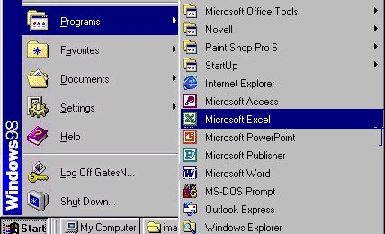

- Choose New worksheet
- Type in the numbers from 5-50 and 2-20 and 258-789 (like this)

5 | 2 | 258
10 | 4 | 36
15 | 6 | 269
20 | 8 | 458
25 | 10 | 978
30 | 12 | 555
35 | 14 | 336
40 | 16 | 123
45 | 18 | 456
50 | 20 | 789

- Go back and insert a new column in front of column A
  - Click on Column A -> insert -> column (from menu bar)
  - It should now look like:
 | 5 | 2 | 258
 | 10 | 4 | 36
 | 15 | 6 | 269
 | 20 | 8 | 458
 | 25 | 10 | 978
 | 30 | 12 | 555
 | 35 | 14 | 336
 | 40 | 16 | 123
 | 45 | 18 | 456
 | 50 | 20 | 789

- Skip a couple of rows and in column A (i.e. A12) Type TOTAL
- To Total- try these
  - Click in the cell you want it to show the total-> click the summation sign ∑ from the menu bar and highlight the cells you want it to total-click enter
  - You can also, highlight the cells in a column and click the summation sign and it will total it by itself (but will default to the cell below the list)-you can cut and paste that total to the cell you want and the formula will remain

 | 5 | 2 | 258
 | 10 | 4 | 36
 | 15 | 6 | 269
 | 20 | 8 | 458
 | 25 | 10 | 978
 | 30 | 12 | 555
 | 35 | 14 | 336
 | 40 | 16 | 123
 | 45 | 18 | 456
 | 50 | 20 | 789
Total | 275 | 110 | 4258

- Excel works by “recognizing” characters in a cell-especially the first item
  - 245 means a number
  - 4/5/02 means a date
  - a letter means text
  - = means a formula will follow
- click in the next column (i.e. column E)
- enter =
- create some formulas (to explore what happens) by using the following:
  - * multiples
  - + adds
  - - subtracts
  - / divides
  - ( ) contain units

Creating Formulas
- Click the cell in which you want to enter the formula.
- Type = (an equal sign).
- Click the Function Button
- Select the formula you want and step through the on-screen instructions
Order of Operations Excel Uses
Precedence | Operation | Operator
1 | Exponentiation | ^
2 | Multiplication | *
2 | Division | /
3 | Addition | +
3 | Subtraction | -
4 | Concatenation (putting 2 strings together, like Jenn & ifer) | &
5 | Equal To | =
5 | Greater Than | >
5 | Less Than | <

Congratulations! Go on to the Grade Book Exercise

