Survey monkey seems great.
I would really like to put a class survey on line. I started to create one on ice cream?

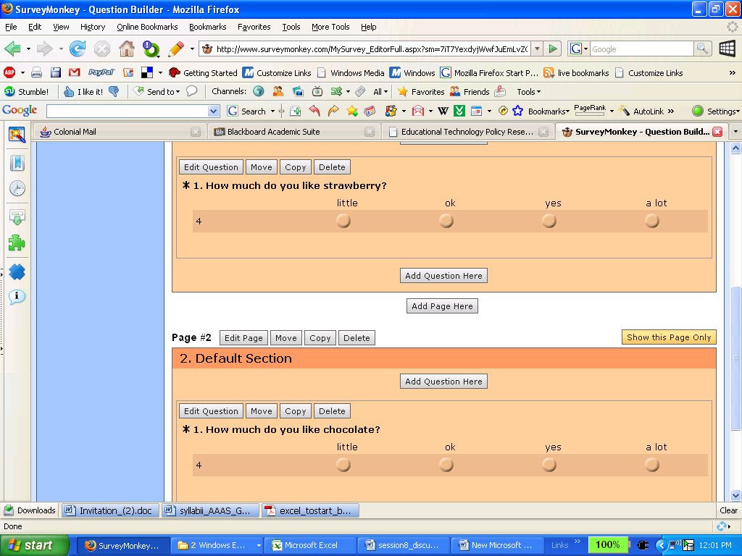

Puzzle maker on discovery=Great
f s l b o t s r s w s k s m z
Biology
animal
bacteria
biology
cells
nucleus
organelles
organism
plant
proteins
sugars

f l e b i u v k x s y n x s b
o r g l g o n x t x i h r i g
b c x a l a l w s e q m y n b
g l r a j e w o t l a d t a c
n s i j q w n o g o l f y g w
d s z o a r r a o y p e w r n
p q f s z p w t g k q d c o u
l a m i n a s n y r v d j j c
b a c t e r i a u x o g k y l
v p i j h l f l r u s k o b e
m n a n x k i p y u m z n z u
l v y p w y a v l x c o h h s
j v n p t b a x o p p q d w h
o t f x a x o w m r v i j o b

Quiz star seems cool Is it worth the money?- (2.75 a month for certain programs- I have started to create a class on a free trial-everthing takes a long time to load
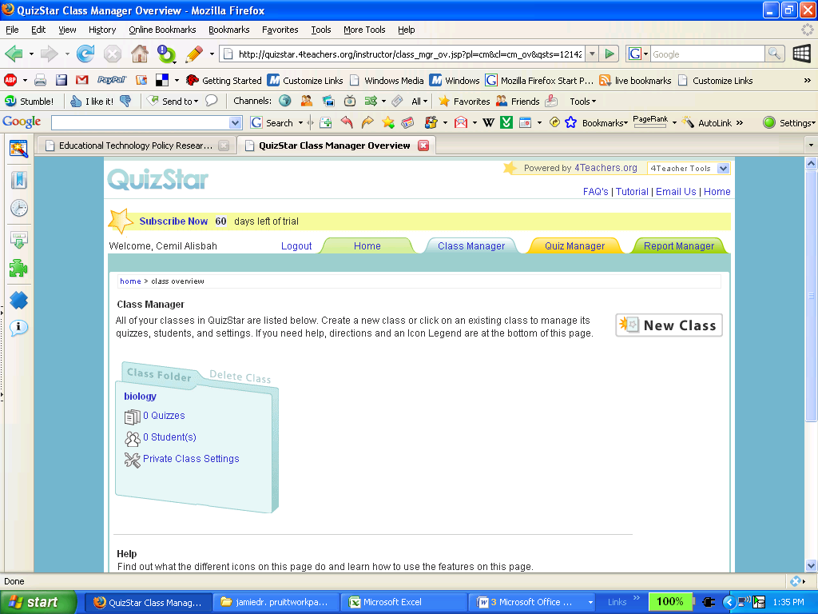

Cool Teaching-Just like it says Treasure trove
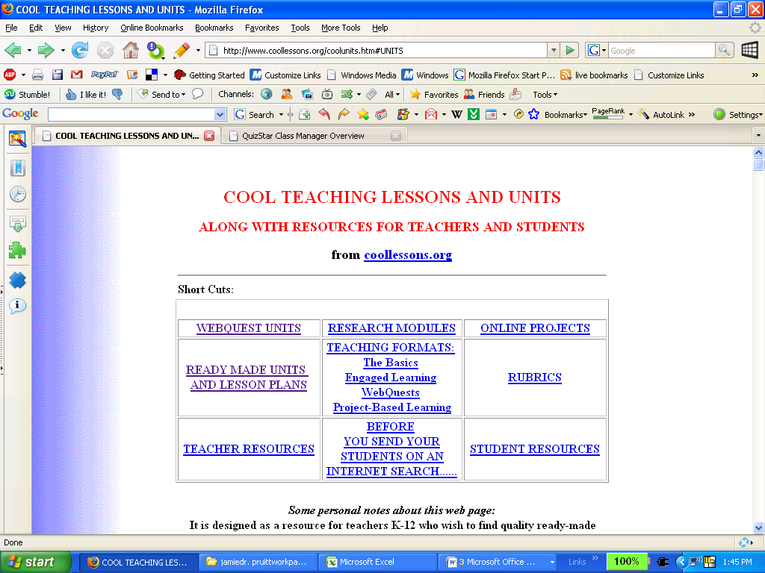

Blue Web Awesome Science lesson plan search engine. I’m just amazed by all the awesome stuff
