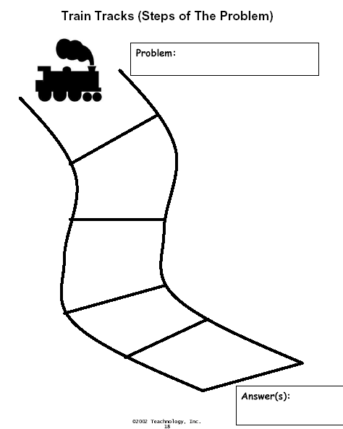

Students would be required to fill in the steps to finding the least common denominator as steps along the train’s path (1. List the multiples of one denominator 2. List the multiples of the other denominator 3. Choose the smallest number that the two lists have in common (not the # 1) etc.)

