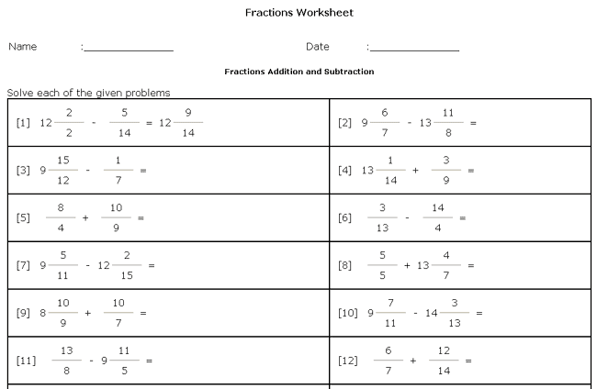
The site is www.teach-nology.com/platinum/fracrewritemem.html

