8.4 Mini Team Assignment (I did this alone. It’s already late and I didn’t want to stress searching for someone to complete this assignment.)

- Lesson Plan
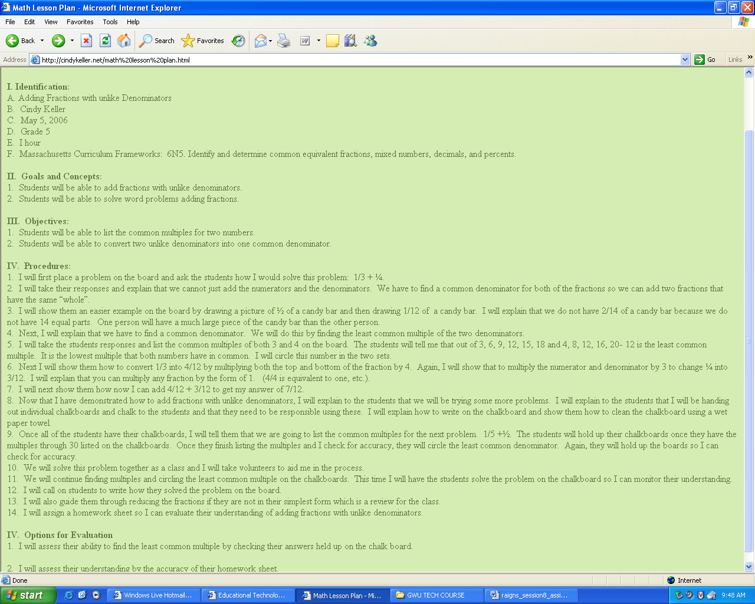

- Visual/Graphic

  - Go to http://www.aaamath.com/fra66j-lcd.html using smartboard and let student’s try

- Assessment http://amby.com/educate/math/2-1-LCM.html

  - Monitor so that students do not view answers. Assessment score must be accompanied by student’s work on paper.

- Rubric (http://www.edtechpolicy.org/onlinequizzes.html#other)
