
Educational Technology Outreach
College of Education
University of Maryland
2127 TAWES
College Park, MD 20742

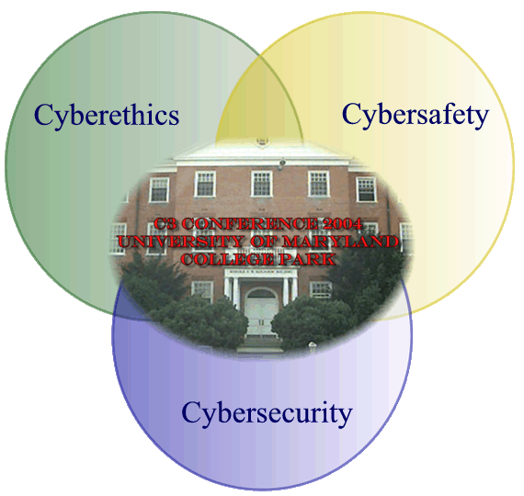

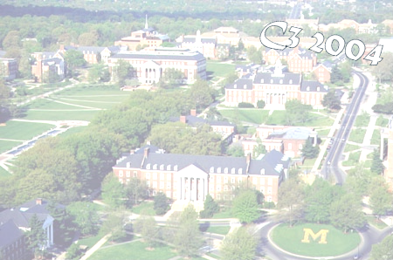
Cyberethics, Cybersafety, & Cybersecurity
C3 Conference

For Professional Educators
Implications for Classroom
and Higher Education Technology Instruction
June 17-18, 2004 - College Park, MD
UMD, College of Education, Benjamin Building
If You’re an Administrator, Teacher, Technology Coordinator, or Faculty Member – You Won’t Want to Miss This!
Get proven and practical strategies from national experts that will provide the legal and practical knowledge necessary for you and your students to maneuver in this technological age!
Register Today! (301) 405-0902

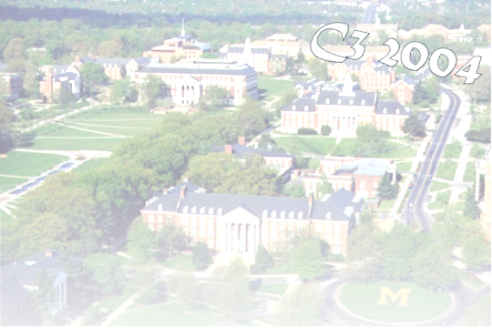
Cyberethics, Cybersafety, & Cybersecurity
C3 Conference

For Professional Educators
Implications for Classroom & Higher Education Technology Instruction
June 17-18, 2004 - College Park, MD
UMD, College of Education, Benjamin Building





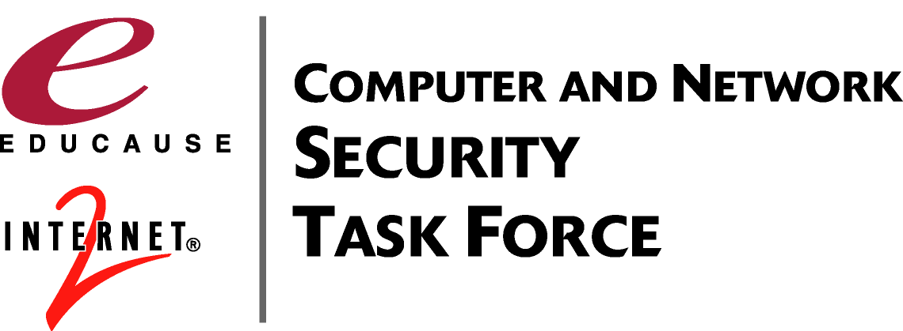
Register Today! (301) 405-0902
For more information see:
www.edtechoutreach.umd.edu
Sessions at a Glance
Walk away with CDROMs and at least Ten Strategies to implement in your instruction as soon as you return to your classroom!
- Property Rights and Copyright issues
- Plagiarism and Electronic Cheating
- Safety and Security: Internet Citizenship–Rights and Responsibilities
- Effective Security Practices
- Cybersecurity for the Digital District
- CyberSmart & other Curriculum Resources
- Accessing Education: IT for Students with Disabilities
- Viruses, Hoaxes, Trojan Horses: Backing Up, Anti-virus protection, and Firewalls
- Mail, Messaging, Spam Control
- Curriculum and Tools for Security Training and Awareness
The digital age has created new concerns regarding the use of non-traditional electronic and Internet resources in the classroom setting. Unfortunately, while the teaching of technology processes and skills has been handed to the classroom teacher, most educators lack the knowledge and up-to date information related to security issues. Teacher technology training has been geared towards skills development and integration techniques. Teachers, in many instances, model incorrect protocol and behavior to their students. Not only does this increase the risks to the security of the teacher’s own classroom and local school system’s information systems, but it also increases the chances that students will follow their behaviors.
“I have come away with a new strong resolve to make this an important on-going topic in my school, with administration, faculty and students. Definitely, the whole community needs to be informed of these issues and more aware of how technology is really changing our ways and responsibilities.”

“Wonderful experience – worth the time. Thank you for sharing.”

“Great speakers, Great forum for sharing with others. Concrete examples, great resources!”
Past Conference Participants
Sponsored by:
Registration Form
C3 Conference 2004 University of Maryland
June 17-18, 2004 College of Education – College Park, MD

Attendee Information (Confirmation of your registration will be sent.)

Name _______________________________________
Preferred Name for Badge ______________________
Job Title ____________________________________
Home Address _______________________________
City________________ State ______Zip __________
County _____________________________________
Home Phone (_____) ________ - ________________
E-mail (please print clearly) _____________________
May we e-mail you about this event and related services and resources? Yes No

School/Organization Name ______________________
School District & Count ________________________
Street Address ________________________________
City________________ State ______Zip __________
School/Organization Phone (____) _____ - _________
School/Organization Fax (_____) ______ - _________
Please check one of the following as your preferred method of contact:
E-mail Home Phone
School Phone Fax

Registrant Information (Each participant must complete a registration form.)

Check Your Registration Type Cost
Early Registration (Must be received by June 1) $ 95
Regular Registration (After June 1) $150
On-Site Registration (As Available) $175
Method of Payment (Registration from CANNOT be processed without accompanying payment)

Signed Purchase Order # ______________ is attached. Check/Money Order # ______________________
made payable to Ed Tech Outreach
Emergency Contact ____________________________________ Phone: (_____) ________ - ________________
Please list special physical accommodations and/or food restrictions.

Easy Ways to Register
Fax to: (301) 405-7138 or (410) 531-7199
Mail to: Ed Tech Outreach
College of Education
2127 TAWES
College Park, MD 20742
Questions call: Toyia Younger (301) 405-0902 tyounger@umd.edu
Davina Mentle (301) 405-8202 dp151@umail.umd.edu
Or visit http://www.edtechoutreach.umd.edu/ for up-to-date information

Cancellations/Refunds: Substitutions rather than cancellations can be made. Please fax/mail substitute and canceling registrants’ names, addresses, phone numbers, and methods of payments to contacts above.

