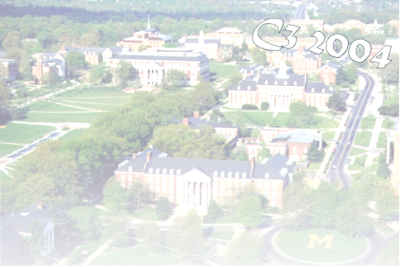






Cyberethics, Cybersafety, & Cybersecurity
C3 Conference

For Professional Educators
Register Today! (301) 405-0902
For more information see:
www.edtechoutreach.umd.edu
Implications for Classroom & Higher Education Technology Instruction
June 17-18, 2004 - College Park, MD
UMD, College of Education, Benjamin Building
Sessions at a Glance
Walk away with CDROMs and at least Ten Strategies to implement in your instruction as soon as you return to your classroom!
- Property Rights and Copyright issues
- Plagiarism and Electronic Cheating
- Safety and Security: Internet Citizenship–Rights and Responsibilities
- Effective Security Practices
- Cybersecurity for the Digital District
- CyberSmart & other Curriculum Resources
- Accessing Education: IT for Students with Disabilities
- Viruses, Hoaxes, Trojan Horses: Backing Up, Anti-virus protection, and Firewalls
- Mail, Messaging, Spam Control
- Curriculum and Tools for Security Training and Awareness
The digital age has created new concerns regarding the use of non-traditional electronic and Internet resources in the classroom setting. Unfortunately, while the teaching of technology processes and skills has been handed to the classroom teacher, most educators lack the knowledge and up-to date information related to security issues. Teacher technology training has been geared towards skills development and integration techniques. Teachers, in many instances, model incorrect protocol and behavior to their students. Not only does this increase the risks to the security of the teacher’s own classroom and local school system’s information systems, but it also increases the chances that students will follow their behaviors.
“I have come away with a new strong resolve to make this an important on-going topic in my school, with administration, faculty and students. Definitely, the whole community needs to be informed of these issues and more aware of how technology is really changing our ways and responsibilities.”

“Wonderful experience – worth the time. Thank you for sharing.”

“Great speakers, Great forum for sharing with others. Concrete examples, great resources!”
Past Conference Participants
Sponsored by:
Early Registration (Must be received by June1 $ 95
Regular Registration (After June 1) $150
On-Site Registration (As Available) $175

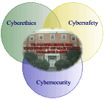

Cyberethics, Cybersecutiy and Cybersafety Conference Registration
June 17-18th, 2004

Name:___________________________________________________________

Organization/School ________________________________________________

Position: _________________________________________________________

Address: _________________________________________________________

City:_____________________________________________________________

State: __________________________ Zip Code: ________________________

email:___________________________________________________________

Phone Number: ___________________________________________________

Dietary Restrictions: ________________________________________________

Davina Pruitt-Mentle  Educational Technology Outreach  University of Maryland  2127 TAWES  College Park, MD 20742-1121  dp151@umail.umd.edu  301 405 8202 | Toyia Younger  Outreach Programs  University of Maryland  0108B Cole Student Activities Bldg  College Park, MD 20742-1121  tyounger@umd.edu  301 405 0902  for school system invoicing, voucher information and campus FRS account

Due to “hands on” nature of many of the sessions, space will be limited.
Make checks payable to: Ed Tech Outreach-UMCP
Cancellations/Refunds: Substitutions rather than cancellations can be made. Please fax/mail substitute and canceling registrants’ names, addresses, phone numbers, and methods of payments to contacts above.
MSDE credit-(with additional requirements) Pending
Early Registration (95.00)
On Site Registration (175.00)
Registration includes refreshments, keynote luncheon, seminar materials, handouts, notebook, CD-ROM and poster.

Note:
Tables will be available for displaying literature and materials. As a courtesy to other conference participants we ask that all cell phones and pagers be turned off during the sessions.

