


CyberEthics, CyberSafety & CyberSecurity (C3) Conference
Sessions at a Glance
- Property Rights and Copyright issues
- Plagiarism and Electronic Cheating
- Safety and Security: Internet Citizenship–Rights and Responsibilities
- Effective Security Practices
- Cybersecurity for the Digital District
- CyberSmart & other Curriculum Resources
- Accessing Education: IT for Students with Disabilities
- Viruses, Hoaxes, Trojan Horses: Backing Up, Anti-virus protection, and Firewalls
- Mail, Messaging, Spam Control
- Curriculum and Tools for Security Training and Awareness
“I have come away with a new strong resolve to make this an important on-going topic in my school, with administration, faculty and students. Definitely, the whole community needs to be informed of these issues and more aware of how technology is really changing our ways and responsibilities.”

“Wonderful experience – worth the time. Thank you for sharing.”

“Great speakers, Great forum for sharing with others. Concrete examples, great resources!”
Past Conference Participants
Sponsored by:
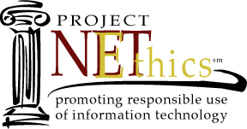





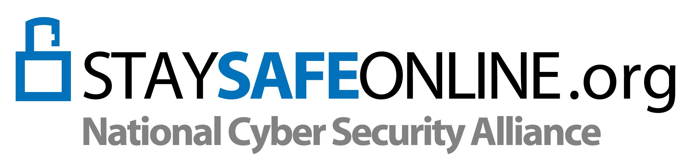
Implications for the Educational Community
Part of the National Cyber Security Awareness Month Initiative
October 6- Pre-conference Workshops
October 7-8, 2005 - Conference Sessions
Samuel Riggs Alumni Center
University of Maryland, College Park, MD
University of Maryland

Walk away with CDROMs and at least Ten Strategies to implement in your instruction as soon as you return to your classroom!
The digital age has created new concerns regarding the use of non-traditional electronic and Internet resources in the classroom setting. Unfortunately, while the teaching of technology processes and skills has been handed to the classroom teacher, most educators lack the knowledge and up-to date information related to Cyberawareness issues, particularly with respect to security issues. Teacher technology training has been geared towards skills development and integration techniques. Teachers, in many instances, model incorrect protocol and behavior to their students. Not only does this increase the risks to the security of the teacher’s own classroom and local school system’s information systems, but it also increases the chances that students will follow their behaviors.

