Sunday | Monday | Tuesday | Wednesday | Thursday | Friday | Saturday
October is Cyber-Awareness Month!
Click on a Day for Activity Detail
Completion Certificate for your Students [PDF... Black & White PDF]
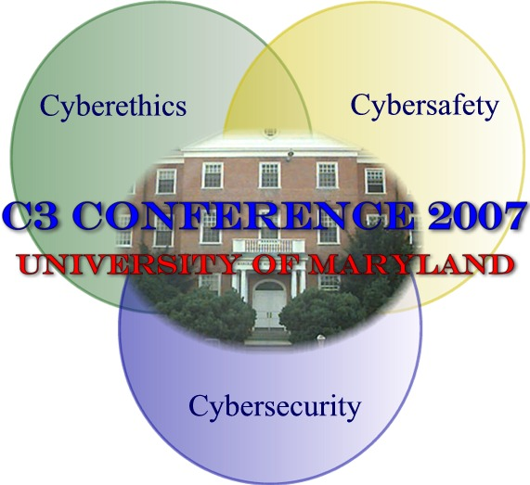 | 1. Learn how to chat safely in online environments - ChildNet International | 2. Read SafeKids.com’s Chat room safety tips | 3. Think Before you post from Cybertipline | 4. Take NCMEC’s Internet Safety Quiz | 5. Take the acronym quiz and download a brochure | 6. Student Rules for Online Safety
7. Review Boston Public Library’s Netiquette Tips or NetManners Netiquette quiz | 8. Try PBS interactive "Teach your kids the Internet rules of the road" | 9. Try PBS interactive "Arthur helps your kids be safe on the web." | 10. Check a site rating before you utilize | 11. Try an interactive internet safety game from AT&T | 12. Read and print out the Children’s Bill of Rights to Online Safety | 13. Read something of interest from the numerous Kids & Teens iSAFE resources
14. Do you know what you & your teacher can and can not “copy” try the copyright quiz | 15. What is Plagiarism? | 16. Learn more about correct citations | 17. Teens- try this exercise on plagiarism | 18. Learn more about copyright before turning in your papers | 19. Learn more about downloading and copyright from cyberbee | 20. When is downloading music illegal?
21. Review NSCA Stay Safe online security/safety tips | 22. Learn how to Secure your email practices | 23. Learn more about protecting personal information | 24. Test your knowledge about identity theft and using online environments | 25. Learn about Identity Theft and children | 26. Learn about Webcams and students | 27. Learn how to protect your home computer
28. Learn more about cyberbullying. | 29. What can you do about cyberbullying? | 30. Stats on Cyberbullying | 31. Interactive media on cyberbullying (flash or non-flash option) | Additional resources can be found at:  ETO's C3 Cybersecurity Portal  October 2007 Calendar created by Spring 2007 EDUC 698I course (Using Information Technology in the Classroom Settingo) members Joseph Bauer, Kirti Chadha, Jolie Farnum-Badley, Kevin Fries, Bettina Grahek, Chris, Jacob, Mira Jones, Sandy Kao, Vishal Khosla, Briana Lefman, Chassidy Lynch, Maria Oasan, Mehreen Sheikh, Devina Vinaik, Brian White, Bradford Wolf

Links
October
- Learn how to chat safely in online environments - http://www.chatdanger.com/ (ChildNet International)
- Read SafeKids.com’s Chat room safety tips - http://safekids.com/chat-room-safety/
- Think Before you post - http://tcs.cybertipline.com/knowthedangers8.htm from Cybertipline
- Take NCMEC’s Internet Safety Quiz - http://www.missingkids.com/adcouncil/lingo.html#
- Take the acronym quiz and download a brochure - http://www.missingkids.com/adcouncil/cpgn.html
- Student Rules for Online Safety - http://safekids.com/kids-rules-for-online-safety/
- Review Boston Public Library’s Netiquette Tips - http://www.bpl.org/kids/Netiquette.htm or NetManners Netiquette quiz - http://www.onlinenetiquette.com/netiquette_quiz.html
- Try PBS interactive "Teach your kids the Internet rules of the road" - http://pbskids.org/license/
- Try PBS interactive "Arthur helps your kids be safe on the web." - http://pbskids.org/arthur/parentsteachers/resources/parentguides/web.tips.html
- Check a site rating before you utilize - http://www.k9webprotection.com/siterating.html
- Try an interactive internet safety game from AT&T - http://www.att.com/gen/general?pid=1391
- Read and print out the Children’s Bill of Rights to Online Safety - http://www.fosi.org/resources/parents/billofrights/
- Read something of interest from the numerous Kids & Teens iSAFE resources -http://www.isafe.org/
- Do you know what you & your teacher can and can not “copy” try the copyright quiz - http://www.copyright.iupui.edu/teachlist.htm
- What is Plagiarism? - http://www.wpacouncil.org/node/9
- Learn more about correct citations - http://www.edu-cyberpg.com/Technology/APAcopyrightelectronic.html
- Teens- try this exercise on plagiarism http://www.fairfield.edu/x13870.html
- Learn more about copyright before turning in your papers -http://www.templetons.com/brad/copymyths.html
- Learn more about downloading and copyright from cyberbee - http://www.cyberbee.com/cb_copyright.swf
- When is downloading music illegal? -http://www.webopedia.com/DidYouKnow/Internet/2004/music_downloading.asp
- Review NSCA Stay Safe online security/safety tips -http://www.staysafeonline.info/practices/eight.html
- Learn how to Secure your email practices - http://www.sonoma.edu/it/safe/practices.shtml
- Learn more about protecting personal information - http://www.att.com/gen/general?pid=1395
- Test your knowledge about identity theft and using online environments -http://onguardonline.gov/quiz/idtheft_quiz.html
- Learn about Identity Theft and children - http://www.idtheftcenter.org/teen/teen.html
- Learn about Webcams and students -http://familyinternet.about.com/od/internetsafety/a/webcams.htm
- Learn how to protect your home computer - http://familyinternet.about.com/od/thefamilycompute1/
- Learn more about cyberbullying - http://www.stopcyberbullying.org/index2.html
- What can you do about cyberbullying? - http://www.internetsuperheroes.org/cyberbullying/
- Stats on Cyberbullying - http://stopbullyingnow.hrsa.gov/adult/indexAdult.asp?Area=cyberbullying
- Interactive media on cyberbullying (flash or non-flash option) -http://www.cyberbullying.info/office.htm

Additional resources can be found at: ETO's C3 Cybersecurity Portal - http://www.edtechpolicy.org/civics.html#Cybersecurity

