Student’s Word Retention Assessment

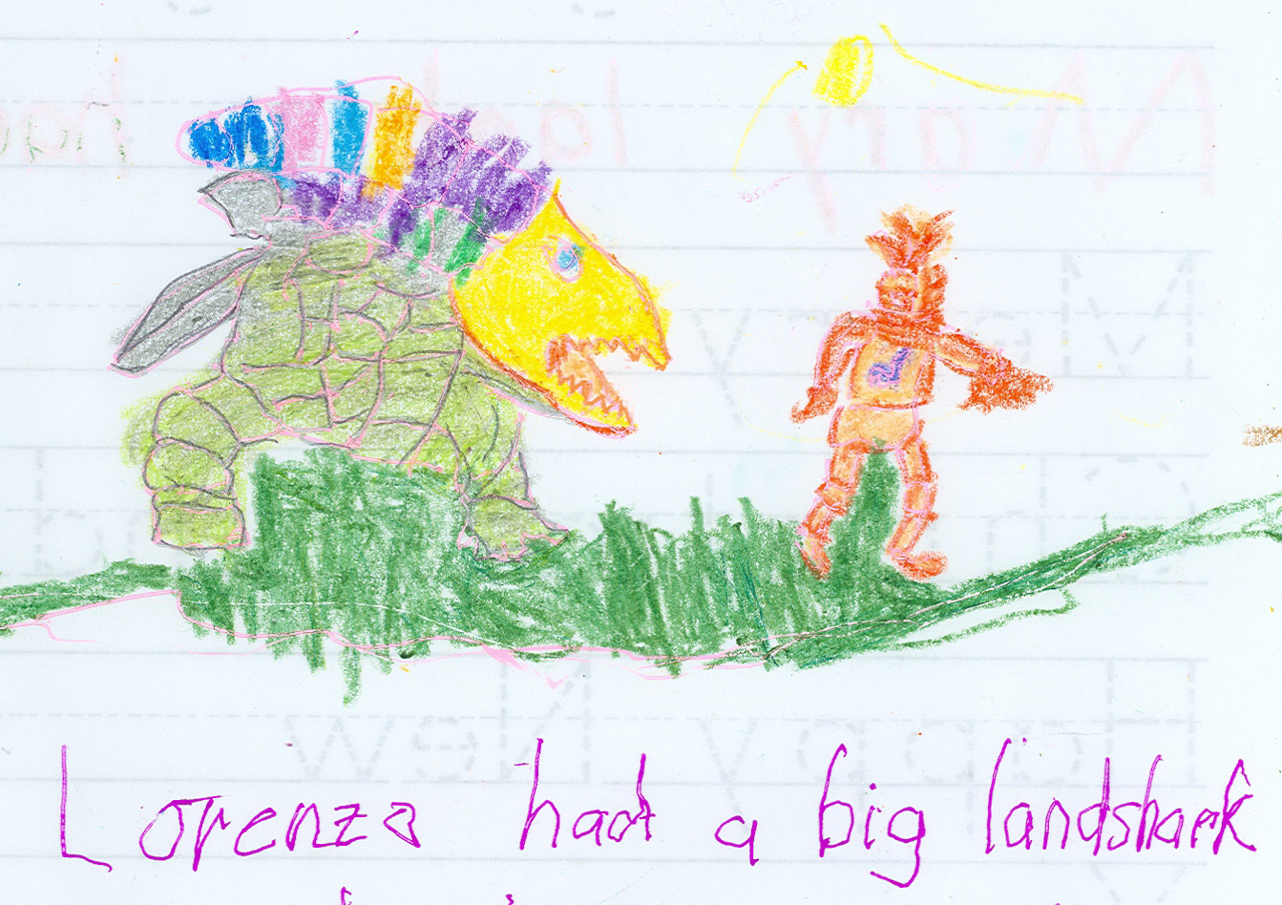

XXXXXXXXX

EDUC 476
Fall 2004

Goal:
1. Purpose: To see if using multiple learning techniques were more effective than single method i.e. to see if using three methods better than the strongest method.

2. Aim: Making general language acquisition easier.

3. Rationale: Prior observation showed that child learned more effectively with sound. I wanted to determine if using the two other techniques as effective. Using multiple assessment techniques would help determine effectiveness of techniques used.

Objectives:

1. What will students be able to do during this lesson? 1. Identify and spell key words out of context: Mary, lamb, teacher, school, etc 2. Develop his own mimicked rhyme. 3. Draw a picture of stanza. 4. Dance his stanza.

2. Under what conditions will students' performance be accomplished? Student will start with computer, will move to writing table, drawing table and classroom floor.

3. What is the degree or criterion on the basis of which satisfactory attainment of the objectives will be judged? Multiple assessment techniques will be used to determine if student acquires all key words: Mary, little, lamb, school, etc.

4. How will students demonstrate that they have learned and understood the objectives of the lesson? Students will write, spell aloud, and draw criterion words. Student will dance and sing their stanza.

Prerequisites: Student has heard rhyme before he knows how to read some of the verbs in the
poem. had, play, etc.

Materials:
1. Computer with sound and internet connection
2. Crayons & Drawing Materials
3. Several copies of poem, “Mary Had a Little Lamb.

Lesson Description
1. What is unique about this lesson? While I had used multiple techniques in teaching in English 205, Introduction to Shakespeare, as well as multiple assessments. I had not used them often with Lorenzo. Using the multiple techniques offered him a new chance for learning and remembering data. Using multiple assessment offered me a chance to see which method or methods would be more effective.

2. How did your students like it? Above all things Lorenzo loves to draw and color. He was eager to move to that part of the lesson.

3. What level of learning is covered by this lesson plan? Student uses knowledge,
comprehension, application, analysis, and synthesis

Lesson Procedure

INTRODUCTION:

1. We brought up target rhyme: "Mary had a little lamb".

2. He and I sang the rhyme. Now he was looking at the screen, but from looking at his eyes, he was not reading.

MAIN ACTIVITY: COMPREHENSION & ANALYSIS

1. We looked for the rhyming words underling the words. (He is going to rewrite the poem) We are still singing over and over at this point so he can find the rhyming words. Used question and answer. Some questions open, some closed: what rhymes with ‘snow’, does ‘go’ rhyme with ‘slow’.

2. Student selects a topic for his poem: Student uses his name or other name, student selects a pet or stuffed animal for the subject of poem, student selects some new rhyming words that relate to his new poem. (he or she might write them down in this case he typed them on computer.)

3. Teacher shows how to analyze poem: that is I asked what happened in each stanza. I start to write on the computer. This is what first stanza does, this is what second stanza does as he answers. I write it on his copy of the poem.

(So at this point he is armed with physics of poem and rhyming words of poem)

MAIN ACTIVITY: COMPREHENSION & SYNTHESIS

4. Student tells teacher what happens in his version of the poem. Student wants landshark to eat ice cream. Teacher asks student for rhyming words. Student develops following stanzas: Here is text of poem and two animals: finch and landshark. One real and one imaginary. He preferred the imaginary one of course.

Mary had a little lamb, XXXXX had a little finch, (big land shark)
little lamb, a little finch
little lamb. a little finch
Mary had a little lamb, XXXXX had a little finch
Its fleece was white as snow. Whose beak was bright yellow
(whose fin was sharp and grey)

Everywhere that Mary went, Everywhere that XXXXX went
Mary went, XXXX went
Mary went. XXXX went
Everywhere that Mary went, Everywhere that XXXXX went
The lamb was sure to go. The finch was sure to go.

It followed her to school one day, It followed him to the 7/11 one day,
school one day, 7/11 one day, ice cream store
school one day. 7/11 one day, candy land
It followed her to school one day, It followed him to the 7/11 one day
Which was against the rules. And fluttered over aisle 11.

It made the children laugh and play, It made the manager shriek and shout
laugh and play, shriek and shout *eat everyone*
laugh and play. shriek and shout (be nice to everyone
It made the children laugh and play, It made the manager shriek and shout
To see a lamb at school. To see a finch at the 7/11.

Teacher wants to Copy Mary had a little lamb. Student has other plans.... move to #6

5. Student draws his first stanza. Actual drawing in appendix. Picture of them with their pet/imaginary friend. We discuss what animals look like, what geometrical shapes needed. Student takes time drawing and coloring...
(Larger unit they make book with one page per stanza.)

6. Dance it again breaking into parts....student uses hand motions to move story along.

7. He does copy poem.

CLOSURE ACTIVITY: MULTIPLE ASSESSMENT:

1. He can identify and read key words out of context. (visual)
2. He has drawn pictures of the stanzas of his poem. (visual)
3. He can spell aloud key words: Mary, lamb, snow, rules, school, etc. (sound)
4. He can write out key words without looking at text: Mary, lamb, snow, fleece
(tactile)

UNIT PLAN AND FUTURE USE

1. Future lessons in the same vein. 1a.Unit do all stanzas: For one lesson we did half the rhyme; in next lesson we do another slowing down in last lesson we finish poem. As a closing activity,
student does whole book (pictures of whole in packet).

We continue unit by covering other rhymes in a similar fashion, using rhymes that are connected to the time of year or the student’s interests.

2. On Thanksgiving, we developed a rhyme for family party: "Peter, Peter Pumpkin Eater." XXXX, who like most small children loves to be the center of attention, read poem to family and cousins (all getting their PhD or teaching at University), he sang the poem, and danced it. Lots of laughter and clapping He then proudly presented his original drawings which were passed about.

3 Tweaking:

Student likes filmo: make animals of lamb and landshark using filmo. He loves to get his hands dirty with the stuff. We have been painting houses and learning words like house, mouse, etc. We draw house, decorate it with Christmas things, we discuss circles, squares, circumference. We also learn words by painting things like snowmen, Santa Clauses, etc. We learn time by cooking things. Lots of fun.

WORD RETENTION ASSESSMENT
Multiple assessment: 1. Non visual, non sound; 2. visual, non sound; 3. sound, nonvisual

ONE DAY AFTER

1. Reading together: WORDS RETAINED AFTER ONE DAY.
Without Visual Clues 0/10
With Visual Clues 5/10
With Sound Clues 7/10

2. Reading together and writing words: WORDS RETAINED AFTER ONE DAY
Without Visual Clues 5/10
With Visual Clues 7/10
With Sound Clues 7/10

3. Reading together, using phonics to sound out words: WORDS RETAINED AFTER ONE DAY
Without Visual Clues 6/10
With Visual Clues 7/10
With Sound Clues 8/10

4. Reading together, using phonics and rhyming words: WORDS RETAINED AFTER ONE DAY
Without Visual Clues 8/10
With Visual Clues 8/10
With Sound Clues 9/10

5. Reading together and spelling words: WORDS RETAINED AFTER ONE DAY
Without Visual Clues 10/10
With Visual Clues 10/10
With Sound Clues 10/10

6. Reading, writing, drawing pictures of words: WORDS RETAINED AFTER ONE DAY
Without Visual Clues 8/10
With Visual Clues 10/10
With Sound Clues 10/10

ONE WEEK

1. Reading together WORDS RETAINED AFTER ONE WEEK.
Without Visual Clues 0/10
With Visual Clues 6/10
With Sound Clues 10/10

2. Reading together and writing words: WORDS RETAINED AFTER ONE WEEK.
Without Visual Clues 5/10
With Visual Clues 6/10
With Sound Clues 7/10

3. Reading together, using phonics to sound out words: WORDS RETAINED AFTER ONE WEEK
Without Visual Clues 6/10
With Visual Clues 7/10
With Sound Clues 8/10

4. Reading together, using phonics and rhyming words: WORDS RETAINED AFTER ONE WEEK
Without Visual Clues 8/10
With Visual Clues 10/10
With Sound Clues 10/10

5. Reading together and spelling words: WORDS RETAINED AFTER ONE WEEK.
Without Visual Clues 10/10
With Visual Clues 10/10
With Sound Clues 10/10

6. Reading writing and drawing pictures of words: WORDS RETAINED AFTER ONE WEEK.
Without Visual Clues 6/10
With Visual Clues 8/10
With Sound Clues 10/10

Note Bene:
Although I report the assessment in the same order, the data was collected randomly.
That is assessment was taken in diverse order so that there would be little contamination.

Brief interpretation & analysis:

Multiple learning provides the student with more enjoyment of lessons, but this brief data
suggests original hypothesis. Student can do more by using memory and sounds. Not just
saying the words with teacher, but sounding out the phonics of the word may help as well
as using rhyming words, but repeating the letters aloud seems the best method.

He has a learning machine that spells words with him that he has used for several months
independently of lessons. This could be limiting the data. He can read the “Dick and
Jane” stories with 80%-90% effectiveness, with the visuals in that text. He looks at
picture and then reads. He can do about 90 pages with only a few moments of hesitation
and only an error or two.

He recognizes words much more frequently when he has used sound to remember them.
He can write and read them, when he spells them aloud first. While he likes to draw
words, he is seems to learn most effectively with sound.

Future consideration: I will continue with all methods as students do change. While it may not be most effective, having the child sing, draw, and dance words is most fun for him. I will keep using the tactile 'writing of the words' as that is done all the way into high school by some teachers. Since XXXX likes to type, I will mix Lorenzo writing sentences by hand with typing on the computer, which he has just started. But for sheer and longer retention, we will still spell words aloud and practice our rhyming games.

