Data Analysis and Interpretation Paper
Data Analysis and Interpretation with Technology Module: EDHD435
Part I

Fall 2004
Heather Kim
November 1, 2004

Background Information
Introduction
Takoma Park Elementary School, is located in Montgomery County, Maryland at 7511 Holly Avenue Takoma Park, MD 20912. The current Takoma Park Elementary School building was built in 1979. When Takoma Park was first built, it began as a K-6 School. When Takoma Park Elementary School first opened, it was a K-5 school. Piney Branch Elementary School was a newer school which opened after Takoma Park in the area. As Piney Branch Elementary developed, students from Takoma Park began to attend and ultimately Takoma Park became a primary school which served those students in Kindergarten, 1st grade and 2nd grade. To date Takoma Park Elementary School (TPES) is a K-2 school which also houses a Head Start Program and School Community Based Classes. Takoma Park Elementary School is also provides the only primary grades Gifted and Talented magnet program in Montgomery County Public Schools. Since the 2001-2002 school year Takoma Park Elementary School's has had a student teacher ratios of 17:1. Beginning in the 2002-2003 school year TPES started an all 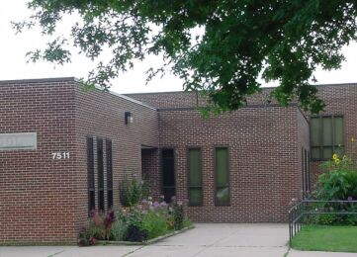
day kindergarten with student-teacher ratios in kindergarten at 15:1.
For more information see the Takoma Park Elementary School’s website: http://www.mcps.k12.md.us/schools/takomaparkes
Takoma Park’s principal, Zadia Broadus says,
at Takoma Park, we are serious about the business of nurturing and teaching children. We maintain an environment where they feel free to take risks, make mistakes, and learn to be thinkers and problem-solvers. We apply this principle in teaching them social as well as academic skills. In order to give each child the best possible opportunity for success, we are committed to keeping children and their learning as our first priority.
Takoma Park implements the primary Gifted and Talented Program for Montgomery County and thus serves as a magnet school. The Gifted and Talented Program is a significant part of the school setting. The Gifted and Talented Program gives students Science or Social Studies everyday. It also provides students with more hands-on experiences in Science and Social Studies. Takoma Park also employs a School Community Based program for exceptional students, which provides those students with special needs education in daily life skills as well as inclusion in a general classroom. The school’s motto remains “Jump into Learning”, which suits their mascot, the dolphin. TPES faculty and staff encourage their students to “jump right in” to academics with no hesitation. 
More detailed information on Takoma Park Elementary School, can be seen by visiting their website at, http://www.mcps.k12.md.us/schools/takomaparkes/.
Demographics
Information and Graphics
Figure 1 exhibits information on the percentage of Hispanic or Latinos living in the Takoma Park, Maryland area. The dark green areas of the map indicate a greater population of Hispanics and Latinos living in Takoma Park, while the yellow represents a less populated area by Latinos and Hispanics.

Figure 1: Percentage of Hispanics and Latinos Living in the Takoma Park Region in 2002.
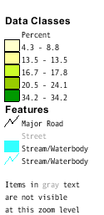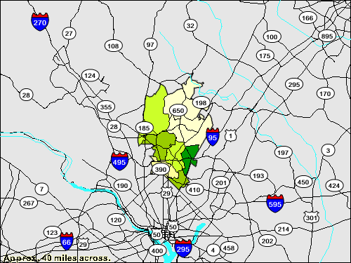
Source: 2000 U.S. Census Bureau
Other Census data indicates that many of these Hispanics are recent immigrants, and speak another language other than English as their primary language. By examining the data, one can infer that the surrounding area schools need to encourage English Language Learners Programs. Takoma Park supplements their English Language Learners program with Reading Recovery and Oasis tutors.
Approximately ten percent of the Takoma Park neighborhood has an average household income under $10,000 (2000, U.S. Census Bureau). Eight and a half percent of the same population falls below poverty level and, 16.1% fall below poverty level for households with no husbands present, almost double of households with both providers present. This means that a great number of Takoma Park students would be eligible to receive free or reduced meals at school.
Staffing
Figure 2 shows that in 2004, 12.8% of classes were not taught by highly qualified teachers at Takoma Park Elementary School. Less than half, approximately 40% of teachers at Takoma Park Elementary School have advanced professional certificates.
Figure 2: Classes Not Taught By Highly Qualified Teacher in 2004
Montgomery County (LEA:15) Takoma Park Elementary (ID:0754)
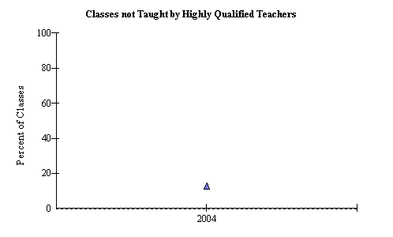

Source: 2004 Maryland Report Card

Technology
Figure 3: Student to Computer Ratio At Takoma Park Elementary School
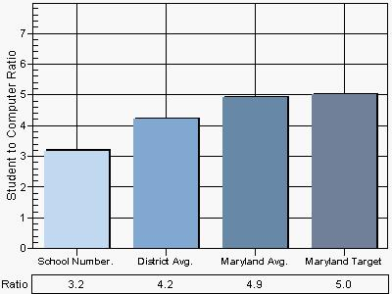
Source: 2004 Maryland Technology Inventory Report
Figure 3 above shows that Takoma Park Elementary School has a 3.2:1 student to computer ratio. Their ratio demonstrates a below district average, which is a 4.2:1 ratio. There are an impressive number of computers in their classrooms (108) and 14 computers in the media center computer lab. 100% of computers in the classrooms are connected to the internet. Takoma Park Elementary Schools ratio exceeds Maryland’s target ratio which is 5.0:1 ratio. All classrooms in the school have at least one computer and 13 % have more than 5 computers for student use. This exceeds Montgomery County Public Schools average. The school also has cable television. TPES has not yet implemented video broadcast or voicemail, while some of the school’s counterparts have. Teachers at Takoma Park have yet to communicate to parents using e-mail, telephone homework hotline, while the majority of other Montgomery County’s schools have.
AYP RESULTS
Figure 4: Adequate Yearly Progress in Reading for Takoma Park Elementary School
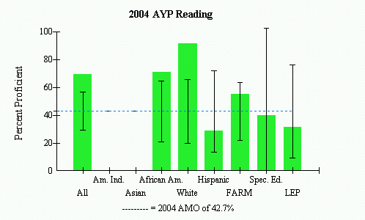
Source: 2004 Maryland Report Card
In 2004, 69.1% of all students at Takoma Park were proficient in reading. Figure 4 above shows that 71% of all African American students were proficient, while only 28.6% of Hispanic students were proficient in reading. White students at Takoma Park were 91% proficient. Although the school as a whole met AYP, individual sub-groups need to improve their proficiency. The Hispanics did not meet the Annual Measurable Objective (AMO) proficiency level benchmark set by the state. However, since there are only a few of these students, the confidence interval allows this sub-group to meet AYP. The same is true for both the Special Education and Limited English proficiency sub-groups.
Mathematics
Figure 5: Adequate Yearly Progress in Mathematics for Takoma Park Elementary School
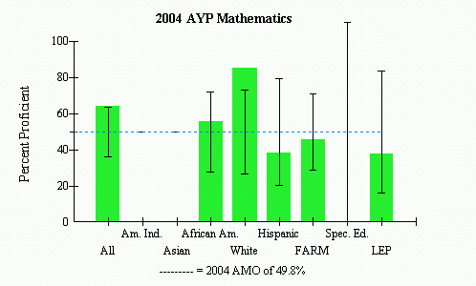
Source: 2004 Maryland Report Card
Figure 5 demonstrates that Math is an area of needed improvement for TPES. Approximately, 64% (63.9%) of all students at Takoma Park were proficient in mathematics in 2004. While 55.3% of African American students were proficient, only 38.1% of Hispanic students exhibited proficiency in mathematics, thus not meeting the state proficiency level set at 49.8%. African American students surpassed the states proficiency level, but only by a small percentage. The Hispanic population, FARM and Limited English Proficiency sub-groups did not meet the state requirements. Therefore, these should be school focus within their Instructional Support Plan.
Areas of Needed Improvement
After examining Takoma Park Elementary School in great detail, I find that the school’s atmosphere and environment encourages students to strive to their greatest potential. The school promotes continued growth and enrichment with collaborative efforts. While this school met AYP in 2004, the school needs to consider the Hispanic, FARM and LEP sub-groups, these groups probably overlap, for additional aid. The school can also consider technology as a form of communication. Using technology as a resource to communicate with parents may be of great guidance for the school.

