Data Analysis and Interpretation Paper
Data Analysis and Interpretation with Technology Module: EDHD 435
Part 1

Fall 2004
Student Name goes Here
November 31, 2004

Background Information

Introduction

Langley Park McCormick Elementary School, school ID # 1719, is located in Local Educational Agency #16, in Prince George’s County Maryland, at 8201 15th Avenue, Hyattsville, Maryland.
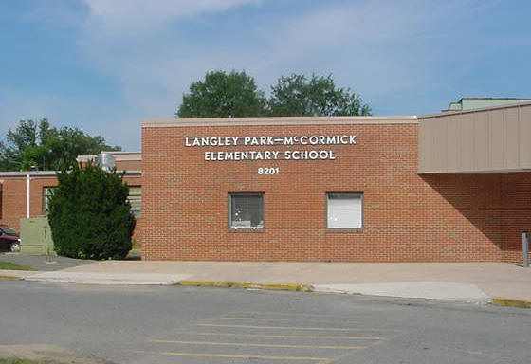
Langley Park McCormick Elementary School is an older school, having opened in 1954. Prior to 2003 the school housed only fourth, fifth, and sixth grades. In 2003, it was reconfigured and now contains Kindergarten through sixth grades. The mission of Langley Park McCormick Elementary School is to provide all students the opportunity to acquire knowledge and develop the skills and work habits to enable them to become productive members of society. Two thirds of the faculty members are new to the building. The school now represents a multicultural neighborhood of largely immigrant families. The majority of the students walk to school. Some students ride the bus in order to safely cross a major thoroughfare, but are still within one mile of the school.
Source: PGCPS website

Langley Park McCormick Elementary is essentially the center of the community. It hosts evening Adult education classes for adult ESOL, citizenship, technology, and G.E.D. Soccer and basketball teams use the gymnasium in the evenings.

Churches use the facilities on the weekends. It serves as an emergency food pantry, and regularly distributes clothes and other necessities to members of the community. It regularly refers community members to local charitable and social service agencies that provide medical, financial, and other community assistance.

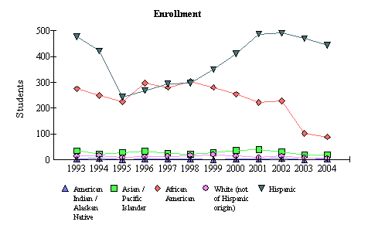
Langley Park McCormick Elementary participants in the “Communities in Schools” program. The program staffs a half-time employee to assist in
Figure 1: Langley Park Elementary School Student Enrollment by Race/Ethnicity from 1993-2004.
Source: 2004 Maryland Report Card

the development of community partnerships. This program has been very successful, and has enabled the school to work in conjunction with community organizations to address a spectrum of school and community needs. More information about the school can be accessed from the school’s website:http://www.pgcps.pg.k12.md.us/~lpmcc/.

Demographics

Detailed demographic information for the LP elementary school can be accessed via the Census Bureau (Fact Finder) http://factfinder.census.gov/home/saff/main.html?_lang=en, by entering the
school’s city and state. For Langley Park, the 2000 Census (the last Census data—only collected every ten years) indicates it is 0.8225 square miles (see Figure 2) and includes a Latino population which has increased from 6,956 to 10,294 (a 48% increase). Over the last decade, the neighborhood’s Latino population grew from about 40% to 63% of the entire area. Due to the large number of immigrants (some of whom are illegal immigrants) it can be inferred that many did not participate in the census. The population number is probably an undercount. Of the 10,294 Hispanics counted in the 10,294 survey, 24% are not identified by nationality, and of the remaining 7,371 people, 5,970 are Central American including 3,483 Salvadorans and 1,825 Guatemalan. Households have a mean income of $44,554, and a median income of $37,939, and 27.5% make less than $25,000/year.

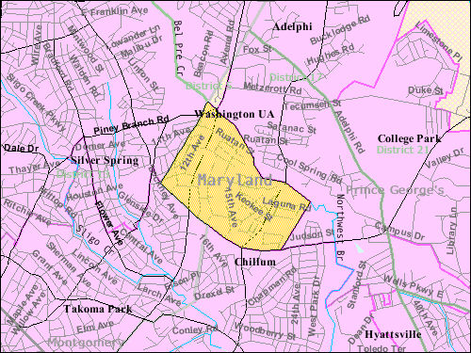
The opening enrollment, in the fall of 2004, was 559 students, 171 of whom are in Kindergarten and first grades. A large percentage of the students (80%) are Hispanic, of which 48% are non-English proficient or Limited English Proficient. An even larger percentage of parents are non-English proficient and are therefore limited in their ability to support their children academically. Typically, this language barrier has been an obstacle to parent involvement not only at home, but in school as well; however, with the current bilingual principal, parent liaison, teachers and secretaries, and now that all meetings are held in Spanish and English, the school is rapidly working to overcome this gap. Sixteen percent of the students are African, Caribbean, or African American. Many of the students in this category are immigrants confronting the same difficulties as the Hispanic population. Less than 1% of the student body is white or Native American, and 3.3% are Asian. As Figure 1 indicates, this low percentage of White, Native American and Asian enrollment has remained constant since as early as 1993. The Hispanic enrollment has steadily increased since 1995, with a significant increase in 1999. There was a slight increase in the African American enrollment in 1995, but numbers have consistently decreased since 1999. 85.8% of the students are on free or reduced lunch programs, and the school is listed as a Title I program school. Students eligible for the free or reduced lunch program are students whose applications for free/reduced price meals meet the family size and income guidelines (as promulgated annually by the U.S. Department of Agriculture) and students approved through direct certification. Title I schools have targeted assistance programs, for example, translators for parents and students, teaching assistants, after school supplemental tutoring programs etc… Title I services are paid by federal funds through the Elementary and Secondary Education Act (ESEA) (the Hawkins-Stafford Amendments of 1988).
Figure 2: Map of Langley Park and Hyattsville, Maryland
Source: 20004 Mapquest

Staffing

Two thirds of the faculty was new to Langley Park-McCormick last year. Currently, fifty six percent (56.4) of all teachers have five years or less of teaching experience. Twenty three percent have 6 – 15 years of experience; 20.5% have more than 16 years of experience. About 21% of the staff hold Advanced Professional Certificates, meaning at least 3 years of full-time professional school-related experience, 6 semester hours of acceptable credit; and a master’s degree, or a minimum of 36 semester hours of post baccalaureate course work which must include at least 21 hours of graduate credit. Fifty four percent (53.6) of the staff hold a Standard Professional Certificate: a valid certificate to teach in Maryland to teach in the core academic subject areas (reading, mathematics, and writing). Twenty three percent of the faculty is provisionally certified, and 21.4% of the teachers currently hold Conditional Certificate. Conditional Certificates are issued at the request of a local school system superintendent to an applicant employed in a local school system who does not meet all certification requirements.

The staff consists of 28 classroom teachers, 5 special education teachers, 7 ESOL teachers, a mentor teacher, 1.6 resource teachers, 1.6 counselors, four paraprofessionals, a .5 media specialist, a media aide, a reading specialist/reading recovery teacher, and a technology teacher. In-service training to develop teachers’ ability to address the special needs of the students is a priority.

Technology

More specifics about technology equipment and use can be viewed from the Maryland Business Roundtable, Annual School State Technology Inventory found at: http://mbrt.org/ . However from http://reports.md.ontargetus.com/SchoolSum.asp?otid=1028&accDesc=Langley+Park%2FMcCormick+Elementary the report one can see that Langley Park Elementary has excellent access to computers in the classroom (4.1:1 student-computer ratio, 100% of the classrooms with Internet access – both above the state targets and state averages-5.1), but the teacher knowledge and skill is lacking (10% with intermediate computer skills, and 20% with technology integration skills – both well below the county and state averages and targets). Thus, the school has the technology, but teachers need more training on appropriate use—especially for this population.

AYP Results and Other Assessments

Average Daily Attendance
The attendance rate reflects the percentage of students present in school for at least half the average school day during the school year. Langley Park McCormick Elementary School has shown a consistently high rate of attendance, averaging 96% over the last five years. In 2004, the attendance rate was 96.3%. The majority of students (46%) who were absent missed less than two days total for the year.
Attendance rate across Race/Ethnicity and Gender was similar: African Americans 96.6% and Hispanics 96.2%.

Reading
In order to meet the federal requirement contained in No Child Left Behind, Maryland must assess student achievement. The Maryland School Assessment (MSA) measures student achievement in K-8 reading and math and grade 10 reading. The MSA information is reported for grades 3 through 8 and for grade 10 in reading (Maryland Report Card, 2004).
The Maryland School Assessment is reported with three statewide performance standards. These standards are divided into three levels of achievement. These levels are Basic, Proficient, and Advanced. The Maryland Report Card explains the differences between the levels as:
- Advanced is a highly challenging and exemplary level of achievement indicating outstanding accomplishment in meeting the needs of students.
- Proficient is a realistic and rigorous level of achievement indicating proficiency in meeting the needs of students.
- Basic is a level of achievement indicating that more work is needed to attain proficiency in meeting the needs of students.
Student performance is reported in terms of these achievement levels:
Reading:
Basic: Students at this level are unable to adequately read and comprehend grade appropriate literature and informational passages.
Proficient: Students at this level can read grade appropriate text and demonstrate the ability to comprehend literature and informational passages.
Advanced: Students at this level can regularly read above-grade level text and demonstrate the ability to comprehend complex literature and informational passages.

Figure 3 shows Langley Park McCormick Elementary School’s MSA Proficiency Levels for grade 3 reading stayed constant between 2003 and 2004 at the Advanced level (0%), increased from 8.9 to 37% at the Proficient level (increase of 28.1%) and saw a 28.1% decrease at the Basic level (from 91.1% to 63.0%). As indicated earlier, the population is made up of primarily African Americans and Hispanics. The 2004 MSA Proficiency Level percent makeup of these two groups is about the same: African American Proficient 37.5% and Basic 62.5 %; Hispanic Proficient 36.6 % and Basic 63.4%.

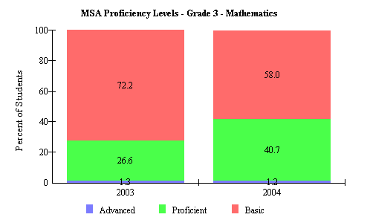
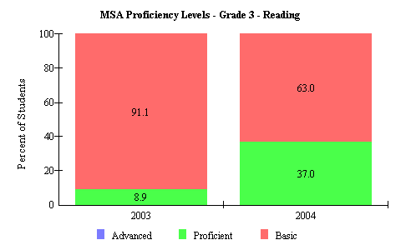
Similar changes were seen in Mathematics (see Figure 4). Although the percentage with advanced proficiency stayed nearly the same (from 1.3 to 1.2%), an additional 14.1% of students moved from the Basic to Proficient category.
Figure 3: 2004 Langley Park Elementary MSA Proficiency Levels Grade 3 Reading
Source: 2004 Maryland Report Card
Figure 4: 2004 Langley Park Elementary MSA Proficiency Levels Grade 3 Mathematics

Source: 2004 Maryland Report Card
In grade 5 reading, the proficient group remained nearly the same, but the advanced group grew by 7.2%, and in math, the advanced group grew by 1.4%, and the Proficient group grew by 15.2% (see Figure 5 and 6). These indicate excellent progress on performance.

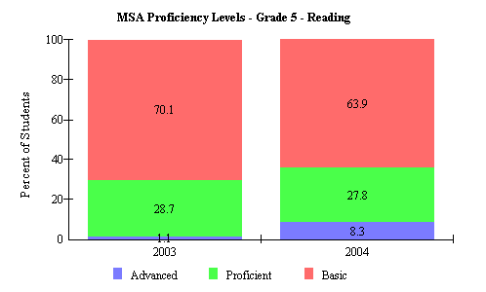
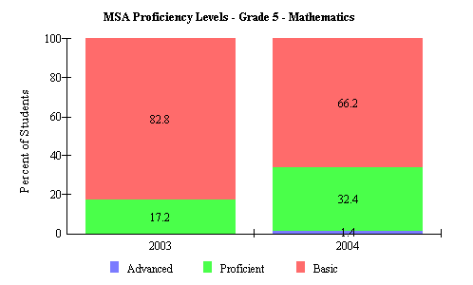
Table 1: Langley Park Elementary School 2003 and 2004 AYP Trends
Figure 5: 2004 Langley Park Elementary MSA Proficiency Levels Grade 5 Reading

Figure 6: 2004 Langley Park Elementary MSA Proficiency Levels Grade 5 Mathematics

Source: 2004 Maryland Report Card
Source: 2004 Maryland Report Card
Prince George's County (LEA:16) Langley Park/McCormick Elementary (ID:1719)

 | 2004 AYP: |  | Met
 |  |  |  | All indicators must be "Met" to make AYP. For details, click on the links below.
 |  |  |  | Percent Proficient |  |  |  |  |  | Participation Rate
 |  |  |  | Reading |  | Mathematics |  |  |  | Reading |  | Mathematics |  |  |  | Attendance
 | All Students |  |  | 03 | 04 |  | 03 | 04 |  | 03 | 04 |  | 03 | 04 |  | 03 | 04
 | American Indian/ Alaskan Native |  |  | 03 | 04 |  | 03 | 04 |  | 03 | 04 |  | 03 | 04
 | Asian/Pacific Islander |  |  | 03 | 04 |  | 03 | 04 |  | 03 | 04 |  | 03 | 04
 | African American |  |  | 03 | 04 |  | 03 | 04 |  | 03 | 04 |  | 03 | 04
 | White (not of Hispanic origin) |  |  | 03 | 04 |  | 03 | 04 |  | 03 | 04 |  | 03 | 04
 | Hispanic |  |  | 03 | 04 |  | 03 | 04 |  | 03 | 04 |  | 03 | 04
 | Free/Reduced Meals |  |  | 03 | 04 |  | 03 | 04 |  | 03 | 04 |  | 03 | 04
 | Special Education |  |  | 03 | 04 |  | 03 | 04 |  | 03 | 04 |  | 03 | 04
 | Limited English Proficient |  |  | 03 | 04 |  | 03 | 04 |  | 03 | 04 |  | 03 | 04
Source: 2004 Maryland Report Card
Adequate Yearly Progress (AYP) performance is shown in Table 1above. We see that in 2004, Langley Park Elementary School met AYP by meeting all Adequate Yearly Objectives (AYO) set by the state in all disaggregated categories. This is an improvement from 2003, where Hispanics, FARMS, and LEP did not meet AYO in areas of reading and mathematics, and Special Education did not met AYO in reading.

Areas of Needed Program Enhancement

Langley Park has been headed in the right direction and needs to continue their hard work.
Areas of needed program enhancement identified in the most recent school improvement plan for Langley Park, indicate the need to focus on the Hispanic population, specifically those Hispanics who are eligible for Free and Reduced Meals and have Limited English Proficiency. A sub-committee was formed to investigate parental needs. For example, the committee might need to know if “homework activities” that require parental guidance, like vocabulary review, are appropriate for this parent population. Additionally, classroom activities and procedures should allow for more teaching assistants/parent /community volunteers to help with supplemental activities that are usually done at home (until a fuller report can be provided). Directions for homework activities that do go home, need to be offered in Spanish. A Parental Community Outreach sub-committee could plan parental activities.

