Data Analysis and Interpretation Paper
Data Analysis and Interpretation with Technology Module: EDHD 435
Part 1

Fall 2004
Emily Hunt
December 13, 2004

BACKGROUND INFORMATION

Introduction
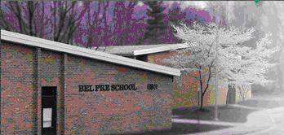

Source: Montgomery County public Schools

Bel Pre Elementary School, school ID # 780, is located in Local Educational Agency #15, in Montgomery County, Maryland at 13801 Rippling Brook Drive, Silver Spring, Maryland. Bel Pre Elementary School is a moderately older school, having opened in 1968 and receiving no renovations thus far. The school houses pre-k through second grade and feeds into another local school, Strathmore Elementary, for third through fifth grades.
The mission of Bel Pre Elementary School in partnership with family and community is to enable each child to develop the knowledge and competencies necessary for success. The school represents a multicultural neighborhood of largely African American and Hispanic families.

DEMOGRAPHICS

Bel Pre Elementary is located in Silver Spring, Maryland (see Figure 1). The 2000 Census indicates that Silver Spring has a population that is 46.6% White, 26.1 % Black or African-American, 22.2% Hispanic, 8.2% Asian, 0.4% Native American or Alaskan Native, 0.1% Native Hawaiian or Pacific Islander, and 11.6% Other.

Figure 1: Silver Spring, Maryland
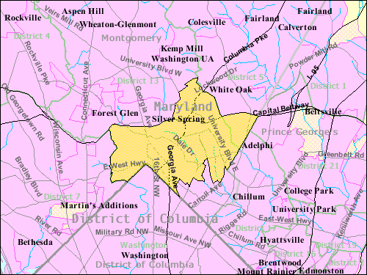

Source: U.S Census Bureau

The school’s population, however, does not reflect the neighborhood Silver Spring population.

Figure 2: Percent Student Enrollment at Bel Pre Elementary School by Race/Ethnicity from 1993 to 2004
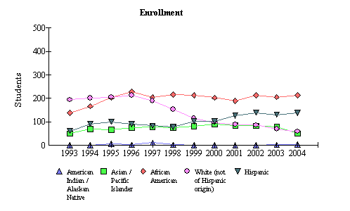

As shown in Figure 2, over the past ten years, the White student population has decreased at Bel Pre Elementary School (43% to 13%) while the African-American (31% to 46%) and Hispanic (13% to 30%) populations have increased. The Asian and Native American populations have remained relatively constant.
Source: 2004 Maryland Report Card
In 2004, Bel Pre Elementary School had 213 African-American students, 138 Hispanic students, 58 White students, 50 Asian/Pacific Islander students, 3 American Indian/Alaskan Native students enrolled as of September 30, 2003. Combined, African-American and Hispanic students comprised over ¾ of the student population.

Students Receiving Special Education Services

Table 1: Special Service: Percent Special Education and Limited English Proficient Students

Year | Percent Special Education | Percent Limited English Proficient
2004 | 8.1 | 8.4
2003 | 6.5 | 4.5
2002 | 7.0 | 6.1
2001 | 7.6 | 14.7
2000 | 6.0 | 13.8
1999 | 6.3 | 4.3
1998 | 6.3 | 8.0
1997 | 6.2 | 4.0
1996 | 8.7 | 5.4
1995 | 11.0 | 8.7
1994 | 12.0 | 9.4
1993 | 6.9 | 7.6
Source: 2004 Maryland Report Card

As shown in Table 1, approximately 1 in 12 students were receiving special education services in 2004 at Bel Pre Elementary School. This statistic has remained relatively constant over the years, with no sharp increases or decreases since 1996. Students who receive special services are students with current Individualized Education Plans (IEPs).
Additionally, 8.4% or approximately 1 in 12 students are considered Limited English Proficient. at Bel Pre Elementary School in 2004. This statistic has doubled since last year, but is similar to other years in Bel Pre Elementary history.
A student is considered Limited English Proficient if he or she has a primary or home language other than English and has been assessed as having limited or no ability to understand, speak, read, or write English. This requires the school to allocate resources for and provide academic support for these students

Free/Reduced Meals

Figure 3: Special Service: Free/Reduced Meal Students
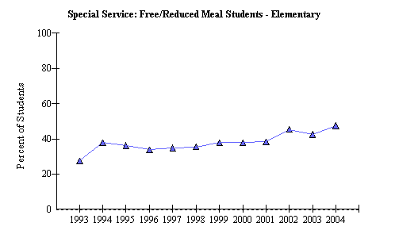
As indicated in Figure 3, the FARM data is very significant. Almost half (47.5%) of Bel Pre Elementary School’s students receive Free or Reduced meals, indicating that almost half of the student population are close to or below the
Source: 2004 Maryland Report Card

poverty level. A major part of the school’s population lives in a low socio-economic environment. This environment could negatively impact their ability to learn without support such as school breakfasts and school supplies for those who cannot afford them.

Staffing

Over half (59.4%) of teachers at Bel Pre Elementary School, hold Advanced Professional Certificates, meaning they hold a master’s degree or its equivalent amount of credits in post-baccalaureate and graduate credits. The remaining teaching staff, 40.6%, holds a Professional Certificate. These are certified to teach in Maryland and hold a bachelor’s degree. All teaching staff hold a Bachelor’s degree or higher in the school.
Even though each teacher holds a Bachelor’s degree or higher, Bel Pre’s data for the year 2004 shows that 12.6% of classes are not taught by highly qualified teachers. According to the 2004 Maryland Report Card, The No Child Left Behind (NCLB) Act requires teachers to have a bachelor’s degree and full state certification and to demonstrate content knowledge in the subjects they teach. Since all teachers have obtained at least a Bachelor’s degree, some teachers must be considered not “highly qualified” because they have not demonstrated content knowledge in the subjects they teach either on test such as the Praxis or through other means.
These teachers will need to demonstrate their content knowledge in order to meet NCLB standards.
In 2004, the staff consisted of 28 classroom teachers, 2 special education teachers, a 0.8 ESOL teacher, 1 resource teacher, 1 counselor, 5.9 paraprofessionals, 1 media specialist, 1 media aide, 1 reading specialist/reading recovery teacher, and 1 staff development specialist (School-o-dex).
Technology Inventory

Figure 4: 2004 Student to Computer Ratio at Bel Pre Elementary School

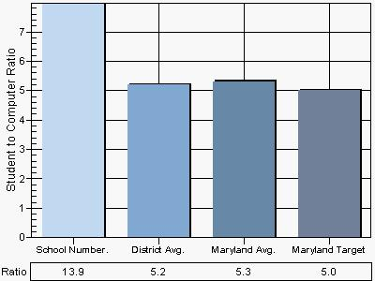
Source: 2004 Maryland technology Inventory

As indicated in Figure 4, Bel Pre Elementary School has an extremely poor student-to computer ratio (13.9 to 1) when compared to the district average of 5.2 to1 and the Maryland average of 5.3 to 1. The school will need to double its number of current computers to reach the targeted student-to-computer ratio in Maryland of 5.0 to 1. While no classrooms have more than five computers, each classroom has at least one computer for student use and one computer for teacher use. One hundred percent of computers in the classrooms have internet access, meeting the Maryland target and exceeding the Maryland totals of 92% in this area of technology.
Bel Pre Elementary uses both e-mail and a school website to communicate between home and school. However, only 40% of Bel Pre Elementary School Students have home internet access, making this type of communication obsolete to a majority of the school’s population. The school uses other methods of communication such as letters, fliers, and phone calls home to ensure communication with this large portion of the school population.
Additional Resources
Bel Pre has some outreach programs in place to promote home-school connections such as Literacy Night, International Day, Family Math Night, and Interrelated Art Shows.

PREVIOUS ACHIEVEMENT RESULTS

Student Attendance
Bel Pre Elementary School showed a high attendance rate of 95.0% in 2004 that met the Maryland state satisfactory standard of 94% students present daily during the school year. Bel Pre Elementary School has shown a consistently high attendance rate over the past four years (e.g., 94.5% in 2000). The attendance rate across each race/ethnicity is also similar. 2004 results showed Asian/Pacific Islander – 95.4%, African-American – 95.5%, White – 94.1%, Hispanic – 94.7%.

Adequate Yearly Progress (AYP)

Table 2: Bel Pre Elementary School 2004 AYP Percent Proficiency School Summary by sub-groups

Montgomery County (LEA:15) Bel Pre Elementary (ID:0780)

 | 2004 AYP: |  | Met
 | Show Trends |  |  | All indicators must be "Met" to make AYP. For details, click on the links below.
 |  |  |  | Percent Proficient |  |  |  | Participation Rate
 |  |  |  | Reading | Mathematics |  |  | Reading |  | Mathematics |  |  | Attendance
 | All Students |  |  | Met |  | Met |  |  | Met |  | Met |  |  | Met
 | American Indian/ Alaskan Native |  |  | -- |  | -- |  |  | -- |  | --
 | Asian/Pacific Islander |  |  | Met |  | Met |  |  | Met |  | na
 | African American |  |  | Met |  | Met |  |  | Met |  | Met
 | White (not of Hispanic origin) |  |  | Met |  | Met |  |  | na |  | na
 | Hispanic |  |  | Met |  | Met |  |  | Met |  | Met
 | Free/Reduced Meals |  |  | Met |  | Met |  |  | Met |  | Met
 | Special Education |  |  | Met |  | Met |  |  | na |  | na
 | Limited English Proficient |  |  | Met |  | Met |  |  | na |  | na

'--' indicates no students in the category. 'na' indicates too few students for AYP rules.
Source: 2004 Maryland Report Card

As evidenced in Table 2, Bel Pre elementary school met AYP in the 2003-2004 school year. Some groups such as Asian/Pacific Islander, White, Special Education, and Limited English Proficient, were exempted from the requirements because the number of students being measured was so few. For a group’s data to count, there must be at least 30 students in the grade that are being tested.

Figure 5: 2004 Percent Proficiency in Reading at BPES by sub-groups
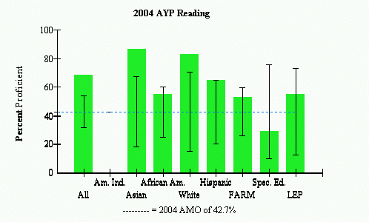
50.9% in 2004 |  | AYP Met |  |  | AYP Met with Safe Harbor |  |  | AYP Not Met
Source: 2004 Maryland Report Card

The Maryland Report Card defines proficiency in reading as, “Proficient: Students at this level can read grade appropriate text and demonstrate the ability to comprehend literature and informational passages.” As shown in Figure 5, all subgroups with the exception of Special Education students (29.4% proficiency) were above the Annual Measurable Objective (AMO) of 42.7% Proficiency. Next year, however, the AMO will be raised to 50.9% Proficiency. The African American students and students who receive FARM are slightly above this proficiency level (55% and 53% respectively). If the students in these groups lose any ground in their proficiency, they may fall below this AYP standard.

Figure 6: 2004 Percent Proficiency in Mathematics at BPES by sub-groups
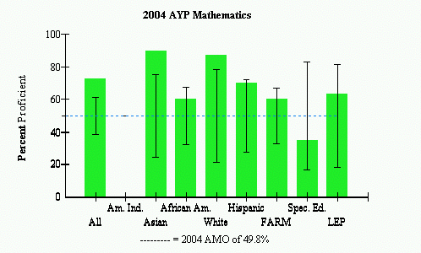
57.0% in 2004 |  | AYP Met |  |  | AYP Met with Safe Harbor |  |  | AYP Not Met

Source: 2004 Maryland report Card

As displayed in Figure 6, Special Education students were once again the only group (35.3% proficiency) that did not meet the AMO of 49.8% proficiency in Mathematics set by the state in 2004. Proficiency in Math, according to the Maryland Report Card is, “Proficient: Students at this level demonstrate an understanding of fundamental grade level skills and concepts and can generally solve entry-level problems in mathematics.”
In 2005, the AMO for Math achievement will raise to 57.0%. The African American students (60% proficiency) and the students who receive FARMS (60% proficiency) are once more the groups that are nearest this targeted proficiency level and therefore are the most likely to fall below this level for the 2005 AYP if they lose ground in this subject.

AREAS OF NEEDED PROGRAM ENHANCEMENT

Bel Pre Elementary School needs to focus on three specific student groups: Special Education, African-American, and students who receive Free and Reduced Meals. The school may have students that fit in one, two, or all three of those groups, so additional support of all three groups may have a profound effect on student achievement.
The educators should research the latest trends in education to find any additional practices that may be of benefit to these students in reading and math. More school-home connections such as more subject-area nights and more letters home from teachers about students’ progress would add to the consistency in these students’ education. An after-school homework club could greatly help low socio-economic students whose parents are working and are not home at night to help them with their homework. While these recommendations would benefit these targeted groups, they also have the potential to benefit all of Bel Pre’s students.
The school should create a committee to focus on research and teaching and learning strategies. It should also set up a committee that focuses on strengthening the school-home connection and meeting Bel Pre’s learners’ needs.
The school should also establish a third Technology Improvement committee to allocate funding for or donations of computer technology. This would benefit all students, especially those of lower socio-economic status who do not have internet access at home.
While the only two out of the three targeted groups count towards the school’s AYP, Bel Pre should focus on all three groups to ensure that truly there is, “No Child Left Behind.”

References

2004 Maryland Report Card: Montgomery County – Bel Pre Elementary (n.d.) Retrieved October 30, 2004, from http://msp.msde.state.md.us/school.aspx?K=150780& WDATA=School

American FactFinder: Fact Sheet – Silver Spring (n.d.) Retrieved Novemeber 30, 2004 from http://factfinder.census.gov

School-o-dex: Bel Pre Elementary School at a Glance (n.d.) Retrieved November 30, 2004 from http://www.mcps.k12.md.us/departments/regulatoryaccountability /glance/fy2004/schools/02780.pdf

Technology Inventory: Montgomery County - Bel Pre Elementary 2004-2005 (n.d.) Retrieved October 30, 2004 from http://reports0304.md.ontargetus.com/ SchoolSum.asp?otid=15x0780&accDesc=Bel+Pre+Elementary

