Data Analysis and Interpretation Paper
Data Analysis and Interpretation with Technology Module: EDHD 435
Part 1

Fall 2004
Ashley Hahn
October 31, 2004

Background Information

Introduction

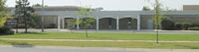

Galway Elementary School, school ID #313 is located at 12612 Galway Drive
Silver Spring, MD 20904. Galway Elementary School is an older school, having opened in December, 1967. Since opening it has grown from as small as 175 students to as high as 785 students. It contains grades Pre-K to 5th Grade. The theme of Galway Elementary School is the 3 R’s: Rights, Respect and Responsibility. And the mission statement is to work cooperatively to enhance self-esteem and thinking skills" and the high expectations we have for all students. The staff is large with several new and/or younger teachers on the faculty. The school represents a multicultural environment. Several students live close enough to walk, but since the district has expanded all the way to above Briggs Chaney Road, the number of bus riders has increased. Briggs Chaney is not in walking distance therefore there has been an increase in the number of busses that serves the school.
Galway Elementary School hosts several activities in the building after school and in the evenings. These include hands-on science programs, jump-rope club, basketball intramurals, and art class. Some churches use the facilities on weekends. A gym was opened in 1977. Galway Elementary School has also taken part in a video project on Olympic Spirit done by the State Department of Education. If needed, the school often refers members to local agencies to help serve them in many of their needs, be it, medical, financial, and other assistance.

More information about the school can be accessed from the school’s website: http://www.mcps.k12.md.us/schools/galwayes/ or through Galway on the county website at http://www.mcps.k12.md.us/schoolodex/schooloverview.cfm .
Neighborhood Demographics

Figure 1: 2004 Map of Silver Spring, Maryland
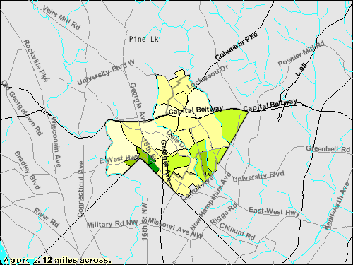

Source: 2000 U.S. Census Bureau
Detailed demographic information for the Silver Spring area can be accessed via the Census Bureau (Fact Finder) by entering the school’s city and state. The demographic breakdown for Silver Spring, Maryland in 2000 for all races is 76,540. Of this total population, 46.6% is White alone, 28.1% is Black or African American alone, 0.4% is American and Alaskan Native alone, 8.2% is Asian Alone, 0.1% is Native Hawaiian and Other Pacific Islander alone, and 11.6% is some other race alone.
The official enrollment of Galway Elementary School can be found by going to http://www.mcps.k12.md.us/departments/regulatoryaccountability/glance/fy2004/schools/02313.pdf . This information was last updated for the 2003-2004 school year when the total enrollment was 686 students. 46.9% of the students were female and 53.1% male. Above the Silver Spring demographics were stated, the following are the demographics for specifically Galway Elementary School. Out of the 686 Galway Elementary School students, 53.5% are African American, 0.6% American Indian, 23.3% Asian, 8.6% Hispanic and 14% white.
Galway Elementary School is considered a Title I school. Of the students at Galway Elementary, 36.6% are eligible for FARMS. Students who are eligible for free and reduced price meals have to meet the family size and income guidelines which change annually by the US Department of Agriculture. Several students also receive other services throughout their school day including Supplementary Speech Services, and ESOL. 12.5% of the students attend one of these services.
Staffing

The staff at Galway Elementary School can be found by going to http://www.mcps.k12.md.us/schoolodex/schooloverview.cfm and clicking on Galway Elementary school and staff list. The school consists of one principal, one assistant principal, two front office secretaries, two art teachers, five building services members, two cafeteria staff, one academic intervention teacher, three ESOL instructors, fourteen Para educators, two media center specialists, three music teachers, two PE teachers, two reading, one speech, five special education instructors, four staff development, and 32 classroom teachers. Of the 32 classroom teachers, there is one pre-k teacher, six kindergarten, five first-grade, six second-grade, five third-grade, five fourth-grade, and four fifth-grade teachers.
The student/instructional staff ratio is 10:8. And the average class sizes are 14 students for Kindergarten, 16 students for Grades 1 and 2, and 25 students for grades 3-5. To better meet the needs of each individual student, there are different professional days/times for teachers as well as in-service training. These set times allow for the teachers to attend staff trainings and/or work on student plans and lessons. This time is time for the teacher, but is very beneficial for the students.
Technology

Specifics related to technology equipment and use, and inventory at Galway Elementary School can be found at http://mbrt.org the Maryland Business Roundtable website, which allows people to view the Annual School State Technology inventory. http://reports.md.ontargetus.com/SchoolSum.asp?otid=739&accDesc=Galway+Elementary. The report shows that Galway Elementary has excellent access to computers in the classroom, showing a 4:1 student-computer ratio, and 100% of the classrooms connected with internet access. Galway’s teacher knowledge and skills is above both Montgomery County totals and State averages. Data seems to indicate that the school has technology and the teachers have the training to incorporate technology in their classrooms.

AYP Results and Other Assessments

Average Daily Attendance

The attendance rate reflects the percentage of students present in school for at least half the average school day during the school year. Galway Elementary School has shown a consistently high rate of attendance over the last several years averaging over 96%. In 2004, the attendance rate was 97%. 57.1% of the absent students missed fewer then 5 days. The attendance rate across Race/Ethnicity and Gender was similar. Over the past five years the lowest attendance rate was 93.9% attendance rate for Hispanics in 2003. This school has a trend of high attendance rates.

Reading

In order to meet the federal requirement contained in No Child Left Behind (NCLB), Maryland is required to assess student achievement. The Maryland School Assessment, (MSA), measures student achievement in grades K-8 in Reading and Math as well as Grade 10 reading. This information is reported and can be found at www.marylandreportcard.org by typing in the county and school to view the data.
There are three levels of achievement that are reported. These levels are Basic, Proficient and Advanced. The Maryland Report Card explains the differences among the levels as:
Maryland standards are divided into three levels of achievement:
Advanced is a highly challenging and exemplary level of achievement indicating outstanding accomplishment in meeting the needs of students.
Proficient is a realistic and rigorous level of achievement indicating proficiency in meeting the needs of students.
Basic is a level of achievement indicating that more work is needed to attain proficiency in meeting the needs of students.
Student performance is reported in terms of these achievement levels:
Reading:
Basic: Students at this level are unable to adequately read and comprehend grade appropriate literature and informational passages.
Proficient: Students at this level can read grade appropriate text and demonstrate the ability to comprehend literature and informational passages.
Advanced: Students at this level can regularly read above-grade level text and demonstrate the ability to comprehend complex literature and informational passages.

Galway Elementary School’s MSA Proficiency for Grade 3 reading between 2003 and 2004 at the Advanced Level decreased going from 9.8% in 2003 to 6.1% in 2004. However, the Proficient Level has increased from 51.8% (2003) to 59.5% (2004). The Basic Level has also decreased from 38.4 to 34.4 percent. Figure 2 below shows Grade 3 proficiency levels for the 2003-2004 school year.
Figure 2: 2003-2004 MSA Proficiency Level for grade 3 Reading at Galway Elementary School
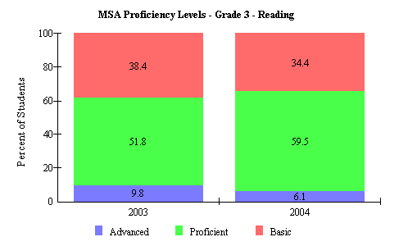

Source: 2004 Maryland Report Card
Proficiency at the Advanced Level showed a marked increase for reading in Grade 5 at Galway Elementary School going from 21.4 in 2003 to 33.1 in 2004. However, the Proficient and Basic levels decreased. Proficient level dropped from 47.6 to 43.0 and Basic proficiency went from 31.0 to 24.0 percent. Figure 3 Summarizes MSA Proficiency Levels by percentage for Galway Elementary School fifth grade reading.
Figure 3 Shows MSA Proficiency Levels by Percentage for Galway Elementary School Fifth Grade Reading
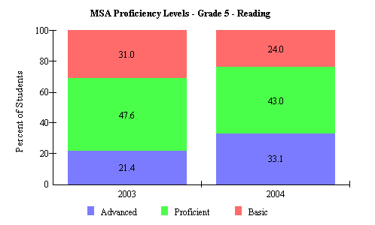

Source: 2004 Maryland Report Card

The data for Galway’s third and fifth grade Proficiency levels in reading indicates a marked increase in reading performance. Reading is an area that needs to be worked on.

Math

Maryland State Assessment (MSA) data is collected for math at the third and fifth grade. Figure 4 Shows MSA Proficiency Levels by percentage for Galway Elementary School third grade math. Figure 5 Shows MSA Proficiency Levels by percentage for Galway Elementary School fifth grade math.

Figure 4. MSA Proficiency Levels by Figure 5. MSA Proficiency Levels by
Percentage for Galway Elementary School Percentage for Galway Elementary School
Third Grade Math Fifth Grade Math
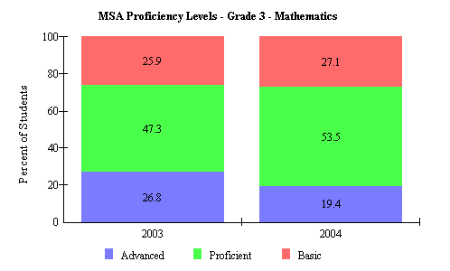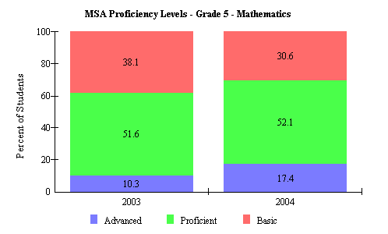
Source: 2004 Maryland Report Card

Data indicates a decrease in the number of students working at the advanced level in Grade 3 2003-2004 however, an increase can be seen of the number of students working at the proficient and basic levels. The math data shows that for Grade 5 Math, from 2003-2004, there was in increase in the number of students at the advanced and proficient level, but a decrease in the basic level.

Table 6. Adequately Yearly Progress for Montgomery County, Galway Elementary School.
Montgomery County (LEA:15) Galway Elementary (ID:0313)

 | 2004 AYP: |  | Met
 | Hide Trends |  |  | All indicators must be "Met" to make AYP. For details, click on the links below.
 |  |  |  | Percent Proficient |  |  |  |  |  | Participation Rate
 |  |  |  | Reading |  | Mathematics |  |  |  | Reading |  |  | Mathematics |  |  |  | Attendance
 | All Students |  |  | 03 | 04 |  | 03 | 04 |  |  | 03 | 04 |  | 03 | 04 |  |  | 03 | 04
 | American Indian/ Alaskan Native |  |  | 03 | 04 |  | 03 | 04 |  |  | 03 | 04 |  | 03 | 04
 | Asian/Pacific Islander |  |  | 03 | 04 |  | 03 | 04 |  |  | 03 | 04 |  | 03 | 04
 | African American |  |  | 03 | 04 |  | 03 | 04 |  |  | 03 | 04 |  | 03 | 04
 | White (not of Hispanic origin) |  |  | 03 | 04 |  | 03 | 04 |  |  | 03 | 04 |  | 03 | 04
 | Hispanic |  |  | 03 | 04 |  | 03 | 04 |  |  | 03 | 04 |  | 03 | 04
 | Free/Reduced Meals |  |  | 03 | 04 |  | 03 | 04 |  |  | 03 | 04 |  | 03 | 04
 | Special Education |  |  | 03 | 04 |  | 03 | 04 |  |  | 03 | 04 |  | 03 | 04
 | Limited English Proficient |  |  | 03 | 04 |  | 03 | 04 |  |  | 03 | 04 |  | 03 | 04

 | AYP Met |  |  | AYP Not Met
Source: 2004 Maryland Report Card
AYP was met at Galway Elementary School in the 2003-2004 academic year.
Areas of Needed Program Enhancement

While data indicates positive gains in several areas, enhancement in programs for Special Education, ESOL and FARMS would be beneficial to the students. The special education and ESOL program should collaborate more with the general classroom teachers, since these students often are pulled throughout the day to go to these programs, thus losing critical classroom instruction. If they collaborate, what is being taught in the classroom can be reinforced in a small group when they work with their ESOL instructor. Reading should also be a focus. The school should strive to get more students to the advanced level in both math and reading. Lastly, since the AYP data indicates that the African Americans have the lowest proficiency percent, they should work with these students to increase their level.

