Data Analysis and Interpretation Paper
Data Analysis and Interpretation with Technology Module: EDHD 435
Part 1

Fall 2004
Jessie Elseroad
November 1, 2004

Background Information

Introduction

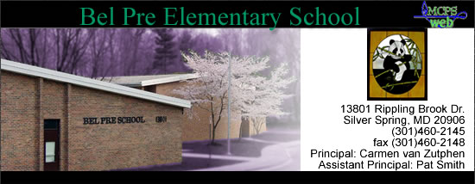

Bel Pre Elementary School, school ID # 0780, is located in Local Educational Agency # 15 in Montgomery County Maryland, at 13801 Rippling Brook Drive, Silver Spring, Maryland. Bel Pre Elementary School opened in September of 1968 serving as a kindergarten through sixth grade school. In June of 1988, the sixth grade was moved to Lee Middle School, and then in March of 1989 the Board of Education paired Bel Pre and the Strathmore school together. This pairing has remained in place since 1989, making Bel Pre Elementary the primary school serving pre-kindergarten through second grade, while Strathmore serves third through fifth grades. In 1992, Bel Pre Elementary experienced many physical changes as a result of a construction project, which added six classrooms and other interior modifications. The mission statement of Bel Pre Elementary School in partnership with family and community is to enable each child to develop the knowledge and competencies necessary for success. The school represents a very diverse community made up of a large number of immigrant families (35.1% of Silver Spring population are immigrants). Some children walk to school from the immediate surrounding neighborhood, but most children do not live in the immediate neighborhood; therefore ride buses.

Demographics
More detailed information for Bel Pre Elementary can be found through the U.S. Census Bureau (Fact Finder) by entering the school’s city and state. For Silver Spring, the 2000 Census indicates the population makeup to be 46.6% White, 28.1% Black or African American, 8.2% Asian, 22.2% Hispanic or Latino, and 0.4% American Indian/Alaskan Native. Forty one percent of people in Silver Spring speak another language other than English at home, and 35.1% of people were not born in America. These statistics help explain the high Limited English Proficiency (LEP) population

Figure 1: Map of Silver Spring, Maryland
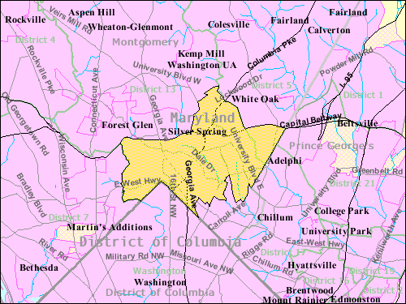
Source: U.S. Census Bureau
present at Bel Pre Elementary. Currently Bel Pre Elementary has a student enrollment of 512 students. The population is made up of 20% White, 41% African American, 18% Asian, and 21% Hispanic. Bel Pre Elementary enrollment has changed over the years. Figure 2 indicates that there has been a decline in the White student enrollment at Bel Pre Elementary from 1993 to 2004, while the African American and Hispanic student enrollment has significantly increased from 1993 to 2004.

Figure 2: Racial/Ethnic Makeup of Student Enrollment at Bel Pre from 1993-2004
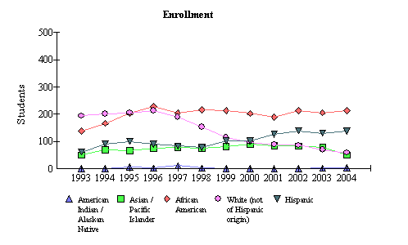
Source: 2004 Maryland Report Card
Based on this data, one would think that the Silver Spring area has changed a lot in the past ten years. However, the school population does not directly correlate with the 2000 Census of Silver Spring. The majority of people in Silver Spring are White, while the African American population is 28.1%, but at Bel Pre Elementary the majority of students are African American at 41%, while the population of White people is 20%. However, the Hispanic population of Silver Spring was consistent with the Hispanic student enrollment at Bel Pre Elementary in 2004.
Bel Pre Elementary attempts to break down the language barrier and bring together the many cultures represented at the school in many different ways. The principal at Bel Pre is bilingual with Spanish being her first language and English her second, so she serves as an excellent liaison for the community. Along with the principal there are also various staff members employed by the school that are fluent in more than one language, not always with Spanish being the case since the population is so diverse. The school also holds events to welcome families such as the breakfast for all parents of LEP students, Hispanic Awareness Assembly, and International night.
Staffing
The teaching staff at Bel Pre Elementary consists of 59.4% of their teachers holding Advanced Professional Certificates, while the remainder (40.6%) hold Standard Professional Certificates. There are no teachers at Bel Pre Elementary with Conditional Certificates. This data means that almost 60% of teachers at Bel Pre have had at least three years of experience in the field plus six semester hours of acceptable credit, and either a master’s degree or at least 36 semester hours of post baccalaureate course work which must include at least 21 hours of graduate credit. The other 40.6% of teachers have obtained a valid certificate to teach all Maryland elementary core academic subjects.
The staff consists of 48 professional members and 22 supporting service members, for a total of 70. There are 29 classroom teachers, 13 paraeducators, and 6 arts teachers (art, music, P.E.). There are also several specialists including: 1 media specialist, 1 focus ESOL transition, 1 math specialist, 1 reading specialist, 1 literacy support, 1 resource teacher, 1 ESOL teacher, 1 speech teacher, 1 academic support member, 1 staff development person, 1 counselor, 1 nurse, and 1 health room technician. The rest of the staff consists of the principal, assistant principal, secretaries, cafeteria workers, and building services.

Technology
More specific information regarding technology equipment and use can be found at the Maryland Business Roundtable, Annual School State Technology Inventory at: http://mbrt.org/. Bel Pre Elementary information indicates the student to computer ratio to be 3.3:1, which is above both the Montgomery County average set at 4.2:1 and the Maryland average set at 4.9:1. All classrooms have Internet access. The school is well equipped in terms of the teachers’ technological skills. The data shows that 91% of teachers have intermediate computer skills, 80% have intermediate internet skills, and 99% have technology integration skills. This data shows that Bel Pre Elementary is doing excellent in terms of technology equipment, specifically computers for the students, and teachers that have technology knowledge and know how to integrate it.

AYP Results and Other Assessments

Average Daily Attendance
The Attendance rate reflects the percentage of students present in the school for at least half of the normal school day. Bel Pre Elementary School has shown a consistent high rate of attendance for the past 12 years, never falling below 94.1%. In 2004, the rate an all-time high of 95%. Of the students that were absent, in 2004, the majority of them were absent less than five days out of the entire school year. The attendance rate across the board in terms of race/ethnicity showed consistent similarity: 95.4% Asian, 95.5% African American, 94.1% White, and 94.7% Hispanic.

Reading and Math
In order to meet one of the federal requirements set forth in No Child Left Behind, every school in Maryland must reach the Annual Measurable Objective (AMO) set by the state of Maryland. The AMO is adjusted each year in an effort of working towards the goal of 100% proficiency in both reading and mathematics by the 2013-2014 school year. Figures 3 and 4 represent Bel Pre Elementary Proficiency levels for reading and mathematics for the 2004 Average Yearly Progress (AYP). AYP is the gain that schools must make every year in terms of the proportion of students reaching proficiency in mathematics and reading. To make AYP, schools must reach the AMO, which is depicted in Figures 3 and 4 by the horizontal, blue, dotted line. By looking at Figures 3 and 4, one might think that the school did not reach the AYP for both reading and mathematics in terms of special education students. Confidence intervals, which are depicted by the black vertical lines in Figures 3 and 4, serve as acceptable boundaries in terms of reaching AYP. If a certain group of students does not quite reach the AMO, but fall within the confidence interval, then they are still considered to have reached AYP. So, yes special education students did reach the AYP, but at a very low percentage rate which slips into the bottom range of the confidence interval. Thus, it is important to look at the graphs and not only if the school met the AYP or not because clearly the expectations are not as high as one might assume. Looking at special education, Bel Pre Elementary School met AYP even if less than 20% of special education students reach proficiency in mathematics and reading. However, in all other categories, the students surpass the AMO. Seventy two and one half percent (2.5%) of all students show proficiency in mathematics and 68.2% of all students show proficiency in reading, both statistics greatly surpassing the AMO.
Figure 3: 2004 AYP Reading: Bel Pre Elementary School 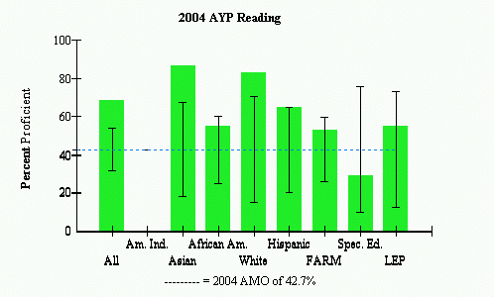
Source: Maryland K12 Website

Figure 4: 2004 AYP Mathematics: Bel Pre Elementary School
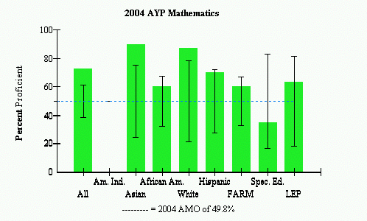
Source: Maryland K12 Website

Areas of Needed Program Enhancement
Bel Pre has shown competency among certain groups of students in reaching the goals in terms of academic achievement, specifically in the subject areas of reading and mathematics, yet there is concern regarding special education, Hispanic, and African American students. Yes the Hispanic and African American students surpassed the state set target but only by a slim margin. As previously discussed, the special education students did not meet the AMO benchmark. Thus Bel Pre needs to focus on its African American, Hispanic, and Special Education students in the subject areas of mathematics and reading. It is important to continue in their efforts concerning reading and mathematics, but to adapt their methods to reach all students.
The school shows great success concerning attendance and technology throughout the school. The attendance rate from 2004 is extremely high indicating that Bel Pre is doing an excellent job of getting their students to school on a regular basis. The teachers’ knowledge of technology as well as the availability of technology in the classroom proves that Bel Pre is prepared and capable of educating its students in technology.
Bel Pre’s latest school improvement plan involves an “Action Plan for Reading” for the 2004-2005 school year. This action plan involves a wide variety of multiple assessments to be completed numerous times throughout the school year, an intervention team which will intervene on a regular basis as soon as necessary, specific skill development tasks, constructivist classroom components, and data collection and analysis of each student’s work. This plan is designed to gain a percentage of proficiency in reading throughout the school by the end of this current school year.
References
Maryland State Department of Education. 2004 AYP reading. Retrieved October 25, 2004, from http://www.mdk12.org/data/ayp_analyzing/tutorial/step2a.asp?K=150780
Maryland State Department of Education. 2004 AYP mathematics. Retrieved October 25, 2004, from http://www.mdk12.org/data/ayp_analyzing/tutorial/step2b.asp?K=150780
Maryland State Department of Education. Bel pre elementary technology inventory summary report. Retrieved October 25, 2004, from http://reports0304.md.ontargetus.com/SchoolSum.asp?otid=15x0780&accDesc=Bel+Pre+Elementary
Maryland State Department of Education. 2004 Maryland report card: enrollment: race/ethnicity & gender. Retrieved October 28, 2004, from
http://msp.msde.state.md.us/Enroll_ByGenderRace.asp?K=150780
Maryland State Department of Education. 2004 Maryland report card: teacher state certification. Retrieved October 28, 2004, from http://msp.msde.state.md.us/TeachersCertificates.asp?group=ADV&K=150780
Maryland State Department of Education. 2004 Maryland report card: attendance rate: comprehensive elementary. Retrieved October 28, 2004, from http://msp.msde.state.md.us/attend.asp?Grade=E&K=150780
U.S. Census Bureau. Fact sheet: silver spring, maryland. Retrieved October 28, 2004 from http://factfinder.census.gov/servlet/SAFFFacts?_event=ChangeGeoContext&geo_id=16000US2472450&_geoContext=&_street=&_county=montgomery&_cityTown=Silver+Spring&_state=04000US24&_zip=&_lang=en&_sse=on

