Montgomery Knolls Elementary School
Introduction
Montgomery Knolls Elementary School is located in the Montgomery Knolls housing development in Silver Spring, Maryland. This school has a Head Start Program through the second grade. Montgomery Knolls is a public school for the county. This school caters to a diverse population. Figure 1 indicates the enrollment at the school in 2004. According to the Figure 1, Montgomery Knolls has enrolled more African American and Hispanic students while declining in their White student population. From 2000 to 2004, the enrollment of African American and Hispanic students has risen between 10% and 20%. This means that there is a diverse learning experience inside each classroom. In 2004, the school population consists of 1% American Indian/Alaskan Native, 9% Asian/Pacific Islander, 15% Caucasian, 35% Hispanic and 40% African American.
Figure 1: Student Numbers by Race/Ethnicity at Montgomery Knolls Elementary School from 1993 to 2004
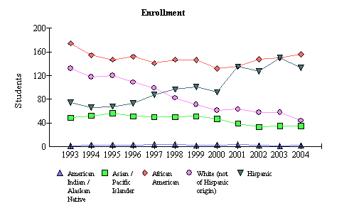
Source: 2004 Maryland Report Card

Montgomery Knolls has shown a sharp increase in Hispanic and a moderate increase in African American enrollment since 2000 to 2004, while the number of White students has declined from 2000 to 2004.
Community
According to the 2000 U.S. Census Report the Montgomery Knolls community in Silver Spring, Maryland, consists of 55.8-68.8 percent White, 7.7-11.3 percent Asian, 13.1-20.1 percent African American, and 9.7-18.4 percent Hispanic. The Census Bureau also reports the following facts about the Montgomery Knolls Development:
- 35.0 percent speak a language other than English at home age 5 and older.
- 6.1-6.4 percent of the community is in the poverty level.
- 28.9-49.5 percent of the community is foreign-born.
- The average household income is between $44,572 and $66,507
Maps provided on the Census Bureau’s website show that the Montgomery Knolls Development is divided between the lower- and upper-middle class. Also, the household income level may be higher than expected because some households consist of more than one family.
Assessment
According to the School Improvement in Maryland website, in 2004, Montgomery Knolls Elementary School met their Adequate Yearly Progress (AYP) in both reading and mathematics. Figures 2 and 3 explain in greater detail the data results.

Figure 2. Montgomery Knolls Elementary School 2004 AYP Percent Reading Proficiency by Race/Ethnicity and Special Interest Groups
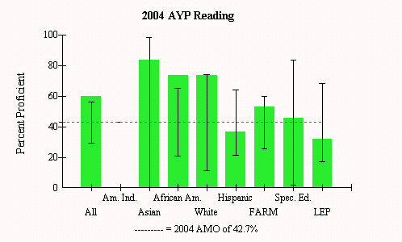

Source: 2004 Maryland Report Card

Figure 3. Montgomery Knolls Elementary School 2004 AYP Percent Mathematics Proficiency by Race/Ethnicity and Special Interest Groups

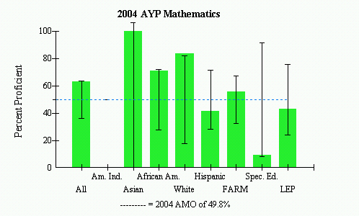
Source: 2004 Maryland Report Card
In the area of reading the sub-groups Hispanic children and Limited English Proficiency (LEP) students (these two groups probably overlap) did not meet the state designated Annual Measurable Objectives Benchmarks (AMO). Additionally, the Special Education sub-group just made the AMO. In Mathematics, a similar trend is seen. The Hispanic and LEP sub-groups did not meet AMO. Additionally, while there are only a few number of Special Education Students included in this data, this group came far from meeting the states targeted AMO. It should also be noted that the Free and Reduced Meals Students (FARMS) does not far exceed the state AMO proficiency level. Since the Montgomery Knolls Elementary School consists of a high Hispanic population, and since many of these students are also counted into the FARM and LEP data sub-groups, this school will have to work on improving the assessment levels for this particular population along with the Special Education special interest group. Since the state targeted AMO proficiency level raises each year, these groups might find it harder to reach AMO and therefore the school might not be able to meet AYP in the future.
Improving these assessment levels is a major focus in the School Improvement Plan. In a meeting held in December 2004, the principal of Montgomery Knolls stressed the need to improve the test scores especially for the second graders. The plan is for all available resources to be put into the improvement of assessment scores by having students spend more time with resource teachers, specials teachers integrating more content into their lessons, and by all staff members supporting each other regardless of grade level.
Staffing
While Montgomery Knolls Elementary School’s current School Improvement Plan focuses on improving both reading and mathematics assessment score, according to the Maryland State Report Card (2004), Montgomery Knolls has a declining number of teachers with Advance Certification.
Figure 4. Montgomery Knolls Elementary School Trends in Teachers with Advanced Professional Certification
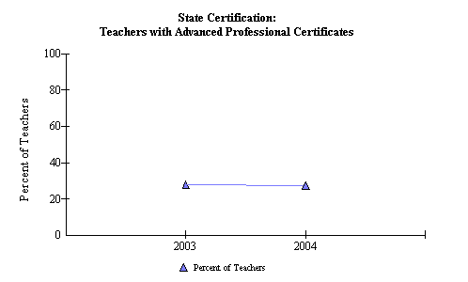
Source: 2004 Maryland State Report Card

As shown in Figure4, approximately 30 percent of teachers at Montgomery Knolls Elementary School have advanced professional certificates. This could pose a problem for the school’s improvement because the teachers may not be as experienced and might not have the training needed to implement some of the curriculum, or the expertise in assessment evaluation and instructional decisions necessary to help students excel in both reading and mathematics.
Attendance and Enrollment
Attendance dropped slightly from 2003 to 2004, according to the Maryland State Report Card.

Figure 5. Attendance rate trends by percent from 1993 to 2004 at Montgomery Knolls Elementary School
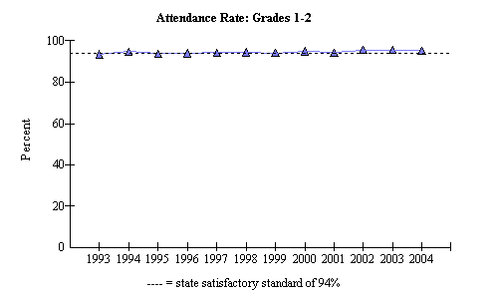
Source: 2004 Maryland State Report Card

Although the attendance rate has dropped slightly from 2003 to 2004, it still remains over 94%. This is a positive sign for Montgomery Knolls Elementary School. It means that the students are coming to school every day so they can receive the education possible to improve their test scores. Shown in Figure 6, enrollment numbers at Montgomery Knolls Elementary School has also declined slightly since 2003.

Figure 6. Total student enrollment trend, in numbers, 1993 to 2004 at Montgomery Knolls Elementary School
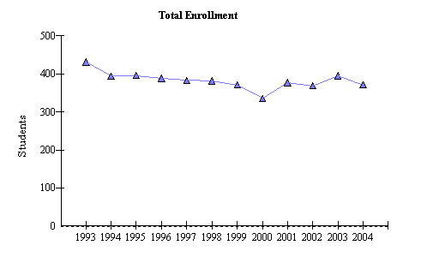
Source: 2004 Maryland State Report Card

On a positive note, this could help the school raise its assessment scores since fewer students will mean smaller class sizes, possibility being more conducive to learning. Figure 7, shows the school has increased its Special Education student enrollment.
Figure 7. Percent Special Education student enrollment trend, from 1993 to 2004, at Montgomery Knolls Elementary School
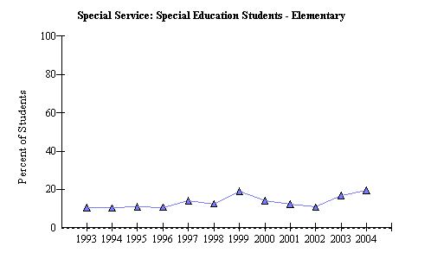
Source: 2004 Maryland State Report Card

This sub-group of students also show a need for improvement on assessment scores. By increasing the number of students in Special Education, the school must provide more resources in order for these students to meet the AYP for reading and mathematics. The teachers and staff will have to work hard in order to meet their School Improvement Plan.

Bibliography

Maryland 2004 Report Card: Montgomery County- Montgomery Knolls Elementary School . (n.d.). Retrieved October 30, 2004, from http://msp.msde.state.md.us/

MSA Proficiency Data for 2003 – 2004 Montgomery County Elementary Schools: Montgomery Knolls Elementary School. (n.d.). Retrieved October 30, 2004, from http://www.mcps.k12.md.us

United States Bureau of the Census (1999). Retrieved 30 October 2004,
fromwww.census.gov.

