Data Analysis and Interpretation Paper
Data Analysis and Interpretation with Technology Module: EDHD 435
Part 1

Fall 2004
Suzan Halabi
November 1, 2004
Background Information
Woodlin Elementary School, school ID #0764 is located in Local Educational Agency #15, in Montgomery County Maryland, at 2101 Luzerne Avenue, Silver Spring, Maryland. Figure 1 is a picture of Woodlin Elementary School, as it opened its doors in 1945 with 95 students in four classrooms.
Figure 1. Woodlin Elementary School in 1945


Source: Montgomery County Public Schools
The school was originally named North Woodside School. The students changed the name from North Woodside School to Woodlin Elementary School. There was one Kindergarten, first grade, second grade, and third grade class. The school consisted of three teachers and the principal, Marvel Hess, who also served as a third grade teacher. The students who attended the school all lived walking distance, which made Woodlin a neighborhood school.
In the 70s, an art, music, librarian and the first ESOL teacher were hired at Woodlin Elementary School. Full day kindergarten began in 1979 and during the 80s, technology was introduced to the school. Woodlin received many computers for

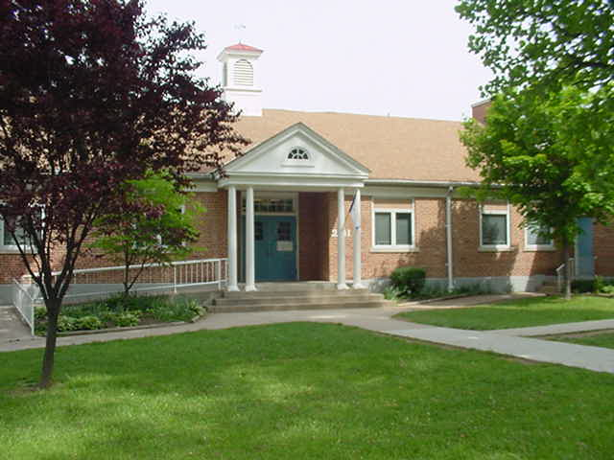

Figure 2. Image of Present day Woodlin Elementary School

students and teachers to use. During this era, Woodlin Wizard, the school mascot, was adopted by one of the students.
The school was built as a U-shaped building which is now called the “lower level”. Since then, new construction has taken place to make the school bigger. Currently, the school has grades K-5 and has 514 students enrolled at the school. More information about the school can be accessed at http://www.mcps.k12.md.us/schools/woodlines/.
Demographics
According to the 2000 U.S. Census, Silver Spring, Maryland, where Woodlin is located, has a population of 76,540. Seventy seven percent of this population is eighteen years and over.
About 46% of the population is White, non-Hispanic (35,678), 28.1% are African American (21,482), 22% are Hispanic (17,004), and 8.2% are Asian (6,293). These percentages are reflected in the student enrollment at Woodlin Elementary school. The school has had a large enrollment of white (non-Hispanic) students. The second largest
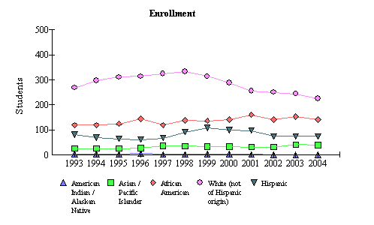
Figure 3: Student Enrollment trends at Woodlin Elementary school from 1993 to 2004

race enrolled at Woodlin is African American. In 2004, with 481 students enrolled, 226 of the students were White, 142 of the students were African American, 74 were Hispanic, and 39 were Asian/Pacific Islander.
The median household income in the Silver Spring Woodlin neighborhood is $51,653. There are 1,127 families (who are in the labor force) below the poverty line and 7,072 individuals are considered below the poverty line.
Staffing
There are three professional certificates available in Maryland, advanced professional certificate, standard teacher certificate, and conditional certificate. 9.4% of the teachers at Woodlin Elementary School in 2004, had a conditional certificate, 59.4% of the teachers have a standard professional certificate, and 31.3% of the teachers had an Advanced professional certificate. In 2004, 12.9% of the Woodlin Elementary School classes were taught by the state definition of “not highly qualified teachers”.
Technology
The 2004 Maryland Business Roundtable Technology Inventory, reports their findings regarding the technology knowledge and skills among the faculty and students in all schools within Maryland. Woodlin Elementary School has excellent sources of technology in their classroom. The school has a 3.8:1 student-computer ratio which exceeds the average for Montgomery County Public Schools 4.2:1 ratio. Every classroom has at least one computer for the students and one computer for the teacher. All the classrooms have internet connection. While data indicates a large technology equipment inventory, it also highlighted the lack of teacher knowledge and skills. Only 75% of teachers use the computers, and only 60% actually use the internet. Only 50% of the teachers integrate technology in their classroom. This falls below the Montgomery County Public Schools average of 78.56% and the state average of 68%. The school could focus on additional technology training amongst the staff members.

AYP Results and Other Assessments
Daily attendance
As shown in Figure 4, the attendance rate at Woodlin Elementary school has been steady since 1993, averaging 94%. As shown in Figure 5, the attendance rate for race/ethnicity is also consistent. Hispanics at 94.6%, White non-Hispanic at 95.8%, African Americans at 95.8%, and Asian/Pacific Islander at 94.5%.
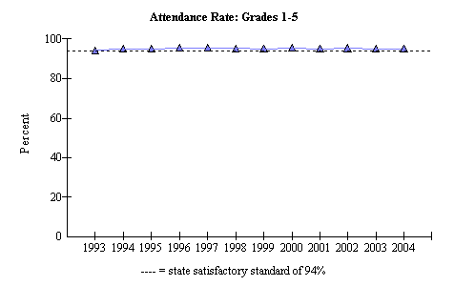
Figure 4. 1993-2004 Attendance Rate for grades 1-5 at Woodlin Elementary School

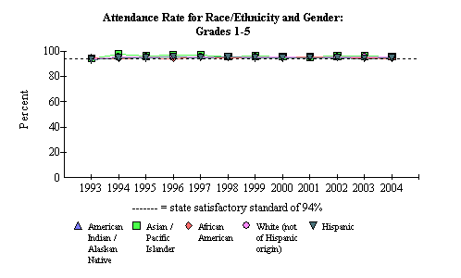
Figure 5: 1993- 2004 Attendance rate for race/ethnicity and gender at Woodlin Elementary School

Figure 6 and Figure 7, indicate there are three different levels of proficiency set by the state. These levels are Basic, Proficient, and Advanced,” (MSDE, 2004).
As shown in Figure 6, 2004 Adequate Yearly Progress (AYP) for 3rd grade Woodlin Elementary students indicates an increase in proficient level of students from 50% to 52.1% from 2003 to 2004. Two other areas of achievement can be seen: advanced readers increasing from 12.9% to 26.0%, a 14% increase and a decrease of 16% of students reading at the basic level.
Figure 7,indicates the Maryland State Assessments (MSA) proficiency levels in mathematics for the 3rd grade during the 2003 and 2004 school year at Woodlin Elementary School. The mathematics proficiency level data differs slightly from the previous Reading proficiency level results. There are more students who are in advanced level of mathematics in 2004. In 2003, 21.4% of the third grade class were assessed at the advanced proficiency level in mathematics. But in 2004, the number increased to 31.9%, about a 10% increase. But at the proficient level, the numbers dropped 12% between 2003 and 2004. In 2003 22.9% were at a basic level and in one year it increased to 25%. The basic level increased about 3%.
Figure 6, MSA Proficiency levels for 3rd grade reading in 2003 and 2004.
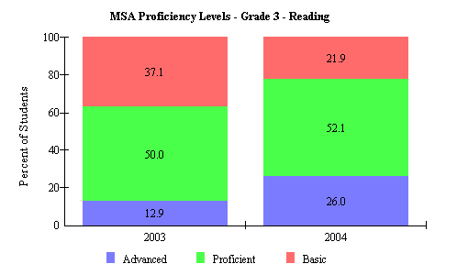
Figure 6: MSA Proficiency level for 3rd grade reading in 2003 and 2004 at Woodlin Elementary.

In 5th grade reading, there are more advanced proficiency readers. There was an increase in the number of advanced proficiency readers between 2003 and 2004 (43%). The proficient readers increased from 20.9% to 34.9%. The basic readers declined from 25.5% to 21.7%.
The 5th grade mathematics proficiency level results are quite different. The advanced readers declined by 1%. In 2003, there were 22.3% advanced readers and in 2004 there were 21.7%. The proficient students increased by about 10%. In 2003, there were 43.6% student proficient in mathematics and in 2004 it increased to 54.2%.

Year
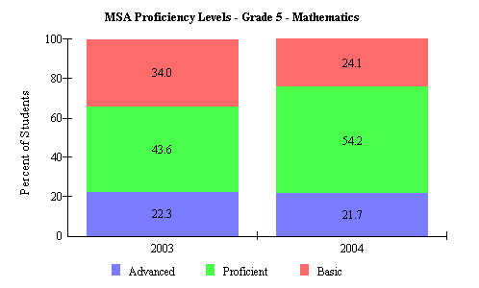
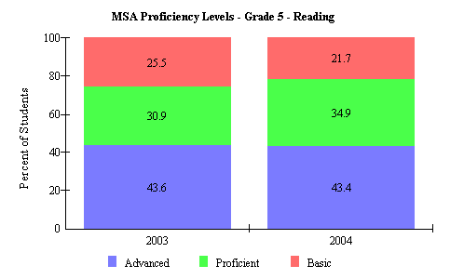
Figure 7: MSA Proficiency Level for 5th grade mathematics in 2003 and 2004 at Woodlin Elementary.
Percent

Figure 8: MSA Proficiency Level for 5th grade reading in 2003 and 2004 at Woodlin Elementary.

Montgomery County (LEA:15) Woodlin Elementary (ID:0764)

 | 2004 AYP: |  | Met
 | Hide Trends |  |  | All indicators must be "Met" to make AYP. For details, click on the links below.
 |  |  |  | Percent Proficient |  |  |  |  |  | Participation Rate
 |  |  |  | Reading |  | Mathematics |  |  |  | Reading |  | Mathematics |  |  |  | Attendance
 | All Students |  |  | 03 | 04 |  | 03 | 04 |  | 03 | 04 |  | 03 | 04 |  | 03 | 04
 | American Indian/ Alaskan Native |  |  | 03 | 04 |  | 03 | 04 |  | 03 | 04 |  | 03 | 04
 | Asian/Pacific Islander |  |  | 03 | 04 |  | 03 | 04 |  | 03 | 04 |  | 03 | 04
 | African American |  |  | 03 | 04 |  | 03 | 04 |  | 03 | 04 |  | 03 | 04
 | White (not of Hispanic origin) |  |  | 03 | 04 |  | 03 | 04 |  | 03 | 04 |  | 03 | 04
 | Hispanic |  |  | 03 | 04 |  | 03 | 04 |  | 03 | 04 |  | 03 | 04
 | Free/Reduced Meals |  |  | 03 | 04 |  | 03 | 04 |  | 03 | 04 |  | 03 | 04
 | Special Education |  |  | 03 | 04 |  | 03 | 04 |  | 03 | 04 |  | 03 | 04
 | Limited English Proficient |  |  | 03 | 04 |  | 03 | 04 |  | 03 | 04 |  | 03 | 04
Figure 9: The 2004 Adequate Yearly Progress performance for Woodlin Elementary School.
The 2004 AYP (Adequate Yearly Progress) performance shown Figure 9, indicates that Woodlin met AYP in all categories, except Special Education, which failed to meet the reading goal.

Areas of Needed Program Enhancement
Overall, Woodlin is working hard to serve their diverse students. Although there are areas in need of improvement. The 2004 Adequate Yearly Progress (AYP) as shown in Figure 9, shows that reading and mathematics scores were met by all sub-groups except special education. According to the MSA results for special education students, in 3rd grade, 90.9% of special education students read at a basic level of proficiency. Only 9.1% of special education students are proficient readers. There are no special education students who are advanced readers. These numbers are quite shocking. 30.6% of the 3rd graders, who are receiving regular education, are advanced readers, and 59.7% are proficient readers. Woodlin Elementary School needs to improve the reading instruction for the special education program. Woodlin needs to work on making sure that the AYP special education reading instruction in 2005 is met.
Woodlin provides excellent technology materials but the teacher lack the knowledge of technology skills. As stated above, only 50% of the teachers actually integrate technology in the classroom. The school should focus on additional technology training for the staff. If the teachers at the school have adequate knowledge about technology, they are more willing to integrate technology in the classroom. The students will then be able to experience technology in the classroom.
If Woodlin Elementary School improved the special education reading instruction and provided the staff with technology training, the school would be able to provide a better education.

Works Cited

American FactFinder—Fact Sheet: Silver Spring, Maryland. http://factfinder.census.gov/ (October 29, 2004).

2004 Maryland Report Card: Montgomery County-Woodlin Elementary. http://mdreportcard.org/aypintro.asp?K=150764 (October 29, 2004).

MSA Proficiency Data for 2003 – 2004 Montgomery County Elementary Schools: Woodlin Elementary. http://www.mcps.k12.md.us (October 29, 2004).

Woodlin Elementary 2002-2003: 2003 Maryland School Assessment Results. http://www.mcps.k12.md.us/departments/sharedaccountability/mspp/fy2003/schools/02764.pdf (October 29, 2004).

Woodlin Elementary School - #764: Schools at a Glance. http://www.mcps.k12.md.us/departments/regulatoryaccountability/glance/fy2004/schools/02764.pdf (October 29, 2004)

Woodlin Elementary Technology Inventory Summary Report. http://reports0304.md.ontargetus.com/SchoolSum.asp?otid=15x0764&accDesc= Woodlin+Elementary (October 29, 2004)

