The Rock Cycle Race  Gulcin Cirik  Dave Comstock  Amy Pastor  Elaine Winfrey | 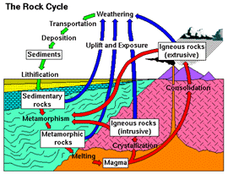

| Instructional Objective | Learners & Context | Object of Game | Game Materials |
| Time Required | Rules | Design Process | References |

Instructional Objective
Learners will be able to identify a variety of factors and processes pertaining to rock formation, rock types, and the rock cycle. The overall instructional goal of The Rock Cycle Race is to provide practice and reinforcement for sixth-grade science students regarding this instructional objective.
State curriculum frameworks focus on teaching Earth Science at the sixth-grade level. The learning standards established for sixth-grade students include developing an understanding of the earth's structure as well as the processes that shape the earth.
The Rock Cycle Race supports these standards. Students play this game by following paths that replicate the processes of the rock cycle. Students advance on the board by successfully answering questions designed to test and reinforce their understanding of these processes and the rock types created from these processes.

Learners & Context of Use
The game targets middle-school students taking integrated physical science which includes a unit on Earth materials, specifically rocks and the rock cycle. Generally, students will have had little prior knowledge regarding rocks and the rock cycle.
The game is designed to be played in a middle-school science classroom. Few accommodations are needed to play The Rock Cycle Race. Table or floor space is needed to set up and play the game. The game can be played once during a 50 minute middle-school class period by three players, or by six players with three teams of two students. Students will need approximately five minutes to set up the board and five minutes to clean up with actual play time lasting between 30 and 35 minutes.

Object of the Game
The Rock Cycle Race is a race board game in which players move along the path of the rock cycle. All players begin at "Start" and the first to reach "Finish" wins the game. The playing path is divided into board spaces that provide players with a choice in the direction of the path taken as well as shortcuts and obstacles.
Players advance along the board by correctly answering question cards. Each question card has two levels of questions-"Rock Questions" and the more difficult "Boulder Questions". The Boulder level questions allow players to advance more board spaces. Before the question is read, the player chooses the level of question she/he will try to answer.

Game Materials
Inside the game box, you will find the following objects
- Rock Playing Pieces
- The Playing Board
- 3 Sets of Question Cards: Igneous, Sedimentary, and Metamorphic
- A 30-Second Timer
- A Die
The Playing Board
The path for The Rock Cycle Race board is divided into three colors corresponding to the three rock categories - igneous is red, sedimentary is blue, and metamorphic is green.
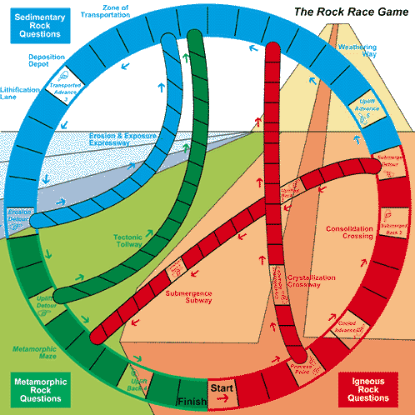
Question Cards
There are also three types of question cards corresponding to the three kinds of rocks - igneous, sedimentary, and metamorphic. The three types of cards use the same color plan as the board path. Players answer questions that match the path section they are in. For example, if a player is in the Metamorphic section (green) they answer questions from the Metamorphic Rock Question cards (also green).
Each card contains two questions: a "Rock Question" (an easy level) and a "Boulder Question," (a more difficult level). The "Rock Question" allows the player to advance 1 to 3 spaces if answered correctly. The "Boulder Question" allows the player to advance 4 to 5 spaces. If the player answers the question incorrectly, she/he will be penalized by the same number of spaces she/he would have been rewarded.
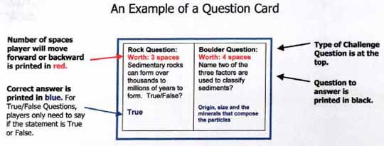

Time Required
A typical game can be played once during a 50 minute middle-school class period by three players, or alternatively, six players with three teams of two players. Students will need approximately five minutes to set up the board and five minutes to clean up. Actual play will last 30 to 35 minutes.

The Rules
Set up
Open the board and place the three types of question cards, Igneous, Sedimentary, and Metamorphic, face down on the designated areas on the board.
Play
- Each player selects a rock as a playing piece and places their rock on "Start."
- Each player rolls the die. The player with highest number goes first. The student to her/his right is the Question Reader who draws from the matching question card pile and reads the question. For example, play begins in the red, Igneous Rock section, and so the Question Reader draws the top card from the Igneous Rock Questions. The third student is the Timekeeper and turns on the 30 second timer. With each turn, these roles shift to the right.
- Before the Question Reader reads the question and the number of spaces each is worth, the Player must pick which type of question to answer: either a "Rock Question" (easy level) or a "Boulder Question" (more difficult level). If answered correctly, a "Rock Question" will allow the Player to advance forward up to 3 spaces. A "Boulder Question" will allow the Player to advance 4 or 5 spaces.
- Once the question and its worth are read, the Timekeeper turns the hour-glass timer. When time has run, she/he out calls "Time". At that point, the Player must give her/his final answer. The Question Reader will see the correct answer on the card and will verify if the answer is correct.
- If the Player answers correctly before time runs out, she/he advances the number of board spaces stated on the card. If the Player answers incorrectly, she/he moves backwards the number of spaces stated on the card. No one can move backwards further than the Start space.
- Next, the Player to the right takes her/his turn. The Question Reader and the Timekeeper roles also shift to the right.
Rules
- The object of the game is to reach "Finish" and the first player to do so wins the game. Players do NOT need to have the exact number of spaces. For example, if the Player is only 3 spaces from finish and correctly answers a Boulder Question worth 5 spaces, then she/he can advance to "Finish" and wins the game.
- Each player attempts only one question per turn.
- The Question Reader draws cards from the top of the question pile and returns to the bottom of the question pile.
- If the Player lands on a space with directions, she/he completes those directions before the next person takes her/his turn. For example, if the Player lands on the board space that says, " Cooled Advance 3" then she/he moves her/his rock piece 3 spaces forward on the board before the next person's turn. This applies with forward movement and backward movement.
- For True/False questions, players only need to say if the statement is True or False. When false, the card states the correct answer which is read by the Question Reader.
- If players land on a Detour space, they must take that path. For example, landing on the "Submerge Detour" forces the Player to proceed along the Submergence Subway.
- At "Process Point", players can move in either direction.
- Where "Submergence Subway" and "Crystallization Crossway" intersect, players must stay on their current path and may not cross over to another path.
Variations
We designed the game to accommodate various numbers of players and types of students.
- To include more students, the game can be play with three teams of two students.
- To accommodate for Special Education, ESL, and other student at different ability levels:
  - All players can play at the Boulder level.
  - All players can play at the Rock Question level. Players would keep playing until they answer incorrectly and then they lose their turn.
- To enable play of the game by the whole class, the teacher can take the role of the Question Reader and Timekeeper. Students can be divided into three very large teams. The board can be posted on the wall or chalk board.

Design Process
Ellington, Addinall, and Percival (1982) discuss the 'snakes and ladders' class of board games and points to The Great Blood Race as a good example of a game that teaches students about the human circulatory system. It occurred to us that such a format could easily support the learning of systems, processes, and cycles found in science. We decided to focus on the rock cycle since one of our team members had a background in earth science and could serve as a subject matter expert.
We gathered background information on the game's content through both web searches and using grade-appropriate text books used in local San Diego schools. The game board was based on an image we found at http://duke.usask.ca/~reeves/prog/geoe118/geoe118.011.html. We also contacted an earth science teacher to review the questions for content and appropriateness. To determine the conduct of the play, we held brainstorming and play trial sessions.
Initially, we intended for players to use a spinner to determine the level of difficulty for each question. However, we soon realized that this was contrary to the literature regarding motivational theory. Keller & Suzuki (1988) point out that one element critical to motivating students is their confidence. Although there are many dimensions to confidence, they state that three of the most important are perceived competence, perceived control, and expectancy for success. Allowing players to select the difficulty of each question supports these dimensions, particularly the latter two. In addition, allowing players to choose levels of questions, and consequently the number of spaces they can move, increases the risk factor for players. Players must strategize. Also, by basing the movement of their pieces on questions about the rock cycle, players are encouraged/motivated to increase their knowledge of the rock cycle in order to win.

References
Books & Journals
Abruscato, J. (1986). Holt science. New York: Reinhart and Winston Publishers.
Blaustein, D., Butler, L., Hixson, B. & Matthias, W. (1999). Glencoe science: An introduction to the life, earth, and physical sciences. Woodland Hills, CA: Glencoe/McGraw-Hill.
Carlson, G. R. (1990). The catalyst collection: outstanding earth/space science activities. Fullerton, CA: The National Science Foundation.
- Ellington, H., Addinall, E., & Percival, F. (1982). A handbook of game design. London: Kogan Page.
Feather, Jr., R. M. & Snyder, S. L. (1997). Glencoe earth science (Teacher wraparound ed.). New York: Glencoe/McGraw-Hill.
Keller, J. M., & Suzuki, K. (1988). Use of the ARCS motivation model in courseware design. In D. H. Jonassen (Ed.). Instructional designs for microcomputer courseware. Hillsdale, NJ: Lawrence Erlbaum.
Electronic
http://www-internal.sandi.net/standards/HTML/SciK12.html
http://duke.usask.ca/~reeves/prog/geoe118/geoe118.011.html
http://volcano.und.nodak.edu/vwdocs/vwlessons/lessons/lesson.html

