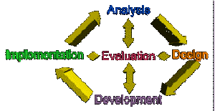
ADDIE

The ID Board Game
by Dallas, William, and Josh
All three of these guys serve some purpose, although at times that purpose is unclear. If you can figure it out, please contact them as soon as possible.

Instructional Objective
The game is designed to give players practice with key concepts and terms about the ADDIE model. Players also learn the components of the model itself as they play and become familiar with what occurs at each phase of the instructional design process.

Learners/Context
The learners are students or professionals studying instructional system design. Players should already have an introduction to the ISD or ADDIE model before they play the game.
The game is designed to be played during class as an exercise to stimulate thinking about the parts of the ADDIE model. Students can also use the game as a review outside of class time.

Rationale
A game is an appropriate format to expose learners to some ADDIE concepts. The ADDIE model is a process, which is analogous to a game in which the players move along a board through each phase of the ADDIE model. Another compelling, yet less structural reason, is that instructional design is often taught in a serious manner. A game may serve to "lighten up the mood" for the new learners and add another type of interaction to their studies.

Rules
Two to four people may play at the same time. Players go through each phase of the instructional design process in order to complete an educational project for a client. As players go around the board, players must answer questions about each phase of the ADDIE model. The first player to collect 5 tokens, on for each phase of the process, wins.
ADDIE can also be played as a case based / role playing game. To play this way, the instructor substitutes their own questions based on a case scenario for each segment of ADDIE . Players then assume the role of a consultant and answer the context based questions in order to make progress in the game.
Here's how to play ADDIE:
To Begin
- Each player chooses a playing piece and places a game piece on the Kick Off Meeting Space
- Each players rolls the die. The player with highest roll gets to go first
- Play continues to next player clockwise from the first player
To Play
- Players begin their turn by rolling the die. After rolling the die, players place their playing piece on the Start space and move the playing piece clockwise the number of spaces indicated on the die.
- When the player lands on a space, they must answer a question or perform an action.
- As a player moves through the first phase, Analyze, they must collect a "A" token before moving out of the Analyze phase. The player must circle the Analyze phase until they are able to collect a token. After collecting a token, they may move on to the next phase.
- Play stops only when a question has been answered incorrectly or the player's token lands upon a STOP space.
- Play continues until one player manages to collect all five tokens.

Board Game Design
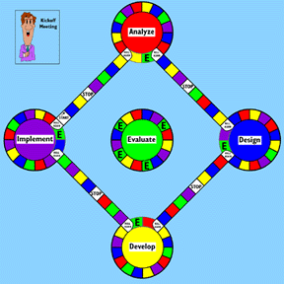
ADDIE is structured like the model. The board has 5 main circles which represent each phase of the ISD model.
The main circles are connected by pathways or ladders which have colored spaces. Each color corresponds to a particular phase of ADDIE, so when a player lands on the square, they must answer a corresponding question.

A complete game includes:
- Game board
- One six-sided die
- Four playing pieces
- Twenty A D D I E tokens (one set for each player)
- Five sets of question cards

Design Process
We started the design process by laughing a lot and calling each other stupid which, of course, is remarkably similar to how we start every other project we do. After we drank sufficient caffeine, we brainstormed about different games we could make. After we landed on the ADDIE model, we all thought this idea had some merit. Why? Because the structure of the process reminded us of a game. It seemed logical that someone would move from phase to phase along a board. The content could be mapped onto a board pretty easily. It was, also, by far the dorkiest idea we came up with, which was no doubt the deciding factor.
After meeting at Dallas' house and eating too much pizza, we got down to work. The basic design was not too difficult to come up with. The thorniest problem seemed to be the questions... there is plenty in the Sally Gordon text and Dr. Rossett's "Training Needs Assessment" for Analyze phase questions. But, how would we come up with enough questions for Develop or Implement? The answer is, for now, that we don't need to. But, if we were to market this game, scenario based cards instead of generic cards make more sense.Scenarios would supply a context for the players in which to role play and answer more open-ended questions.

References
Gordon, S.E. (1994). Systematic training program design: maximizing effectiveness and minimizing liability. Englewood Cliffs, NJ: Prentice Hall.
Rothwell, W.J. & Kazanas, H.C. (1992). Mastering the instructional design process : a systematic approach. San Francisco, CA: Jossey - Bass.
Rossett, A. (1987) Training needs assessment. Englewood Cliffs, NJ: Prentice Hall.

