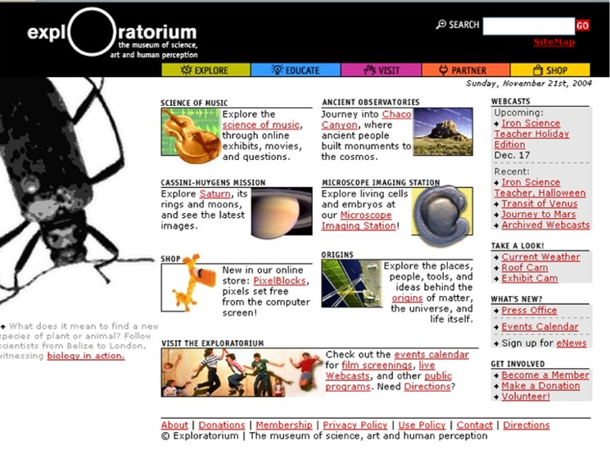
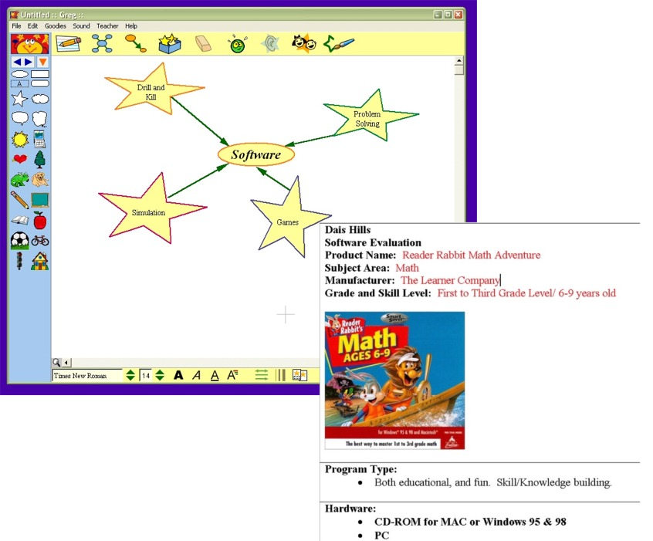
Spring 2006

IT in the Classroom Setting

EDUC 478/698I

Thursday 7:00 PM

Delivered Online: WebCT

This course is designed to introduce students to the strategies, resources, tools and organizational concepts for using technology to facilitate classroom learning and school administrative functions.
Specifically designed to cover all 7 Maryland Teacher Technology Standards (MTTS)
Throughout the course, a hands-on, learner-centered approach will enhance student ability to explore and contribute to best practices in the use AND the infusion of technology to enhance student learning and motivation to learn.
Previous Student Comments
I really enjoyed the course and would love to take another class under your instruction.
I thought the class was overall very informative. I learned about the many different aspects that were associated with technology and education. I thought the thing that I enjoyed the most was the TappedIn experience. I also enjoyed learning about other perspectives in the class regarding discussion topics. I now have a more well-rounded knowledge of technology in the classroom.
This course was VERY interesting and FUN. I was able to learn about resources I had never known to exist. I was able to interact with other students and learn at the same time as other about this whole other field of unknown information. Overall, an excellent course to take, to learn from, and to remember. I highly recommend to other students.
For more about the course: syllabus, standards met, past products, course outline visit: http://www.edtechoutreach.umd.edu/CourseInfo/educ478IT.html

