Using Microsoft Office to Create Interactive Learning Materials

Microsoft Excel

Part One: Excel Fundamentals………………………………………………………………………3
The Interface 3
Performing Simple Calculations 3
Using Simple Functions and Cell Ranges 4
The sum() Function 4
The average() Function………………………………………………………………………………………5
The count() Function 5
The Gentle Art of Cell Formatting 5
Alignment 6
Font 6
Border 6
Patterns 7
Protection 8
Using Form Controls – An Introduction 8

Part Two: Creating a Simple Quiz 10
The Purpose 10
The Exercise 10
Setting Up 10
Adding Drop-Down Boxes and Input Ranges 12
Question 1 14
Question 3 14
Question 4 14
Question 5 14
Question 6 14
Question 7 14
Question 8 14
Question 9 14
Question 10 14
Working with IF Statements 14
Calculating the Final Score 15
Adding a Macro and Calculate Button 15
Locking and Securing the Worksheet 19

Part Three: Using Excel to Create Statistical and Mathematical Exercise 21
The Purpose 21
Setting Up 21
Creating Graphs 22
Adding Slider Controls 24
Finishing Up 25

Part One: Excel Fundamentals

The Interface

Excel’s toolbars and menus follow a fairly standard format and share common features with many of Microsoft’s other products.

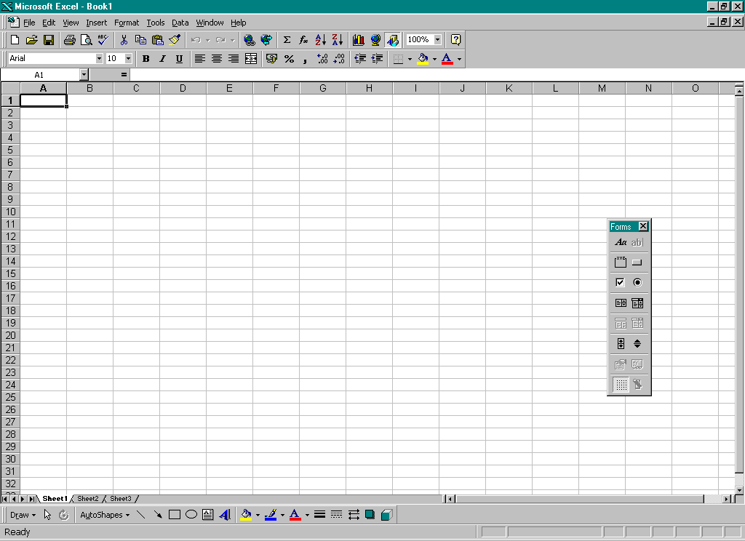

Towards the top of the window is the fairly standard array of toolbars and menus, many of which are specific to Excel itself.

An Excel worksheet is split into cells. Each cell can be referenced using the grid present within Excel itself. Using a combination of the column (represented by a letter) and the row (represented by a number) you can quickly reference any cell using a simple notation such as A1, B16, C24. When you later move onto working with calculations and formulae you’ll be using cell references a lot.

Performing Simple Calculations

One of the biggest advantages Excel has over a standard table in Word is its ability to perform calculations. These can range from simple formulae like adding the value of two cells together, ranging through to complex IF, THEN, ELSE style statements and statistical calculations.

Take a look first at the most simple of Excel calculations: addition.

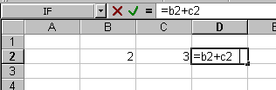

In the example above, the formula provided in the highlighted cell will add together the values of cells B2 and C2. Notice how the calculation was preceded with the = sign. The = sign tells Excel that the cell is going to contain some form of calculation. Without this, it would simply display b2+c2 as text.

The biggest advantage here is that D2 will always contain the sum of B2 and C2. If later you update B2 to (say) 5, the value of D2 would automatically change to 8 to represent this change.

Alongside addition this simple calculation format can also be used for:

- Subtraction ( - )
- Multiplication ( * )
- Division ( / )

Using Simple Functions and Cell Ranges

Functions are built into Excel to make routine every day calculations, and mathematical and statistical exercises easier. This section covers using functions to perform routine tasks, lists a few of the more common ones and also demonstrates the use of cell ranges for working with multiple values.

The sum() Function

First of all look at the sum() function.

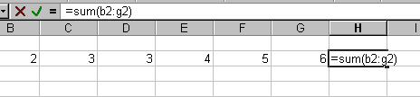

Notice how the format changes. First comes the familiar = sign, telling Excel this cell will contain a calculation or formula of some sort.

=sum(b2:g2)

‘sum’ is the name of the function; the brackets contain the arguments, in this case the cell range. Read the colon ( : ) as the word ‘to’. Basically the software is being asked to sum up all the values from cell B2 to cell G2.

The average() Function

Average() works in almost exactly the same as sum()except that, instead of totalling up a range of values, it provides the mean average of them.

The syntax for this function is:

=average(b2:g2)

You’ll find this function very useful when preparing online quizzes or similar tests as it will enable you to provide average scores for answers and results.

The count() Function

Count() is used for adding up every instance of a value in a series of cells. Take the diagram below as an example.

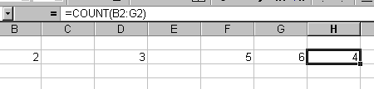

You can see in the example that 4 cells in the range specified have values in them, so the value returned from the count function is 4.

This simple function has many practical uses, for example keeping a tally of correct answers for a quiz or totalling up the number of questions a student has answered.

The Gentle Art of Cell Formatting

To access the Cell Formatting screen, simple select any cell or group of cells, right click and choose Format Cells from the pop up menu. The cell formatting screen has a number of purposes and below the function of each individual tab is examined .

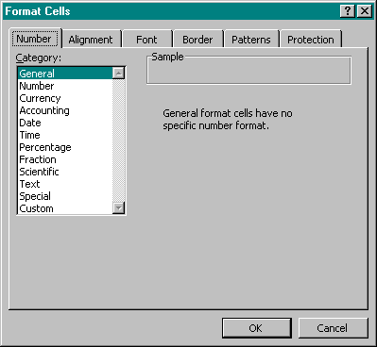
This screen allows you to select an appropriate number format for the contents of your cell, providing of course that it contains a number.

You can use these controls to perform such tasks as adding decimal places to the number in a cell, setting a currency value or working with time and dates.

Alignment

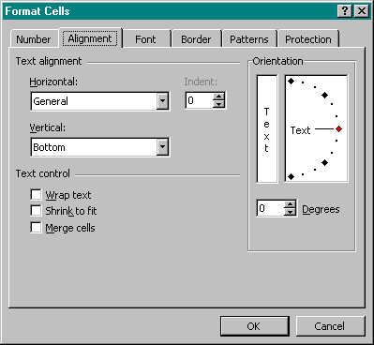
Horizontal and Vertical alignment settings
These controls allow you to create text at any angle, which is ideal for diagonal column headings.
Wrapping and Merging Controls

Font

The font tab offers the standard font formatting controls present in all Microsoft applications. For a detailed reference to this panel, please see the Font Formatting section in the Word manual.

Border

The border tab allows you to control the look of the border of the cells you currently have selected. The tab looks like this:

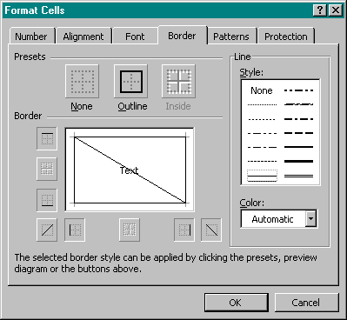
Preview and customisation controls.
Border presets.
Line style controls
Border colour setting.

Patterns

Patterns is used for controlling the shading or fill of a cell.

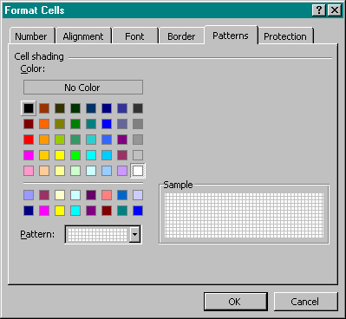
Choose your desired colour from the selection on the left. Then, using the drop down box below, it’s possible to select a pattern for the cells.

Protection

The protection tab only really comes into play when locking worksheets or creating secure applications.

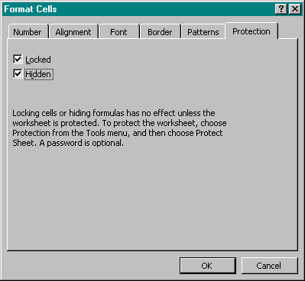

Locking (or unlocking) cells on a protected worksheet allows you to define areas where the user is able to enter information. This is particularly useful for the creation of online forms or quiz type worksheets.

Using Form Controls – An Introduction

As you take Excel further and begin to create wholly independent learning applications, as opposed to just using Excel as a spreadsheet , you’ll find yourself quickly needing to investigate and use form controls.

To begin with, if you can’t already see it, select View > Toolbars > Forms to make the forms toolbar visible.

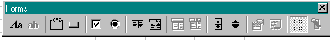

Above you can see the forms toolbar. Examine the icons from left to right.

- Label is just that - a quick way of adding a wholly transparent floating text box to a form.

- Edit Box, when available, allows you to enter a text field which the user can type into. This option isn’t used very often as a spreadsheet cell can effectively serve the same purpose.

- Group Box allows you to group two or more controls together. For example this is used to tell Excel that certain radio buttons or check boxes are options for the same question etc.

- Button is just that. One of the most common uses of buttons is as controls. By assigning macros to buttons we are able to add a lot of functionality into Excel. A macro is a saved sequence of commands or keyboard strokes that can be stored and then recalled with a single command or keyboard stroke. The example at the end of this manual uses a button to reset and calculate the score on the quiz.

- Check Box also does just that. Adding a check box allows the user to tick / untick a control providing you with a TRUE or FALSE in a cell of your choice.

- Radio Buttons work in a very similar way to checkboxes, the difference being that they work in groups and not on their own and, instead of returning a TRUE/FALSE value in the cell you specify, the group will return a numbered value which was dependent on which option was selected. This is very similar to the drop down box control looked at later.

- List Boxes present a scrolling list of items in a very similar way to a drop down box. As with the drop down box you need to provide a cell reference for the output value (a number representing the option that’s selected) and an input range (a range of cells that contain the options the list box will contain). The key advantage of a list box over a drop down box is that it’s possible to select more than one item by holding the CTRL key and clicking on the options.

- Drop Down Boxes are covered in detail in the section entitled “Adding Drop-Down Boxes and Input Ranges”, within the exercise at the end of this manual.
The next two icons are used for editing and customising List Boxes and Drop Down Boxes once they’re added to your worksheet.

- Scroll Bars are ideal for questions or options that can have a lot of different numerical values. Imagine a question that could have any answer between 1 and 100 - the easiest option would be to create a scroll-bar, with a minimum value of 1 and maximum of 100 that is incremented in steps of 1. A scrollbar also has a cell link attached to the control. This cell’s value will update to reflect the current state of the scrollbar.

- A Spinner works in a similar way to a Scrollbar but instead of scrolling the user can move the value of the linked cell up and down in increments using the up and down arrows provided.

- Control Properties is used to access quickly the properties for any form control in your workbook.

- Every form control has Visual Basic code underlying it that controls how it works and what it does. Edit Code is a shortcut to access the code for a particular form control.

- Toggle Grid can be used to switch on or off the gridlines which surround the spreadsheet’s cells.

The Excel Help facility gives a detailed description of all of Excel’s form controls and how they can be used in conjunction with macros to create fully functional learning applications.

Part Two: Creating a Simple Quiz

The Purpose

This exercise will allow you to create a simple quiz using a series of drop down boxes on an Excel Spreadsheet. The user will have to select what they believe to be the correct answer to each question, and then click on a button which will calculate their score as a percentage. All this will be housed in a wholly secure spreadsheet application which can be distributed as needed and adapted to suit any form of quiz or question set.

The aim is to create something like the following:

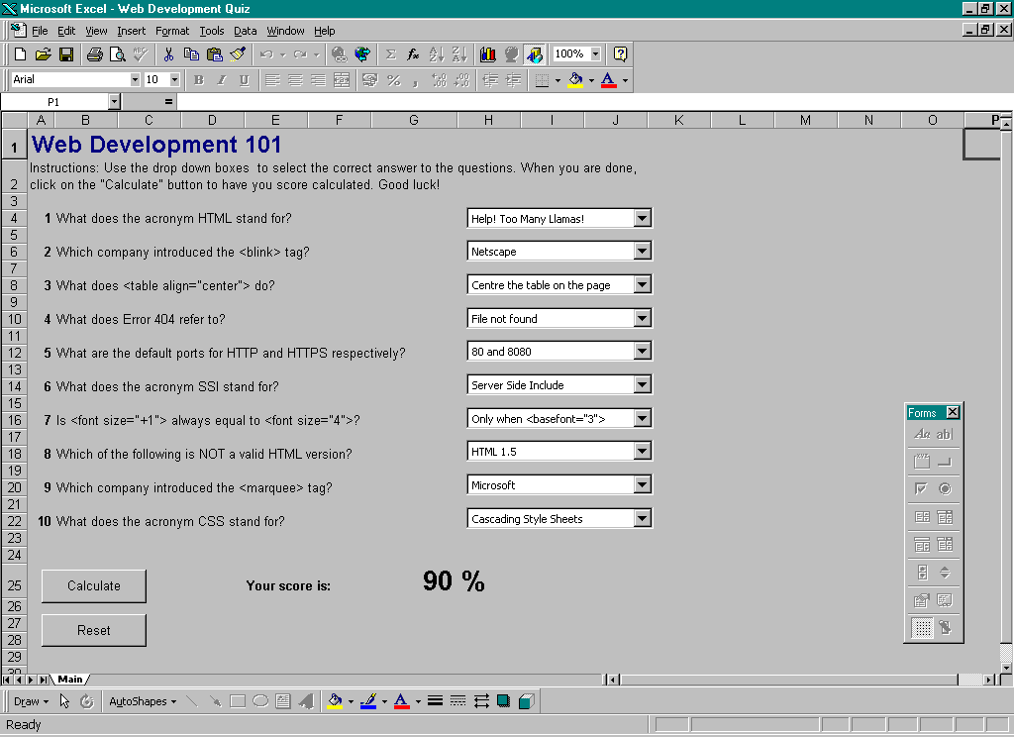

The Exercise

Setting Up

- First of all you need to create a new Excel spreadsheet by selecting File > New and creating a new workbook.

- The first step here is setting up the look and feel of the exercise. Ensuring Sheet 1 is selected, add a title to the exercise. You may also wish to add some instructions to the quiz as well, though you will learn how to do this using Tool Tips later on. The formatting and look of the title is a purely aesthetic choice and is up to you. The example here is titled Web Development 101.

- Next you need to add the questions. Again, this is just a case of entering text in the appropriate cells. Add the following questions to your exercise:

1. What does the acronym HTML stand for?

2. Which company introduced the <blink> tag?

3. What does <table align="center"> do?

4. What does Error 404 refer to?

5. What are the default ports for HTTP and HTTPS respectively?

6. What does the acronym SSI stand for?

7. Is <font size="+1"> always equal to <font size="4">?

8. Which of the following is NOT a valid HTML version?

9. Which company introduced the <marquee> tag?

10. What does the acronym CSS stand for?

Ensure these are well spaced out and easy to read. It’s also worth making sure your screen doesn’t scroll too much.

- Form Controls will be used a lot in this exercise, so it’s a good idea to have the forms toolbar showing at all times. To activate it (if you’ve not already done so) select View > Toolbars > Forms.

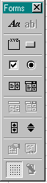 | The only form elements you’ll need in this exercise are the Button element and the Drop Down Box element. However it’s well worth finding your way around this toolbar for future reference as this is where you’ll insert and deal with a lot of, if not all the controlling elements of any Excel application.

Adding Drop-Down Boxes and Input Ranges

- Drop down boxes in Excel work slightly different than those in Word. There’s an example of adding one here, and you’ll then have to repeat this for each of the questions you've added onto your quiz.

- Select the Drop Down Box tool on the forms toolbar. You’ll need to draw out a drop-down box to the size you want. Don’t worry too much about the size here as you can always resize it later on.

- Once you’ve inserted the control, right click on it and select Format Control. You should see a window like the one below.

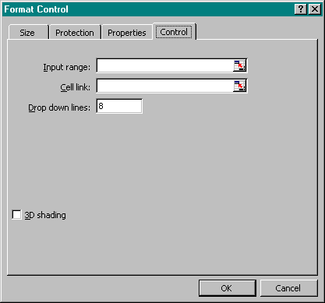
Input range asks you to specify the cells that control the menu options. By clicking on the small icon to the right of the text field you can select them by dragging over them.
3D shading is purely an aesthetic choice.
Drop down lines controls the number of lines seen at once when the box is dropped down.
Cell link asks you to specify the cell where the currently selected item will be reflected.

The example below willmake that clearer.

Question 1 asks What does the acronym HTML stand for?” so start with that. Sheet 2 is where you’ll be keeping the options for the questions and also the workings of the system. When you havefinished, you’ll be locking Sheet 2 and hiding it so everything is kept neatly out of the way. For now though, select it by using its tab on the bottom left of the screen

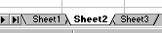

Next, you need to enter the options for the first question as below. Place each option in a separate cell below one-another.

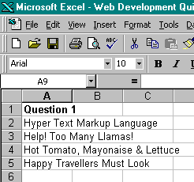
The Question 1 heading here serves no purpose within the exercise itself, it is merely for our reference and will tell us which question these options belong to.

You now need to return to Sheet 1 and go back into the control properties. Using the controls highlighted below, select the group of cells that contains the options for the drop-down. In the example above these are A2 to A5.

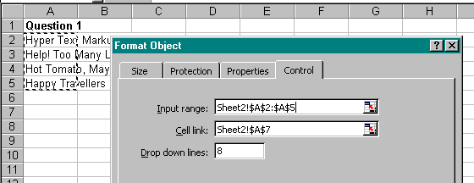

You should notice how it creates the Input Range for you based on what you’ve selected. Next fill in Cell link: again you should select a cell on sheet two which will contain the selected value. A7 on Sheet 2 is a good selection in this case. The Drop down lines option should be set to 4, as that is how many options you’re providing.

How does cell linking work?

You’ll find that the cell you’ve specified as the cell link will contain a number when you’ve pressed OK. The number represents the currently selected option from the list. For example, the number 1 in the example above would tell us that Option 1 (Hyper Text Mark-up Language) is currently selected in the drop down box on Sheet 1. You can then use an IF Statement to tell the user whether or not they’re right or wrong as shown later on.

- For now, repeat this process for all the other questions using the following options.

Question 1  Hyper-Text Mark-up Language*  Hot Tomato, Mustard and Lettuce  Happy Travellers Must Look  Help! Too Many Llamas!  Question 2  Netscape*  Microsoft  AOL  Macromedia  Question 3  Centre the table on the page*  Centre the contents of the table  Turn the table upside down  Centre the table's background  Question 4  Server not found  File not found*  Directory not found  Internet not found  Question 5  80 and 8080*  67 and 12  1 and 2  A and B | Question 6  Silly, Silly Sausage  Server Side Index  Server Side Include*  Severe Server Irritation  Question 7  Yes  No  Only when <basefont="3">*  Only when <basefont="5">  Question 8  HTML 2.0  HTML 1.5*  HTML 3.2  HTML 4  Question 9  Netscape  Microsoft*  AOL  Macromedia  Question 10  Centre for Systems Studies  Cascading Style Sheets*  Coloured Slipper Socks  Cascading Style Snippets

The correct answers are marked with an asterisk (*).

Working with IF Statements

- This is where the exercise starts to get a little bit complicated. Take the example below.

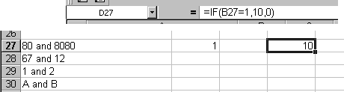

This is the layout for question 5. The cells in the first column represent the options for the question. The highlighted cell above containing the number 1 is the Cell link you specified earlier on. The number 1 shows that on the first sheet the first option in the drop-down is selection.

Look at the cell containing the number 10 That contains the IF statement you’re going to be using. The close-up of the formula bar above shows the code you need. Look at the IF statement in more detail:

IF(B27=1,10,0)

Because it’s a function, it needs to be contained in brackets. For example IF(arguments). All functions within Excel follow this format. Look at the arguments.

B27=1, = here you’re providing the criteria which Excel will evaluate before doing anything. In this example you’re saying that if cell B27 has a value of 1, do this, otherwise, do something else.

B27=1,10,0 = this completes the picture. If B27 contains the number 1, return a value of 10 (i.e. a correct answer), if not, return a value of 0 (a wrong answer).

Given the format of the IF statement above, see if you can repeat this process and create similar statements for the rest of your questions.

- Remember that the first number (in this case 1) represents the correct option in the drop-down field, so if option 4 was correct the IF statement would read IF(B27=4,10,1).

- Also worth considering is the value of 10 you’re using to signify a correct answer. There are 10 questions in this quiz, each one is worth 10% of the total score, so if the user gets it right you record a score of 10 (or 10% correct). It’s possible to weight some questions more heavily than others by altering the value returned for a correct answer and thus build up a more complex scoring system.

Calculating the Final Score

Because all your IF statements are in one column, you can use the SUM function to add them all up and present a final score. In the example, all the IF statements are in the D column, so you’d use the function:

SUM(D1:D45)

You should notice similarities between the SUM and IF functions. All Excel functions operate inside the same format.

This will keep a running total of the contents of the D column. Basically this means it’ll keep a running total of the user’s score as they alter the options on the front page.

Adding a Macro and Calculate Button

The quiz is almost complete. To summarise, you’ve added the question, built in a mechanism to return answers and added a formula to total up the user’s score and keep track of it. However, the user isn’t going to see the second worksheet with the options, formulae and total, so you’re going to add a calculate button to the first sheet which, when pressed, will return the user’s score based on what they’ve got selected in the drop down boxes.

The first hurdle you need to tackle is the fact that once you’ve secured this sheet and locked it, there’s no way you can copy and paste the result from the SUM function into the first sheet using a macro. So here’s what you do:

- On the first sheet, in an out of the way cell (for example Z1 or something similar) type an equals sign (=) . Now, before clicking away navigate your way to the cell on the second worksheet that contains the SUM formula you entered earlier. You should see the cell highlight with a dashed line as shown below.

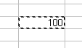

Press the Return key and you should now see that the value of the cell on the first worksheet matches the value of the cell on the second worksheet. This new cell will update automatically as the cell doing the SUMming changes. You can now leave the second worksheet alone.

Using the font formatting controls, change the colour of the text in your new cell so that it matches the background of the exercise and is invisible. This is so that the workings out can’t be seen by the user. When you lock the worksheets later on the workings will be completely secure as the user won’t be able to select them by clicking in the cell.

Look at the calculating and scoring section on the first sheet:

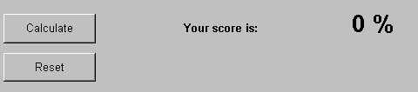

You’ll be reproducing this on the first sheet below the drop down question and answer boxes.

To add a button select the button icon on the Forms toolbar and drag one out to the required size.
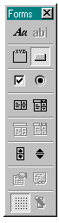 | Draw out two buttons. You can edit the name by clicking on the button itself and typing over the default name Excel has given it. Call one Calculate and the other Reset.  Your next step is recording two macros that will:  - “Calculate” the score by copying the value from your “secret” cell into the appropriate cell on the front sheet and…  - “Reset” the quick[???] by inserting a value of 0 in the appropriate cell on the front sheet.

Recording your Macros will be the next step:

By recording a macro you’re recording your actions and a series of steps that are needed to accomplish a task. Uses of macros are very varied. Some could be copying data from one sheet to another at the touch of a button, creating a graph or clearing a series of cells.

Before recording a macro you should plan in your head what you want to accomplish. The Record Macro tool records every action you take, so if you make a mistake you could end up having it recorded permanently.

Deal with the Reset macro first.

- Select Tools > Macro > Record New Macro. You should be presented with the screen below.

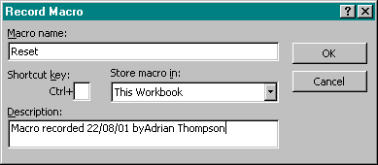

- Give the Macro a name. Here you’ve given it the original title of Reset. You can choose to store a macro in just one workbook as you’ll do here, or in Excel itself so that you can use it over and over again on different spreadsheets. Because your macro is only specific to this application you’ll leave the option as default.

- Description is purely a note for your own reference. Shortcut Key allows you to assign a short-cut key to the macro. These two fields are optional and not really needed for this exercise.

- Once everything is set up click on OK. You’re now ready to record your macro. First of all have a look at the new floating toolbar that should have appeared:

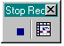 | Once you’ve done all the things your macro is going to do click the Stop Recording button as highlighted on the left. Your macro is now complete and ready to be assigned to a button.

- First of all record a macro which adds a value of 0 to the cell shown below (just by typing it over the top of whatever is in there).

In the example here, the % symbol is in a different cell to the number. This makes calculation easier as you’re dealing with whole numbers and not percentages.

- When your macro is recorded and you’ve saved it by clicking on Stop Recording… button you can assign it to a button. Right click on the Reset button and select Assign Macro from the pop-up menu.

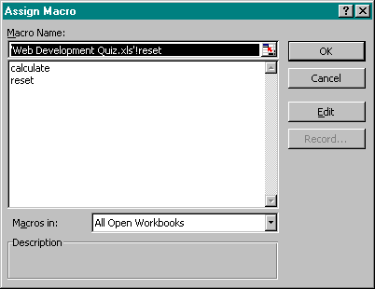
Simply select the appropriate macro from this list and click OK. This list will contain a list of all the macros available to you.

- That’s it. The macro will now execute when you click on the button.

- To finish off… remember the cell you created earlier with the invisible text that was a link to the second sheet? The one with the current score in it? You need to record another value that copies and pastes the value of that cell into the one that contains your result. Call this macro calculate. Remember to check your macros are working properly before you move onto the next step.

Locking and Securing Your Worksheet

So far you’ve created a question set, built mechanisms for answering them and allowed the user to retrieve a score based on how many correct answers they’ve accumulated.

The last step in this rather lengthy exercise is to lock the workbook, hide the sheet with the answers and IF statements and secure the file so that its inner workings can’t be tampered with.

First of all hide the sheet with the workings out by:

- Selecting the second sheet using the tabs at the bottom of the window.

- Select Format > Sheet > Hide. The sheet is now hidden and not easy to get back. Therefore it’s imperative that before you do this you make sure everything is working properly.

Lastly secure the worksheet so that the only thing the end user has access to is the form controls which you created – the drop down boxes and buttons. To do this:

- Select Tools > Protection > Protect Workbook… to bring up the following window.

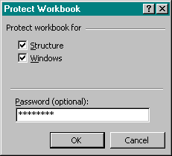

- Check both boxes and give the workbook a password. Protecting the workbook prevents anyone from altering the structure or viewing hidden worksheets without the correct password.

- Lastly protect your main Worksheet so its contents and structure cannot be altered. This time (making sure the first worksheet is selected) go to Tools > Protection > Protect Workbook…

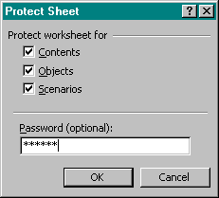

- Enter an appropriate password, again making sure all the boxes are checked.

Your simple quiz is now complete. Hopefully you can see how Excel form controls and advanced functions can be put to great use, and how Excel can be much more than a mathematical package.

The best way to proceed now is practice.

Part Three: Using Excel to Create Statistical and Mathematical Exercises

The Purpose

This exercise uses a combination of Excel’s form controls and graphical data representation tools to create an interactive version of the Supply and Demand model often taught in Business Studies programmes.

The exercise will look something like this.

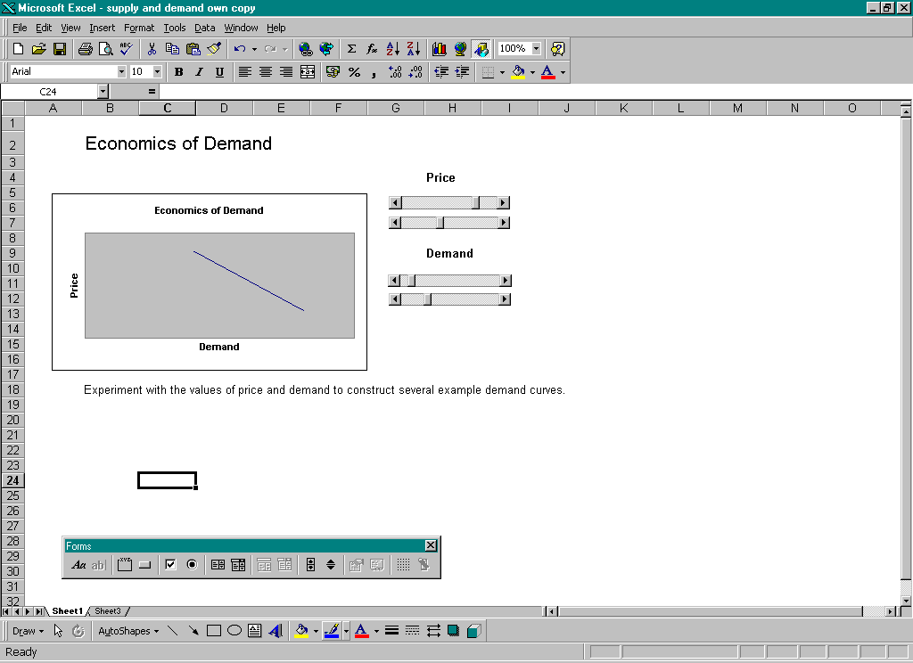

Setting Up

First you’ll need to create a new workbook for this exercise Your first step is creating a graph. Later you will add the form controls that can be used to manipulate this graph.

Sheet 2 is going to control all the working out for this exercise, while Sheet 1 contains the exercise front end and graph controls.

Take a look at the simple data used for this example.

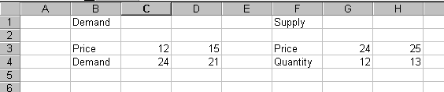

Because you’re only creating simple curves here, you need only two values for Price and two values for Demand / Quantity. This will allow you to mark two points on a scatter graph, and draw a simple line between them.

You’ll be using two graphs which you’ll be able to manipulate using form controls, one for Supply and one for Demand. You will use Excel’s graphing functions to create graphs.

Creating your Graphs

First of all, select the data you want to graph. You will be creating the demand graph first so the appropriate data is highlighted here. | 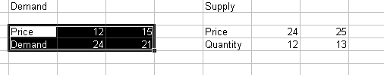

Now select Insert > Chart. You should be presented with the first step of the Insert Chart Wizard.

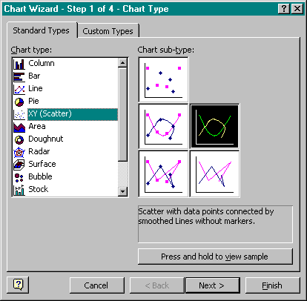 | Here you need to select the appropriate type of graph for your data. The type of graph needed for this exercise is a XY (Scatter) graph. You need to use the highlighted subtype for your graph. This is the Scatter with data points connected without markers subtype.

Selecting the chart data source is, in most cases not necessary as you selected the source data before entering the Chart Wizard. In this case, all you need do at this stage is click on Next >.  The next dialogue box is the Chart Options screen. This section of the wizard has 5 sub-sections; each one is optional but allows you to add further layers of customisation to your chart. | 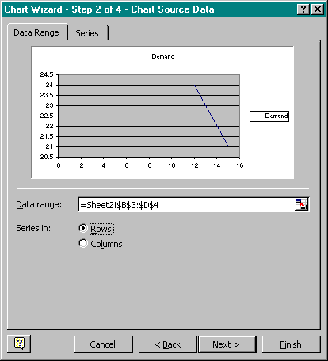

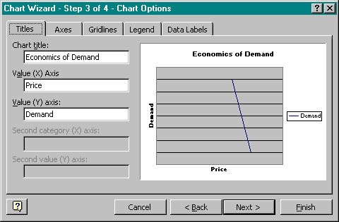 | Titles allows you to add labels to the axes of your chart. In the example, the X axis represents Demand and the Y axis represents Price.
In the Axes tab, you can remove the values for both the X and Y axis. You’re only demonstrating a principle here and exact numeric values aren’t too important. | 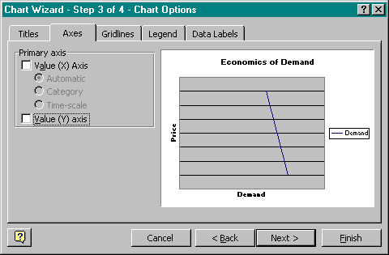
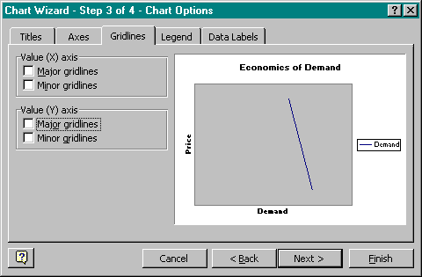 | The Gridlines tab provides control over the chart’s gridlines. You can add or remove major and minor gridlines on both the X and Y axis from here. They have been removed for this example as they’re not really necessary without values on the axes.
The Legend tab allows you to choose whether or not to include a legend with the graph. A legend is mainly used for pie or bar charts and is not really needed in this case, so you can uncheck Show legend. | 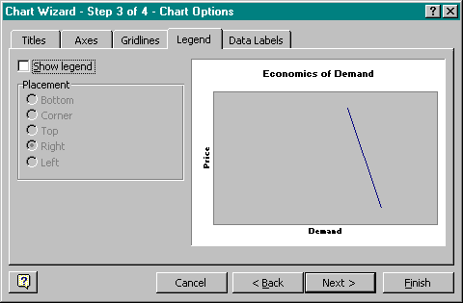
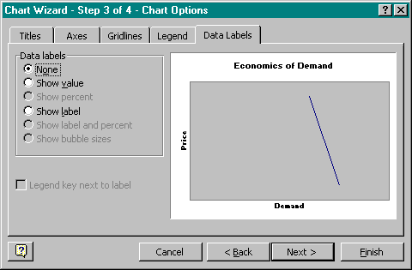 | The last option here is whether or not you wish to show Data Labels. A data label adds to a bar, pie slice or scatter mark by placing its numeric value next to it. In this case it’s not needed.

On clicking Next you should be presented with the fourth and final step of the wizard and select where the new chart is going to go. In this case you need it As an object in Sheet1. | 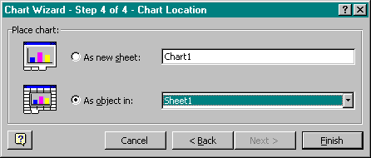

Your graph should now be present on Sheet1. At this stage it’s a good idea to resize your graph using the resizing handles around its edge. Remember you’ve got to fit two graphs, a number of form controls and some complimentary text on this sheet.

You’ll need to repeat this process later on to add your second graph, but for now concentrate on adding the controls for the graph.

Adding Slider Controls

So far you’ve created your graph using values that you’ve entered. What you’re going to do now is re-create those values, but instead of using plain numbers you’ll be using a slider form control so that users can manipulate them from the first sheet.

First off, make sure the Forms toolbar is visible by selecting View > Toolbars > Forms if you can’t already see it.

The scrollbar form control is the one you’ll be using and is highlighted above. Select the scrollbar tool and draw out a small scrollbar on your first sheet. Size and orientation aren’t too important for now as you can always change these later.
Once your scrollbar is inserted, right click on it and select Format Control from the pop up menu.  You should see the dialogue box to the right. Below is an explanation of what each of these controls does. | 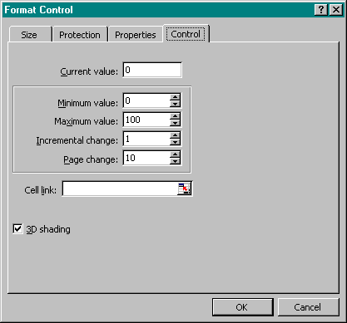

Current Value reflects the current state of the slider. This is an easy way of setting the starting value of the control.

Minimum Value is just that, the minimum value of the scrollbar.

Maximum Value is the maximum value the scrollbar will allow. These two values allow you to set boundaries for your chart and add a level of control to your simulation.

Incremental change reflects the value change for the scrollbar with each click of the arrows at either end of the scrollbar

Page change reflects the incremental value change as the mouse is held down over the scrollbar control.

Cell Link allows you to browse to a cell which will contain the numeric value of the scrollbar.

Click on the small icon to the right of the cell link field and then browse to Sheet2. You’ll need to the first Price value to begin with. You’re going to be using two sliders to control this curve. One will control the height of the curve and one the gradient. The highlighted cell below (ie the first column) controls gradient.

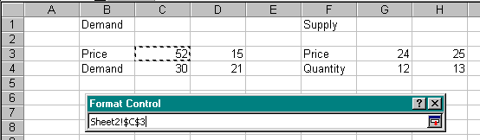

Once you’ve selected the correct cell, click on the icon highlighted above to return to the Format control window and click OK to confirm your choices.

Finishing Up

That’s your first slider added. You now need to repeat this process three more times. In the end you should have four scrollbar controls linked to the four cells highlighted above. You need:

- A height control for Price
- A gradient control for Price
- A height control for Demand
- A gradient control for Demand

Add a title and some sample questions to your chart. For example:

“What happens when price increases?” and “What factors can affect demand aside from price?”. If you wish you can use the question and answer model from the previous exercise to make these interactive.

The rest of the work on this sheet is purely aesthetic. One thing you may wish to do is hide the gridlines using the following control on the Forms toolbar.

You may also wish to make sheet2 hidden by selecting it, followed by Format > Sheet > Hide. You can also protect the workbook, making it totally secure by selecting Tools > Protection > Protect Workbook and entering a password twice. Protecting and securing workbooks and worksheets is covered in more detail in the previous exercise.

Creating more complex mathematical simulations requires a solid mathematical background, unlike this relatively simple example. Given the tools are your disposal it’s possible to create fully interactive mathematical simulations with advanced testing facilities. The possibilities are only limited by your imagination.

