From: http://ferl.becta.org.uk/display.cfm?resID=1591

Summary
Most computer users are familiar with at least the basic functions of Microsoft’s "Excel" spreadsheet program. However it is not generally appreciated that Excel can be employed for a variety of purposes beyond its basic functions as a spreadsheet.
The examples which follow are ones which have actually been used successfully in teaching Maths and Further Maths at A and AS level, including curriculum 2000 but I would hope that it would not be too difficult to envisage using similar techniques at any level.
Most computer users are familiar with at least the basic functions of Microsoft’s "Excel" spreadsheet program. However it is not generally appreciated that Excel can be employed for a variety of purposes beyond its basic functions as a spreadsheet.
The examples which follow are ones which have actually been used successfully in teaching Maths and Further Maths at A and AS level, including curriculum 2000 but I would hope that it would not be too difficult to envisage using similar techniques at any level.
Using Excel as a teaching tool has many advantages. These include the following:
- Excel is almost universally available and therefore avoids the need to purchase expensive software.
- Many staff will already be familiar with the program’s essential functions and the need for INSET will therefore be minimized.
- Most students following Advanced level courses will also be taking Key Skills in It and will therefore be able to use Excel for themselves in a mathematical context.
Excel is particularly useful for demonstrating numerical methods and iterative techniques and the first section of this case study gives several examples.
Using Excel in the classroom requires a PC linked to a device which will allow a roomful of students to view the screen output. At Shrewsbury Sixth Form College we have used both an OHP tablet linked to a laptop and a large screen monitor linked to a conventional PC. Both these methods give adequate results but we are currently attempting to acquire projectors which give a larger, clearer and brighter image and do not require partial or complete blackout. Interactive whiteboards would present an ideal solution but remain prohibitively expensive.

Numerical methods and iterative techniques.

Example 1: Simple iteration.
The spreadsheet below has been used to calculate the first ten terms of the iterative sequence x_{n+1} = x_{n} – x_{n}² for various values of x_{0.} The example shown uses a starting value for x₀ = 0.5. Any modern graphical calculator can achieve the same results with the use of the ANS function but executing the iteration on Excel has several advantages, namely:
- Results can be printed or copied and pasted into a Word document, particularly useful if the student wishes to incorporate the results into a piece of coursework.
- The chart wizard function in Excel can be used to create an x-y scatter diagram which graphically illustrates the behaviour of the iterative sequence, showing if it is diverging, converging or oscillating. The results can be shown on the same Excel worksheet. Achieving the same end result with most graphical calculators will involve programming and switching from one mode to another, thereby losing the benefits of a simultaneous display.
This technique lends itself to numerical techniques for obtaining solutions of equations, notably x = g(x) iteration and the Newton-Raphson method. It is particularly useful in the former case in illustrating that certain re-arrangements of f(x) = 0 into the form x = g(x) do not always produce an iterative formula which converges to a solution.
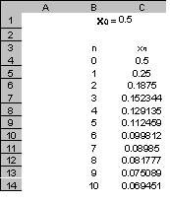
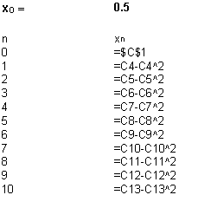
The table above shows the formulae used to produce the spreadsheet.
The next two example examine more sophisticated uses of the same basic idea.

Example 2: A step by step method for solving differential equations
This can be used in in two ways. The step length dx can be altered to demonstrate how a more accurate solution can be achieved at the expense of more calculation and a function which is easy to integrate algebraically can be used to determine the optimum step length required to get a result to a desired degree of accuracy. A pre-prepared spreadsheet can be used to provide a classroom discussion point or students can be taught the basic techniques traditionally and then be told to create their own spreadsheets, thereby enhancing their understanding of the iterative process.
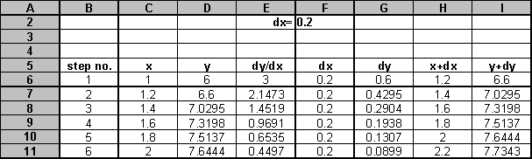
The following table shows the formulae used to produce the spreadsheet:
step no. | x | y | dy/dx | dx | dy | x+dx | y+dy
1 | 1 | 6 | =D6/(1+C6^4) | =$F$2 | =E6*F6 | =C6+F6 | =D6+G6
2 | =H6 | =I6 | =D7/(1+C7^4) | =$F$2 | =E7*F7 | =C7+F7 | =D7+G7
3 | =H7 | =I7 | =D8/(1+C8^4) | =$F$2 | =E8*F8 | =C8+F8 | =D8+G8
4 | =H8 | =I8 | =D9/(1+C9^4) | =$F$2 | =E9*F9 | =C9+F9 | =D9+G9
5 | =H9 | =I9 | =D10/(1+C10^4) | =$F$2 | =E10*F10 | =C10+F10 | =D10+G10

Example 3: Solving simultaneous equations by Gauss-Seidel iteration
Two equations of the form y = mx + n and y = px + q can be re-arranged into the form shown in the spreadsheet and the appropriate values for the six constants a – f entered, together with a value for x₀.
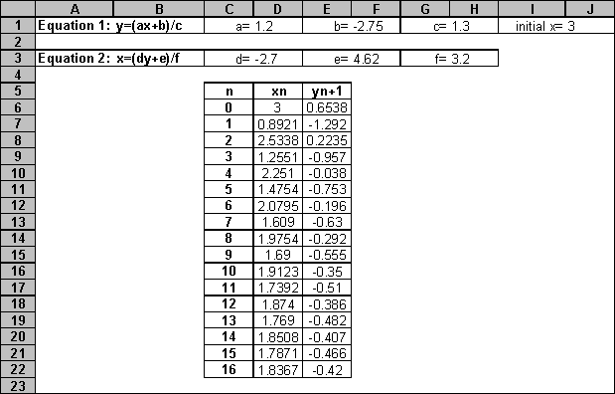
The method can easily be extended to solve more equations with more unknowns.
The formulae used are shown below:
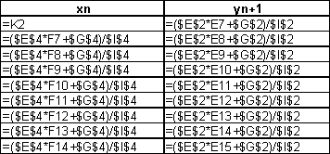
Data Plotting

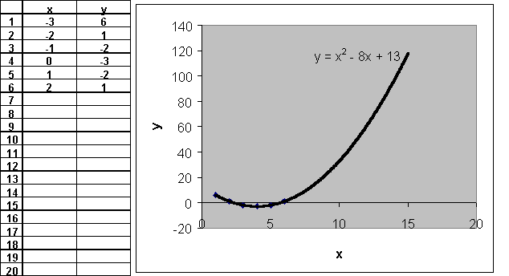
Example: Simple data plotting
If set up beforehand, can be used in a class experiment ( eg "Shoot" in "Newton’s Laws of Motion", SMP 16-19 ) to enter data as the experiment is conducted.
Method: Set up an empty table, select both columns and use the chart wizard to create a scatter diagram. Then, from "Options". plot the line of best fit and suggest a possible function to model the data.

Excel as a Database
Example: Excel as a searchable database
The example demonstrated, the Unicef database, has been taken from the United Nation Children’s Fund "State of the World’s Children 2000" website at:
http://www.unicef.org/sowc00/
This is an excellent site, full of data, with lots of back-up information and enormous amounts of interesting data available.
The statistics tables are available for free downloading, but I haven’t been able to do it by following Unicef’s instructions. However, it’s a simple matter to select and copy the whole table and paste it into an Excel spreadsheet. Be aware though that each data table come in two halves, Afghanistan to Lebanon first, followed by the rest of the UN nations. There is then endless scope for mathematical analysis of the data. For examples, students could be directed to find the 10 richest and 10 poorest nations ( use GNP per capita ) and then find means for infant mortality rates, birth rates etc. Scatter diagrams could be plotted and analysed to determine whether a linke may exist between GNP per capita and infant mortality.
small section of the database is shown below
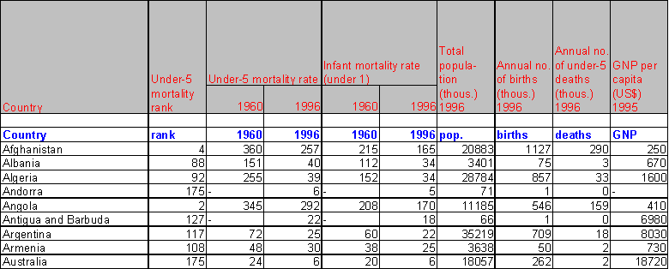A

Simulations on Excel
Example: Using Excel to simulate the throwing of a fair die
This example is designed to demonstrate the relationship between relative frequency and probability and simulates the throwing of a fair die a large number of times.
To generate a random whole number between a and b inclusive, use the following formula:= INT( RAND ( ) *b )+ a. So here for example, to simulate a single throw of a fair six-sided die we use: =INT(RAND()*6)+1

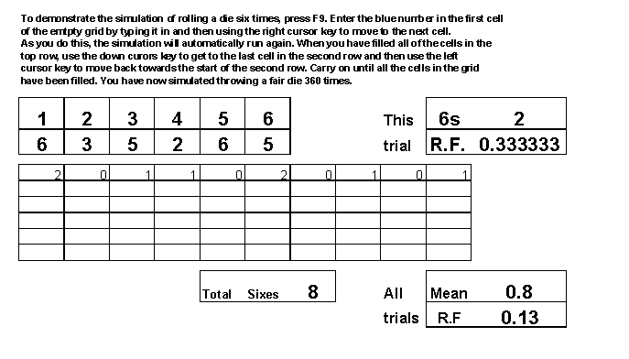

Interactive Worksheets.
The example used here tests a student’s ability to calculate means and standard deviation without using the inbuilt statistical functions on a calculator. Nine items of data are generated at random (see right) and the student is then invited to calculate the mean and standard deviation. Hyperlinks take the student to a part of the spreadsheet where answers are displayed. The student can change the data repeatedly by pressing F9 until they are confident that they have mastered the technique. 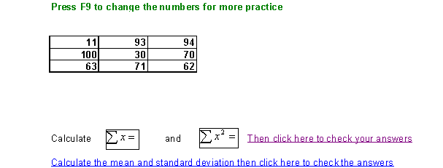

Controlling Spreadsheet Input by using Slider Bars
In the example shown here, the contents of cell B2 can be changed by clicking on to the slider bar. To insert a slider bar into a spreadsheet, click on "View" on the toolbar, right click and then choose "Forms". The toolbar shown below is now displayed.
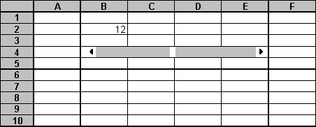
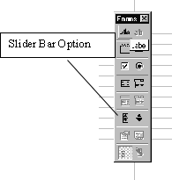
By selecting this option and clicking and dragging, a slider bar can be inserted into the spreadsheet, either vertically or horizontally.
By moving the cursor on to the slider bar and right clicking, a dialogue box appears with the option "Format Control". Choosing this option gives the dialogue box shown below.
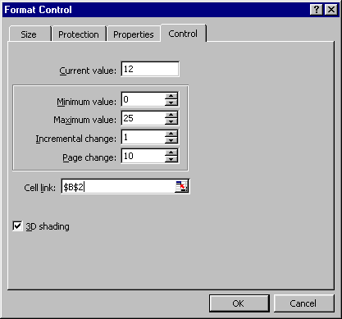
In this example, which refers to the simple spreadsheet above, the slider bar has been set to change the contents of cell B2 to values from 0 to 25 inclusive, with an incremental change of 1. Note that the maximum and minimum values must both be positive and the incremental change must take the value of a positive integer. The limitations imposed can be easily overcome however.
If, for example you need to get the slider bar to produce values between –10 and +10 with an increment of 0.1, proceed as follows. Set the parameters in the "Format Control" dialogue box as Minimum 0. Maximum 200 and Incremental Change 1. Then. In a new cell, insert the formula "=(B2-100)/10".

Using the Slider Bars to Illustrate the Effect of Linear Scaling on Mean and Standard Deviation
In the example shown here, slider bars have been set up to vary the values of a from 1 to 10 inclusive and of b from 1 to 10 inclusive.
The effects on the mean and standard deviation of the re-scaled data can then be compared with those of the original data set.
Note that the appropriate statistics have been calculated using the "function wizard" option in Excel.
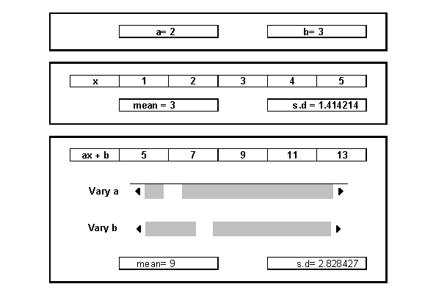

Summary
Excel is an extremely versatile and useful tool which can be used to help with the teaching of Mathematics at all levels. Its chief advantages over commercially available software are that it can be easily adapted for a variety of purposes and that it is available on most PCs at no extra cost.
The only real problem with using Excel is that it requires a suitable degree of expertise to actually set up the spreadsheets. Once set up by a suitably experienced user however, since most PC users are familiar with the most basic features of Excel they can be used by others possessing even the most limited spreadsheet skills.

