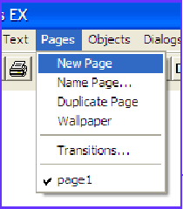
Pages
Your project can have lots of pages in it, so it’s great for presentations, games, stories, slideshows… But you will need to be able to move around your project. Here’s, how…

Create as many pages as you like by selecting new page from the Pages menu.
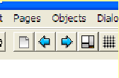
You can move from page to page in lots of ways. Here’s three.

Method One (easy)
Click the page turn buttons at the top of the page. It’s that easy!

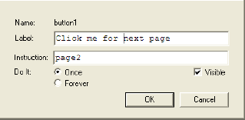
Method 2 (still pretty easy)
Add a button to the screen, give it a label like Click me for the next page, then type the page you want to go to in the instruction slot. It doesn’t HAVE to be the next page...

Method Three (the hardest here)
Use your page turn instruction in a procedure; it might look like this;
to collision
announce [whoah! We hit!]
page3
end

