ZigZag Activity
Variables: Turning into Procedures

So far you have had your turtle perform commands such as fd (forward) and rt (right). You can use these commands and use words the turtle already knows to teach it new words so that it can draw interesting designs with one click of the mouse! | 

First, hatch a turtle. Write commands in the command center to draw a simple design, such as this: |  | 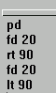 | Now you can teach the turtle a new word so that it will always draw this design when it comes to the word.

The new words you teach the turtle are called procedures. Here's how:

- Click on the Procedures tab.  - Type a title line for the procedure. It always begins with the word to, followed by the name of the procedure. Hit the Enter key to move to a new line.  - Type (or copy and paste) the commands you want into the body of the procedure, below the title line.  - The last line of a procedure is always the word end on a line of its own. | 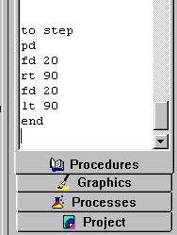

Let's see if the turtle has learned the new word, step.
You can test your procedure in any of these ways:

1) Type the name of the procedure in the command center and hit Enter. (Try typing it several times or placing it in a repeat command.) | 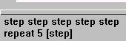

2) Make a button and give it the name of the procedure. Set it to "once" and click it several times. Now right-click the button and set it to "many times."  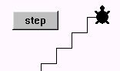 | 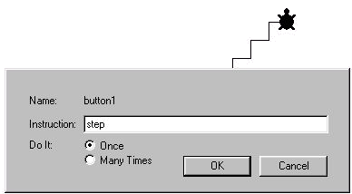
3) Right-click on the turtle to open its dialog box. Type the name of the procedure as its instruction, set to "many times," or use the procedure name in a repeat command, set to "once." Close the dialog box and click on the turtle. | 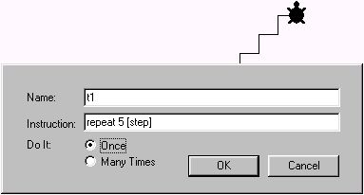

You can use the name of one procedure inside another procedure. Here, step is a "sub-procedure" of 5steps. 5steps is a "superprocedure." | to 5steps  repeat 5 [step]  end
You can use that superprocedure inside of another procedure! Now the superprocedure becomes a subprocedure:  to turncolorsteps  setpensize 3  setc 65  repeat 4 [5steps  rt 90  setc color + 20]  end | 
By using simple procedures inside of other procedures, you can build more and more complex procedures and teach the turtle many new words.

- Can you combine commands and procedures into a superprocedure to create the design shown at the beginning of this activity?
- Can you create other interesting designs with the click of a button?

