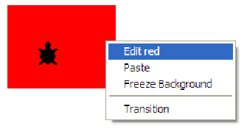
How do I make turtle do something when it goes over a colour?
You can make things happen when the turtle goes over an area of colour on the screen. This is very useful to control your projects. Paint an area of colour onto your page,
then right click it and select Edit.

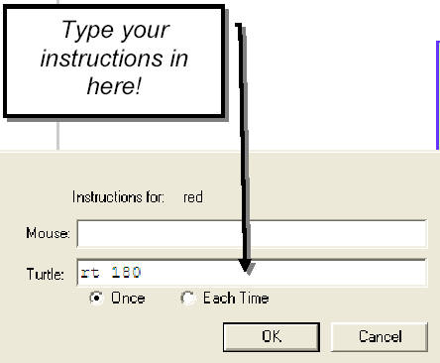
You can put an instruction in the mouse or turtle lines, this means that you could have the program responding to the mouse pointer or a turtle crossing over a colour. In this example, the turtle turns round if it crosses an area of red.
Each turtle can have its own colour command. Just right click the turtle and choose open backpack. Click the Rules tab, and enter the command in the On Color line. The dropdown menu lets you choose which colour you want the turtle to respond to. That way, different turtles can do different things when they go over the same colour!
