Operating Systems:
Windows 95/98

Action | Display
Every Windows or Macintosh computer has built-in accessibility features. Accessible features allow users to adjust keyboard, mouse, display, audio, and other controls to meet individual learning needs.  On a Windows computer, go to the Start button, select Settings, then Control Panel and Accessibility Options.  We will explore all of the Accessibility Options below. To activate any of these options, click the OK button to try it. | 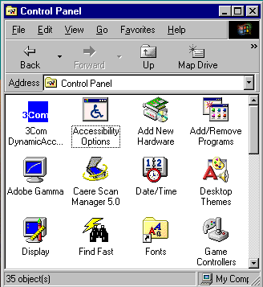
In the Accessibility Properties window, click on the Keyboard tab.  Click on the StickyKeys box, if users have difficulty holding the <Shift> key down for capitalized characters or symbols. This feature electronically locks <Shift>, <Alt>, or<Control> down for one keystroke then automatically releases (unlike <Caps Lock>).  Click on the FilterKeys box to slow the start of automatic repeat or ignore brief, accidental keystrokes.  Click on the ToggleKeys box, if users accidentally press keys that change keyboard operations (<Caps Lock>, <Num Lock>, and <Scroll Lock>). This option provides auditory feedback for these accidental key presses. | 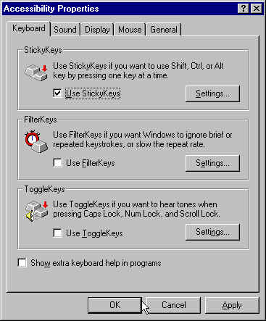
Click on the Sound tab, if users need to convert sounds to visual signals. There are two adjustments:  - SoundSentry flashes the desktop, active window or caption for system warnings.  - ShowSounds interacts with program to display captions for speech and sounds. | 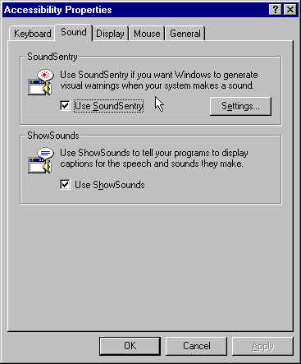
Click on the Display tab. Some users may need a higher contrast than possible by adjusting the contrast control on the display. The High Contrast feature in Display enlarges the text and reverses the contrast. Click on Settings, to see the options. High Contrast color schemes are white on black, black on white or custom. | 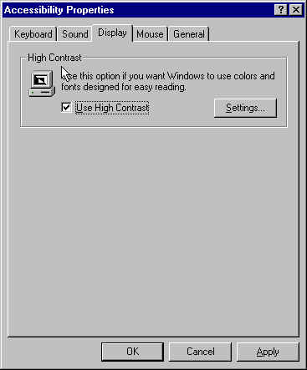
Click on the Mouse Keys tab. Mouse Keys is available for users who struggle to control a mouse. Select the Mouse Keys feature to turn the numeric keypad into a mouse keypad. The 5 key is the left button for clicking while the other numbers move the cursor in 8 different directions.  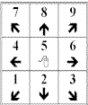 | 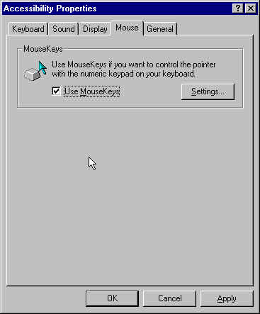
Also in Mouse Keys, click on the Settings button. Users can slide the toggle buttons to adjust Top Speed and Acceleration of the pointer for better control of the keypad. | 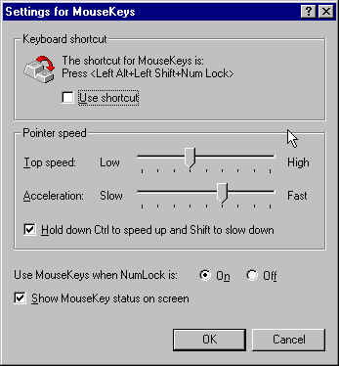
Click on the General tab for other accessibility features. These options are  - Automatic reset: options for allowing the computer to return to standard (default) control methods after a set period of time and  - Notification: options for the computer to give sound warnings when turning an accessibility feature on or off.  - Serial Keys: a method for connecting other electronic devices via the Serial Port to control a computer, such as an augmentative communication device. | 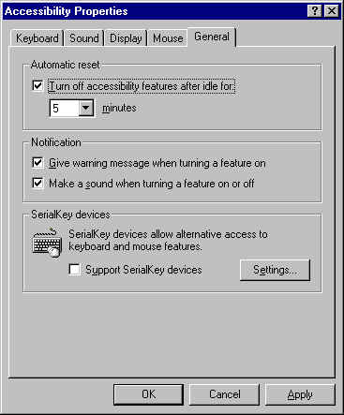
Close the Accessibility options by clicking on the OK or Cancel buttons, then close the window.

Click on other Control Panel options to adjust properties of the Keyboard, Mouse, and/or Display.

Keyboard Properties offers adjustments to the automatic repeat speed and the delay before automatic repeat begins. This may help people who tend to press keys too long. | 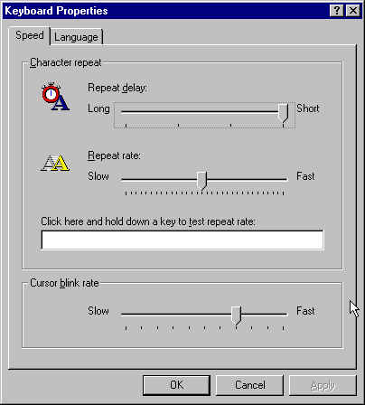
Mouse Properties offers adjustments to mouse speed, pointer speed, and the visibility of the cursor. On the Visibility options, try the Sonar and Trails to help with finding and tracking the cursor on your screen | 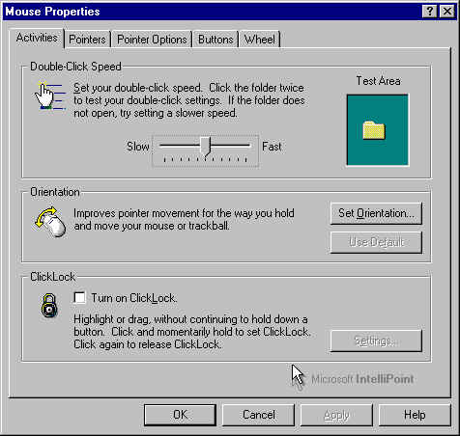
Display Properties, in the Appearance features offers 2 adjustments to enlarge the text in menus and windows. | 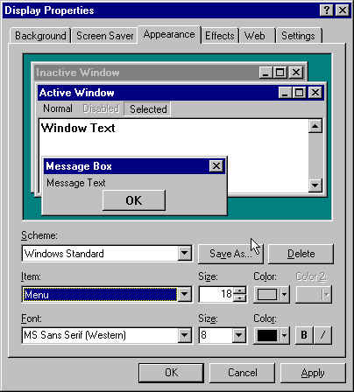
Additional Windows accessibility information: http://www.microsoft.com/enable/default.htm
For Macintosh accessibility features go to: http://www.apple.com/disability/easyaccess.html

