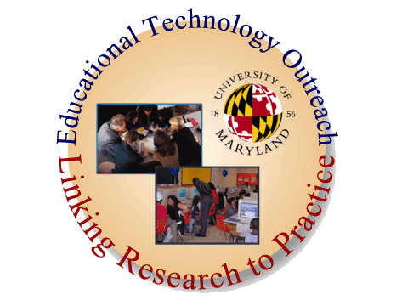

Advancing Achievement in Technology and Science
(DC ACTS) Fellows Summer Leadership Institute

Developing Strategic Plans and Strategies to Increase Student Achievement in Science

August 15 through August 19
9:00 AM -12:00 AM
AAAS, Washington, DC

Agenda

9:00 Welcome and Introductions
Overview
Objectives, Goals, and Outcomes

10:30 Connections Overview
Strategic Planning, Strategic Management Model, Long Range
Planning
Working Towards Improving Student Achievement
Exercise/Case Study I
Exercise Case Study II
Lesson Plan Analysis

Break (on your own)

11:30 Strategic Management Plan
External Analysis

12:00 Wrap up
HW: Reading/Exercises

