LOOKUP and what it means

This spreadsheet attached with this exercise contains data which you will then follow the steps to find the letter grades via the LOOKUP option.

The school will be starting a new peer mentoring initiative. Students who do well in classes will be mentoring/tutoring students who are not doing as well--or having a difficult time. Please use the Conditional Formatting feature to "tag" all your high achieving students (for all assignments) AND "tag" all students having a hard time. You may choose the definition of high performing and low performing. You can also choose how you would like to "tag" them in your Excel spreadsheet--i.e., what colors or patterns etc...

- To convert from a number grade to a letter grade
  - You must have a set of grades and the average or final grade that you would like converted already done
Name | M/F | IEP | Race | Title1 | Learning Style | Test-SI | #1Quiz | #2 Quiz | Quiz #3 | HW AVE | Unit Test | Investigation | Notebook | Notebook | Investigation | Unit Test | HW | Quizzes | GRADE%
Adams, M. | M |  | Black | Yes | Listening | 0% | 60% | 55% | 65% | 0% | 50% | 55% | 63% | 63% | 55% | 25% | 0% | 60% | 43%
Banks, S. | F |  | Black | Yes | Hands-on | 50% | 75% | 85% | 68% | 74% | 90% | 80% | 85% | 85% | 80% | 70% | 74% | 76% | 78%
Baxter, A. | F |  | Black | No | Reading | 50% | 75% | 70% | 80% | 76% | 0% | 50% | 50% | 50% | 50% | 25% | 76% | 75% | 53%
Campbell, C. | F |  | Black | Yes | Cooperative group | 80% | 45% | 100% | 100% | 90% | 98% | 98% | 98% | 98% | 98% | 89% | 90% | 82% | 93%
Charity, Marlynn | F |  | Black | Yes | Hands-on | 50% | 100% | 80% | 80% | 79% | 99% | 70% | 90% | 90% | 70% | 75% | 79% | 87% | 79%
Dowdell, W. | F |  | Black | Yes | Cooperative group | 90% | 80% | 60% | 70% | 85% | 86% | 50% | 85% | 85% | 50% | 88% | 85% | 70% | 73%
Foston, J. | F |  | Black | Yes | Reading | 100% | 100% | 100% | 100% | 95% | 75% | 100% | 98% | 98% | 100% | 88% | 95% | 100% | 96%
Head, D. | M |  | Black | Yes | Study | 0% | 82% | 70% | 82% | 68% | 50% | 80% | 78% | 78% | 80% | 25% | 68% | 78% | 67%
Holt, S. | F |  | Black | Yes | Listening | 70% | 0% | 0% | 60% | 45% | 0% | 0% | 50% | 50% | 0% | 35% | 45% | 20% | 27%
Jackson, K. | F |  | Black | Yes | Assistance | 60% | 60% | 45% | 0% | 65% | 65% | 50% | 50% | 50% | 50% | 63% | 65% | 35% | 53%
Jeffcoat, M. | M |  | Black | Yes | Listening | 50% | 0% | 60% | 0% | 0% | 70% | 0% | 0% | 0% | 0% | 60% | 0% | 20% | 15%
Jenkins, T. | F | X | Black | Yes | Hands-on | 35% | 70% | 100% | 100% | 98% | 69% | 0% | 100% | 100% | 0% | 52% | 98% | 90% | 59%
Johnson, C. | F |  | Black | Yes | Listening | 55% | 68% | 100% | 90% | 88% | 0% | 100% | 50% | 50% | 100% | 28% | 88% | 86% | 72%
Johnson, K. | F |  | Black | No | Assistance | 0% | 44% | 75% | 70% | 72% | 0% | 85% | 50% | 50% | 85% | 0% | 72% | 63% | 56%
Marshall, D. | F | X | Black | Yes | Attention | 90% | 70% | 100% | 100% | 100% | 105% | 100% | 100% | 100% | 100% | 98% | 100% | 90% | 98%
McKoy, M. | F |  | Black | No | Reading | 50% | 60% | 80% | 90% | 85% | 80% | 85% | 95% | 95% | 85% | 65% | 85% | 77% | 82%
Powell, S. | F |  | Black | Yes | Cooperative group | 90% | 70% | 100% | 90% | 100% | 68% | 100% | 110% | 110% | 100% | 79% | 100% | 87% | 96%
Plight, D. | F |  | Black | Yes | Reading | 80% | 60% | 98% | 100% | 100% | 70% | 100% | 110% | 110% | 100% | 75% | 100% | 86% | 95%
Queen, A. | M |  | Black | Yes | Reading | 0% | 60% | 85% | 70% | 50% | 75% | 50% | 0% | 0% | 50% | 38% | 50% | 72% | 41%
Reddic, P. | F |  | Black | Yes | Reading | 50% | 50% | 60% | 80% | 80% | 70% | 80% | 70% | 70% | 80% | 60% | 80% | 63% | 72%
Small, C. | M | X | Black | Yes | Attention | 80% | 60% | 0% | 70% | 0% | 55% | 70% | 70% | 70% | 70% | 68% | 0% | 43% | 55%
Sprigs, S. | F |  | Black | No | Cooperative group | 0% | 70% | 50% | 45% | 45% | 70% | 65% | 0% | 0% | 65% | 35% | 45% | 55% | 42%
Wilcher-Simpson,M. | F |  | Black | No | Study | 0% | 70% | 80% | 70% | 88% | 63% | 80% | 80% | 80% | 80% | 32% | 88% | 73% | 71%
Womack, B. | F |  | Black | Yes | Cooperative group | 0% | 50% | 60% | 45% | 35% | 75% | 70% | 0% | 0% | 70% | 38% | 35% | 52% | 42%
 |  |  |  |  |  |  |  |  |  |  |  |  |  | 20% | 30% | 20% | 15% | 15% | 100%
You can cut and paste this into Excel and increase the font if needed
  - Once in the Excel spreadsheet
  - Double click on the column cells to resize the format
  - Click in the cell NEXT to the first final grade cell (e.g., Adams final grade = 43%)
  - In the formula location (in the menu box location)—click on the fx (a pop up box will appear)
  - Choose Lookup & Reference (you might need to navigate to this in the pull down window section). Lookup & Reference translated to look at the number I tell you (e.g., the average score) and convert it to a reference value I tell you (e.g., the letter grade)
  - Choose Lookup---then OK
  - Popup box appears—choose LOOKUP(lookup_value, lookup_vector, result_vector) this translates to look at the average score—look at the grading scale range this falls into---assign a letter grade to that value)
See Next Page as well
Click OK 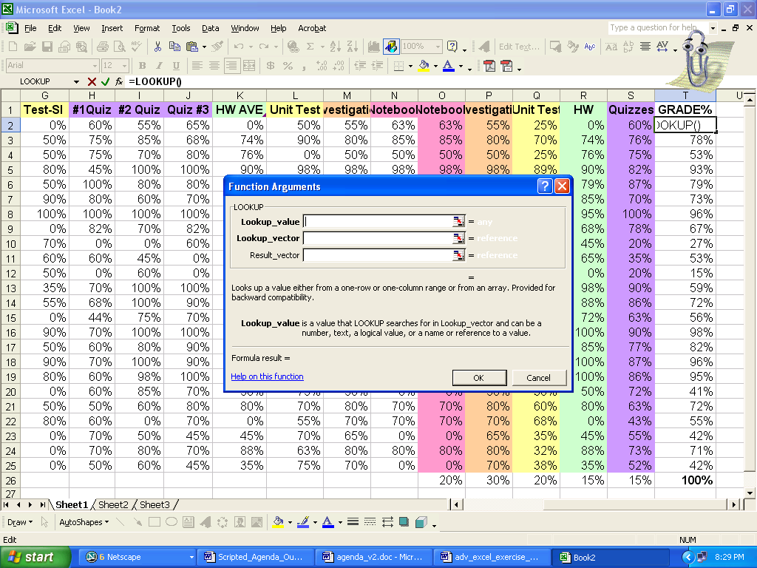
Lookup For Grades
F | 0%
D | 60%
C | 70%
B | 80%
A | 90%

  - A new popup appears
    - In the Lookup_value area-click on the AVE grade cell (T2)
    - Next line-lookup_vector—highlight the grade ranges [0% 60% 70% 80% 90%]
      - Click on F4 key to make this range absolute
    - Result_vector area-highlight the grade range [F D C B A]
      - Click on F4 key to make absolute values… =LOOKUP(T2,$I$28:$I$32,$H$28:$H$32) make sure $ in front of everything except the first one
    - Enter
  - Highlight the rest of the cells---Copy the formula to the other cells
  - The number grades are converted to letter grades

Why F4? The LOOKUP table (where you tell the computer what the letter grade will be e.g., 40 and below = F, 41-50 =D etc… what ever you have decided) does not change—but the students and student grades that you want the computer to convert will. The F4 places a $ sign in front of the values –this tells the computer to “set” or refer back to that LookUP table. If you didn’t apply this, the range would slowly start to change, the range of grades would slowly start to change.

