Grade Book Templates
Introduction to Excel
Mini assignments making/downloading Excel templates
These activities will allow you to explore Excel by on using existing templates/populated data, as well as designing your own grade book that will connect standards with the curriculum you/your teachers will cover in their classroom. While this could be done for any grade level (including post secondary) and any state, region or discipline that has created “standards”, we will use the DCPS standards and curriculum to practice.

Mini Assignment 1:

Go to the http://www.k12.dc.us/dcps/curriculum/assess1.html On the right side (in a box) click on the View District Data.
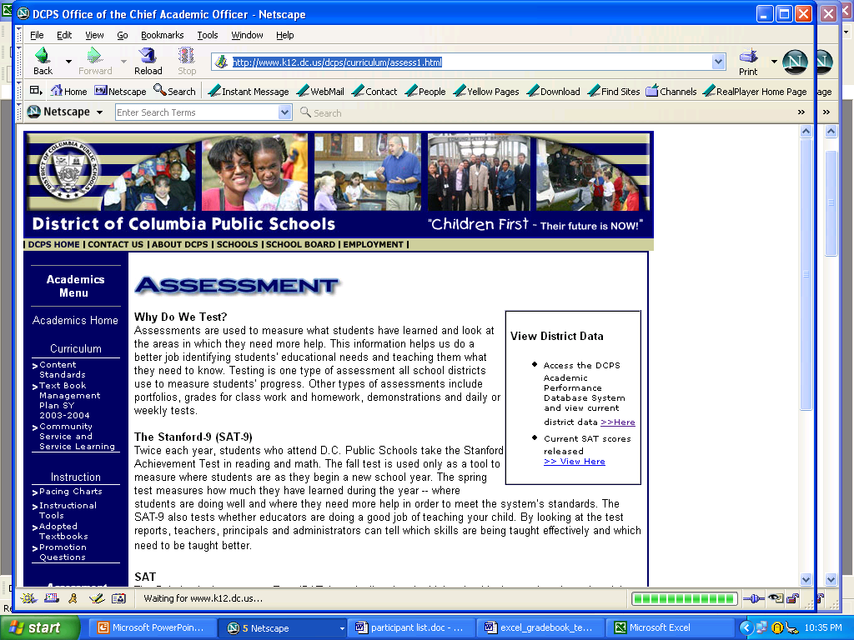
Click Here
Next, select the data you want to look at by selecting the appropriate fields.

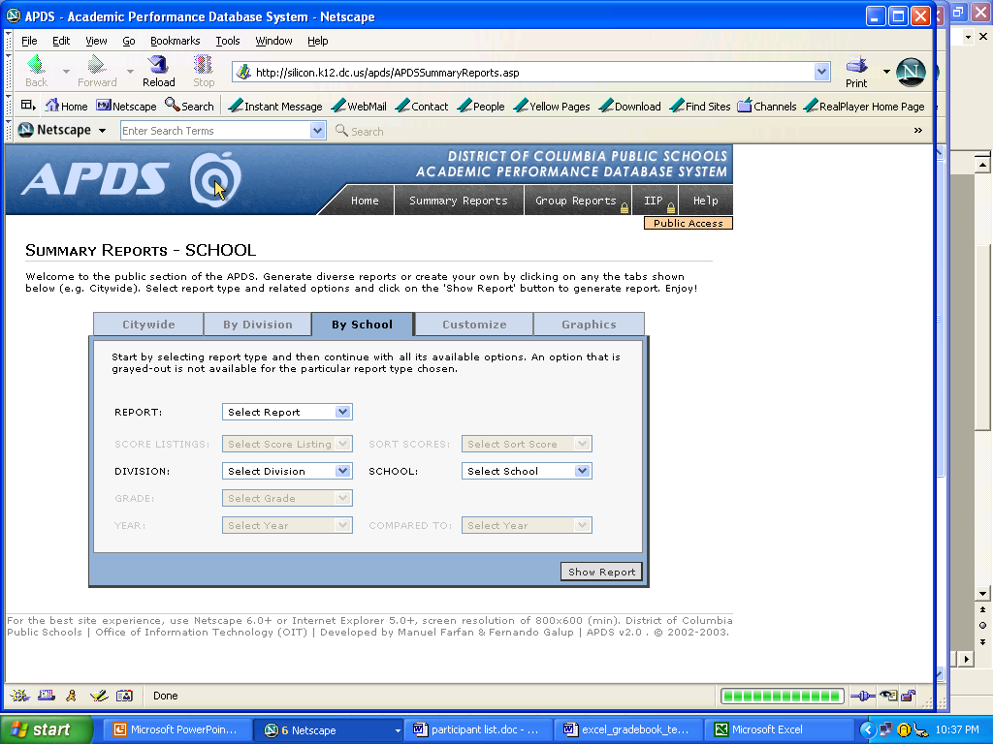
Click Show Report
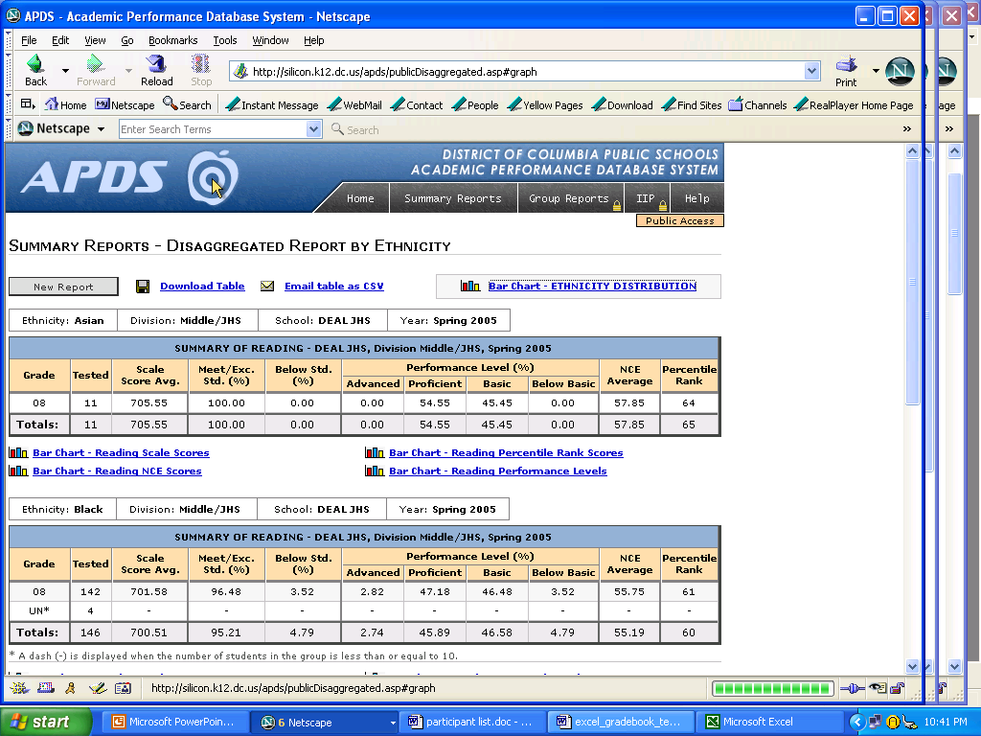
Click on the Download Table—this will convert to an Excel file. Save the file. Remember to include your name in the file extension.

Mini Assignment 2:

Set up a typical grade book (at min. 6 students), including first and last name of student and student ID. Add a field for each of the following: gender, race, Learning style, IEP, Title I (if you know). Next include several assignments just like you would in your typical grade book—and randomly assign grades (include a variety of assessments).Next, through tool bar -> Insert -> Comments reference or tag each of your assessments with the proper standard each assessment was aligned to.
Save the file. Remember to include your name in the file extension.

