
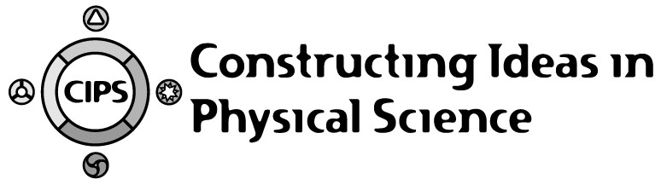
CIPS
Constructing Ideas in Physical Science

Project Directors: Fred Goldberg and Sharon Bendall at San Diego State University, Patricia Heller at the University of Minnesota, and Robert Poel at Western Michigan University, supported by NSF Grant ESI-9812299

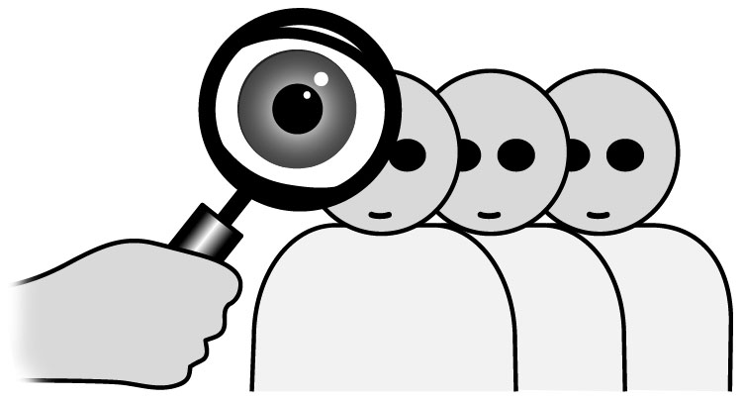
CIPS is an inquiry-based, year long physical science course that engages seventh or eighth grade middle school students in constructing meaningful understanding of important physical science concepts. (See http://cipsproject.sdsu.edu.) Based on research on student learning, extensive hands-on experiences are complemented by powerful and innovative computer software. CIPS employs a learning cycle pedagogy consisting of elicitation of initial student ideas, development of new or modified ideas, student consensus on final ideas, and application of ideas to new situations. The course content is based on National Science Education Standards and Project 2061 Benchmarks, and CIPS is designed to meet Project 2061 evaluation criteria. Attached is a list of Benchmarks that the course is designed to meet. The pedagogy and the sequencing of activities were carefully designed to provide opportunities for students to develop a deep understanding of these Benchmark ideas. In the curriculum a major focus is on students gathering experimental evidence to support these ideas. From their own experiences, students would be able to answer the questions, “What do we believe?” and “How do we know?”

Throughout the six units in the CIPS course students learn to apply energy and force ideas to describe myriad physical science interactions that occur in the world around them. The course is hierarchical in structure, but can be split over two years. By the end of the course students should be able to observe and apply their science ideas to explain phenomena in their daily lives. To help support this, students learn to write and evaluate scientific explanations. This process is introduced slowly and is highly scaffolded early in the course, then the scaffolding is gradually reduced as the course progresses. In a similar way, students also develop the ability to evaluate experimental conclusions and to design their own experiments.

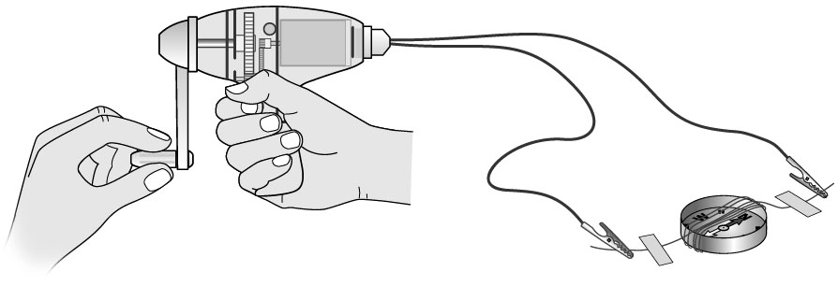
The first unit, Electric Circuit and Electromagnetic Interactions, is an introduction to some of the nature of science ideas. Using the context of electricity and magnetism, students learn how to evaluate whether an experiment is a fair test, and they learn the criteria for what makes a good argument in science. As the unit continues students learn about the interactions theme, and begin to use energy ideas to describe some interactions involving magnetism, electric circuits, electromagnetism and sound. For instance, students design and build a simple electric circuit to model the raising/lowering bar, flashing lights and clanging bells at a railroad crossing, and then use energy transfer ideas to describe the series of interactions that are involved.
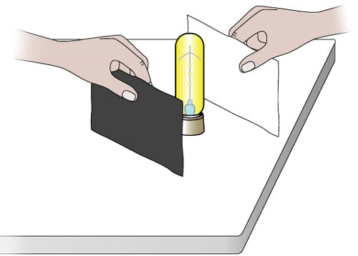
In the second unit, Light Interactions, students explore energy transfer in the context of phenomena involving light and color. Students consider that an object can be seen when light waves emitted or reflected by the object enter the eye, thus exploring the interaction between light and the eye, and also exploring what happens when light reflects from shiny and non-shiny surfaces. Through continued exploration students develop an understanding of what happens when light strikes a colored object, i.e. some colors of light are absorbed and some are reflected (or transmitted), and the mix of reflected (or transmitted) colored light entering the eye determines the perceived color of the object. The unit ends with an activity where students design a way of showing how different colored lights can change the appearance of objects.
The following unit, titled Interactions and Motion, applies energy ideas to describe mechanical interactions, and introduces forces. Students encounter a variety of common mechanical interactions including applied, resistive (friction and drag), stretchy, and gravitational interactions. Using special low friction cars and other simple apparatus, students develop an understanding of Newton’s First and Second Laws of motion, and of mechanical energy. Appealing contexts such as skateboarding, bike riding and bungee jumping are utilized in the unit. The unit concludes with an exploration of gravitational interactions and orbital motion. Students end the unit by explaining phenomena such as satellite motion and amusement park rides.

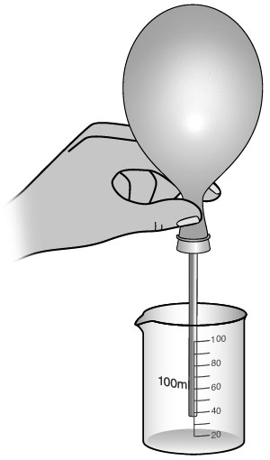
Conservation of Energy is the fourth CIPS unit. Throughout the first half of the CIPS course students learn about energy being transferred from one object to another, and that energy can change from one form to another. In this unit, students are first introduced to the concept of conservation by keeping track of mass changes in systems. Then students extend the conservation model to encompass energy conservation. Several of the CIPS simulators provide tools for students to keep track of energy changes, and hence they can use the simulators to gather support for the energy conservation idea in different contexts. Unit Four concludes by examining the societal issues of useful energy and efficiency. In the last activity students develop a response to the question, “If energy is always conserved, then why are we worried about conserving energy?”

Matter and Interactions is the next CIPS unit. Students are introduced to the conceptual model that matter is made of small particles, and that scientists use this model to explain the properties and interactions of matter. Students apply the small particle model to explain some properties of solids, liquids and gases. For example, one activity uses magnetized marbles to emulate the fluid movement of a liquid. In addition to hands on activities, the Matter and Interactions unit makes frequent use of specially designed computer simulations to help students make connections between the macroscopic behavior of matter and its microscopic (simple particulate) behavior.

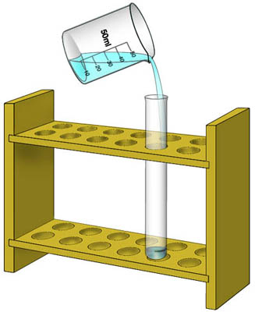
The final CIPS unit is Chemical Interactions. Students begin by considering several situations where substances interact, resulting in one of two possibilities: physical mixing or chemical interactions (producing new substances). They interpret these events in terms of the small particle model, developed in the previous unit. Focusing on chemical interactions, students then proceed to consider how so many substances can be produced from a limited number of elements. During the last parts of the unit students consider how chemical reactions require both the right kind and the right amount of interacting substances.

All CIPS units make use of simulation software especially designed to complement the CIPS pedagogy and physical science content. The software can be employed in whole class settings with the use of a projection system, or can be used by student groups or individuals if enough computers are available. The software is especially useful for helping students check their analysis of hands-on experiments, and for setting up phenomena that cannot be explored experimentally in a middle school setting. The simulators use multiple representations and conceptual models to help students deepen their understanding of the Benchmark ideas. Attached is a very brief description of some of the simulators.

In conclusion, CIPS has been developed collaboratively by a team of university-based scientists and science educators and experienced middle school teachers, with input from representatives of the scientific and mathematics communities, including Project 2061 staff. CIPS is a five year project that began in September 1998. Field test opportunities are available for a limited number of school districts.

For further information, contact:
Fred Goldberg fgoldberg@sciences.sdsu.edu, (619) 594-6609 or
Sharon Bendall sbendall@sciences.sdsu.edu, (619) 594-2909.
Screenshots from three of the CIPS Computer Simulators

This screenshot is from the EM Devices simulator. It shows a circuit consisting of a hand-cranked generator, an ammeter, bulb and compass. A special window displays the compass deflection. Also included is an energy bar graph showing the energy inputs, outputs and changes associated with the generator | 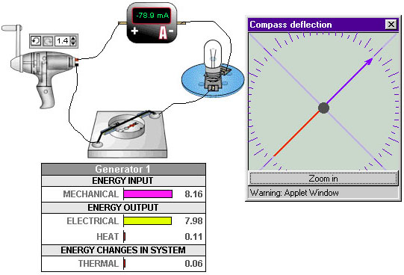

This is from the Interactions and Motion simulator. It shows a ball having been dropped from rest onto a surface. The red arrow indicates the velocity of the ball. A strobe diagram representing the path of the ball is shown. Also included is a graph of the speed of the ball versus time, and an energy bar graph showing the energy changes in the ball-earth system. | 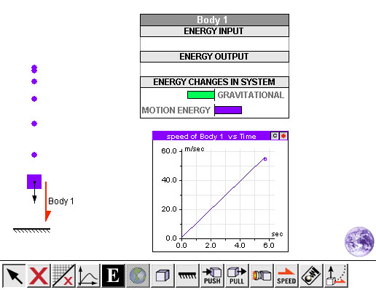

This screen shot is from the Ideal Gas Small Particle Model simulator. In the upper left is a cylinder where macroscopic experiments can be performed. In this case the cylinder is heated with nitrogen gas inside and the pressure, volume and temperature are measured. (A clock can also be placed in the simulator to keep track of time.) A graph shows how the volume changes with temperature as the gas is heated. An ultrascope tool can be placed inside the gas cylinder and displays a microscopic model view of the moving particles of the gas. The average energy of the gas particles is displayed. | 