Excel Tutorials

Pivot Table
A Pivot Table is used to summarize data and look for patterns that otherwise are difficult to identify. This tutorial will show you how to get started – the best way to understand how it works is to do it. Returning to a gradebook example – if you have information such as demographics or learning styles, you can examine how different groups are doing. We start with the spreadsheet shown below:
Looking at the spreadsheet, it is not obvious how the different genders are doing, or how different learning styles are performing. So we decide to look at a pivot table. Click in the table, and then click on Data→Pivot Table and Pivot Chart Report. Click on the popups as shown.
Name | Gender | Support | Strategy | ComprehensionWritten Responses | ComprehensionMultiple Choice | Structural Analysis and Vocabulary | Writing Fluency | Language | Writing Skills | Total Score |  | Support
Adam | Male | 1 | 88% | 83% | 83% | 83% | 75% | 82% | 100% | 85% |  | 1 = Independent
Bob | Male | 2 | 50% | 67% | 100% | 56% | 42% | 55% | 50% | 60% |  | 2 = Partial
Caitlin | Female | 1 | 75% | 58% | 75% | 67% | 75% | 73% | 100% | 75% |  | 3 = Full
Davon | Male | 1 | 75% | 75% | 79% | 89% | 75% | 82% | 100% | 82% |  | 4 = Alternative Test
Eddie | Male | 1 | 100% | 92% | 92% | 94% | 100% | 100% | 100% | 97%
Felicia | Female | 2 | 38% | 42% | 42% | 50% | 25% | 18% | 50% | 38%
George | Male | 3 | 75% | 80% | 80% | 80% | 80% | 80% | 80% | 79%
Heidi | Female | 2 | 93% | 93% | 91% | 72% | 72% | 88% | 78% | 84%
Inga | Female | 1 | 88% | 100% | 96% | 87% | 87% | 77% | 92% | 90%
John | Male | 1 | 88% | 50% | 88% | 100% | 100% | 86% | 96% | 87%
Kevin | Male | 2 | 92% | 86% | 100% | 93% | 93% | 91% | 92% | 92%
Lori | Female | 2 | 90% | 90% | 100% | 87% | 87% | 86% | 92% | 90%
Melvin | Male | 3 | 88% | 97% | 100% | 93% | 93% | 100% | 88% | 94%
Nora | Female | 1 | 87% | 100% | 100% | 100% | 100% | 95% | 100% | 97%
Oliver | Male | 2 | 0% | 100% | 88% | 96% | 93% | 82% | 92% | 79%
Paulette | Female | 3 | 96% | 100% | 100% | 88% | 100% | 91% | 83% | 94%

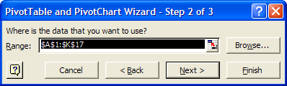
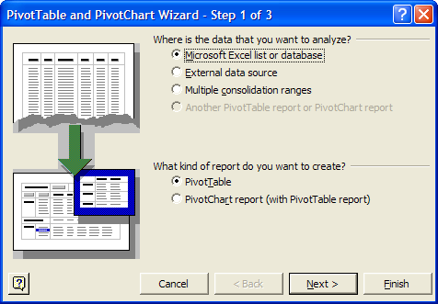
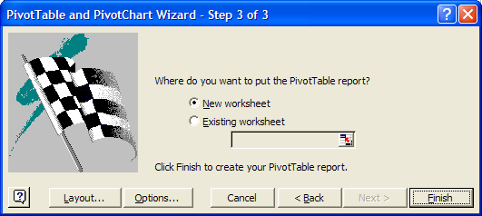
The worksheet on the next page is created.
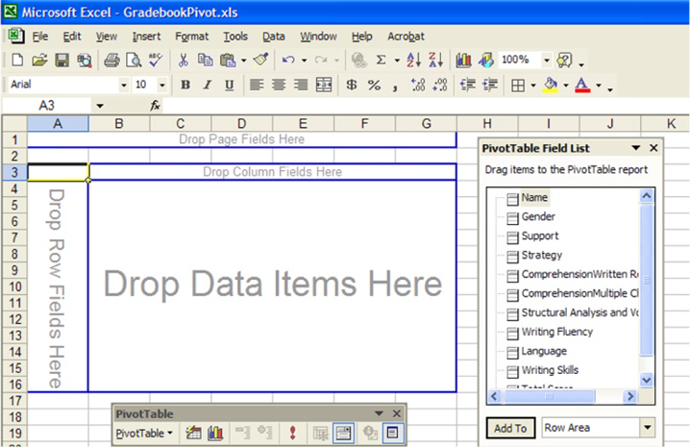
The pivot table contains all the fields from the previous spreadsheet. Click on, drag, and drop Gender in the Row Fields, drop Support in the Column Field and drop Total Score in the Data Field.
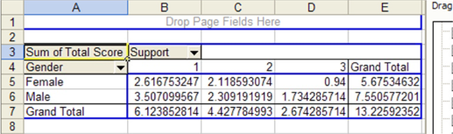
But we don’t want “Sum of Total Score”, we want average. Double click on “Sum of Total Score.”

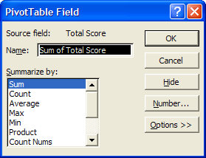
Click on Average on the field that pops up, and click OK.

Also change the data field to %.

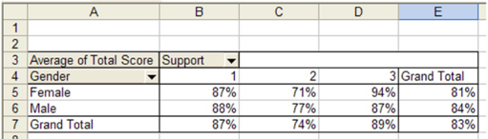This is obviously a nice way to summarize your data. Play around with the pivot table as you can move fields in and out. Notice the down arrows next to Gender and Support. You can filter the data much like the AutoFilter function described earlier.

There are numerous tutorials on the internet describing pivot table use. A nice introduction is at http://it.fuqua.duke.edu/public/2001PivotTableIntroduction.pdf and some links at http://www.geocities.com/jonpeltier/Excel/Pivots/pivotlinks.htm .

