Excel Tutorials

Conditional Formatting (“Red Flagging”)
Conditional formatting allows you to have a cell to have a “red flag” depending on its contents. You can use this to look at a large group of data and automatically change the background of each cell, its borders, or its font characteristics. To do this
- Click on the cell whose formatting you want to change (“flag”).
- In the menu bar, click on Format→Conditional Formatting.
- 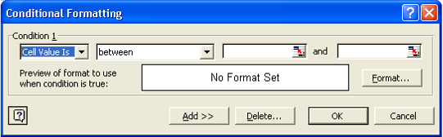Edit the appropriate values in the box which pops up.
- Click the Format Button.
- Edit the Font, Border, and Patterns (Color) tabs to fit the style you would like. Remember, this formatting will only be used if the condition is TRUE.
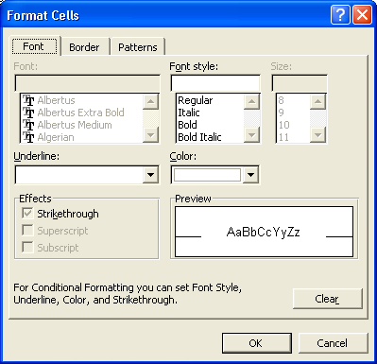
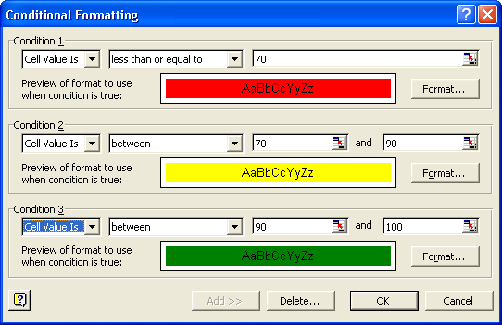
- If you would like to add additional conditional formatting, Click on the ADD>> button above. You can have three conditions per cell.
Example Completed Conditional Formatting Pop up

To copy and paste this formatting
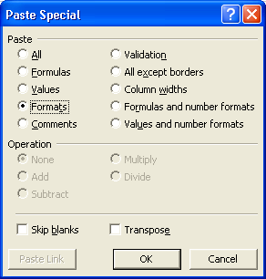
- Click on the cell which has the formatting you wish to copy.
- Either type Ctrl-C or do Edit→Copy
- Click on or highlight the cell(s) that you wish to have the same formatting.
- DO NOT TYPE CTRL-V.
- From the menubar, use Edit→Paste Special
- Click on Formats radiobutton.
- Click OK button.

You do not use the regular Paste (Ctrl-V) because you are not copying a value or a formula, instead you are copying the “formatting” of the cell, i.e. the conditional color selection.

Sorting
There are several different ways to sort depending on what you want to do.

Sorting by One Column
- The easiest way to sort your spreadsheet is to click on a cell with data in the column you want to sort, and then click the ascending or descending () button.
- The other columns in your spreadsheet should stay with the appropriate row.

Sorting by Multiple Columns
In some cases you want to sort by more than one column. For example, you may want to sort first by grades, and then alphabetically within each grade.
- It is easiest if you first Click on a cell within the first column you want to sort.
- In the menubar, click on Data→Sort.
- You can choose up to three columns to sort by.
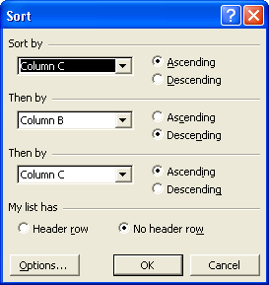

Autofilter
Another interesting way to sort, is using the Autofilter function. Autofilter does not sort, as much as select fields that contain a selected value.
- It is easiest if you first Click within the first column you want to sort.
- In the menubar, click on Data→Filter→Autofilter
- Down arrows will be added to the top rows of your columns.
  - You can select a particular group.
  - The top “10” values (This number is selectable)
  - A custom set of values
  - All
This allows an easier method of examining specific groups. For example, you might want to see if there are any commonalities among gender groups, ethnicities, or different performance levels. Sometimes having all the data can be distracting.

Using Excel Like a “Database”
Once you fill out a spreadsheet with Column and Row Headings, Excel will automatically allow you to access your data with database like forms. For the purposes of Excel, each column is treated as a different “Field”, and each row is treated like a “Record”. For example, thinking about a gradebook, each person with the associated data would be considered a record, and each data item (i.e. Name, Gender, Ethnicity, Homework 1, Homework 2, etc.) is considered a field.
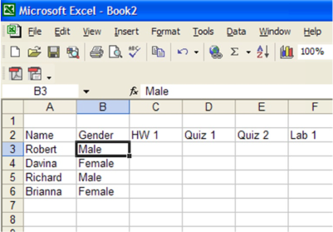
Given the spreadsheet to the right.

- Click anywhere within the “data” area of the spreadsheet.
- Click on Data→Form.

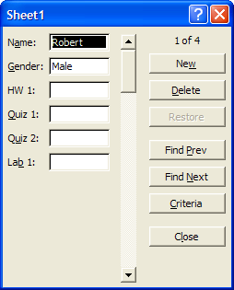
- The form to the right appears. You can use this form to fill in your data, scroll through the data, or search for particular fields (i.e. Brianna).

Pivot Table
A Pivot Table is used to summarize data and look for patterns that otherwise are difficult to identify. This tutorial will show you how to get started – the best way to understand how it works is to do it. Returning to a gradebook example – if you have information such as demographics or learning styles, you can examine how different groups are doing. We start with the spreadsheet shown below:
Looking at the spreadsheet, it is not obvious how the different genders are doing, or how different learning styles are performing. So we decide to look at a pivot table. Click in the table, and then click on Data→Pivot Table and Pivot Chart Report. Click on the popups as shown.
Name | Gender | Support | Strategy | ComprehensionWritten Responses | ComprehensionMultiple Choice | Structural Analysis and Vocabulary | Writing Fluency | Language | Writing Skills | Total Score |  | Support
Adam | Male | 1 | 88% | 83% | 83% | 83% | 75% | 82% | 100% | 85% |  | 1 = Independent
Bob | Male | 2 | 50% | 67% | 100% | 56% | 42% | 55% | 50% | 60% |  | 2 = Partial
Caitlin | Female | 1 | 75% | 58% | 75% | 67% | 75% | 73% | 100% | 75% |  | 3 = Full
Davon | Male | 1 | 75% | 75% | 79% | 89% | 75% | 82% | 100% | 82% |  | 4 = Alternative Test
Eddie | Male | 1 | 100% | 92% | 92% | 94% | 100% | 100% | 100% | 97%
Felicia | Female | 2 | 38% | 42% | 42% | 50% | 25% | 18% | 50% | 38%
George | Male | 3 | 75% | 80% | 80% | 80% | 80% | 80% | 80% | 79%
Heidi | Female | 2 | 93% | 93% | 91% | 72% | 72% | 88% | 78% | 84%
Inga | Female | 1 | 88% | 100% | 96% | 87% | 87% | 77% | 92% | 90%
John | Male | 1 | 88% | 50% | 88% | 100% | 100% | 86% | 96% | 87%
Kevin | Male | 2 | 92% | 86% | 100% | 93% | 93% | 91% | 92% | 92%
Lori | Female | 2 | 90% | 90% | 100% | 87% | 87% | 86% | 92% | 90%
Melvin | Male | 3 | 88% | 97% | 100% | 93% | 93% | 100% | 88% | 94%
Nora | Female | 1 | 87% | 100% | 100% | 100% | 100% | 95% | 100% | 97%
Oliver | Male | 2 | 0% | 100% | 88% | 96% | 93% | 82% | 92% | 79%
Paulette | Female | 3 | 96% | 100% | 100% | 88% | 100% | 91% | 83% | 94%

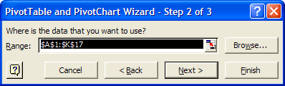
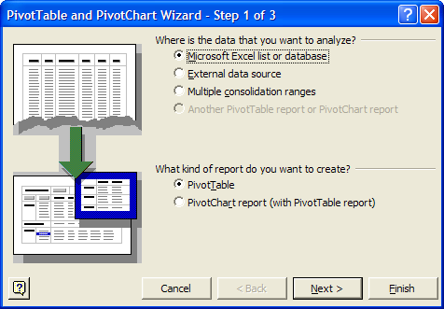
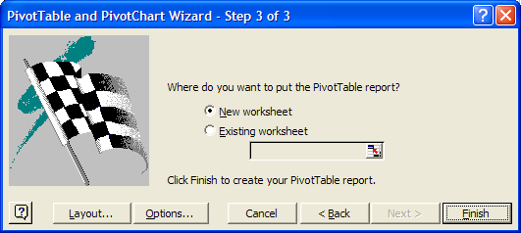
The worksheet on the next page is created.
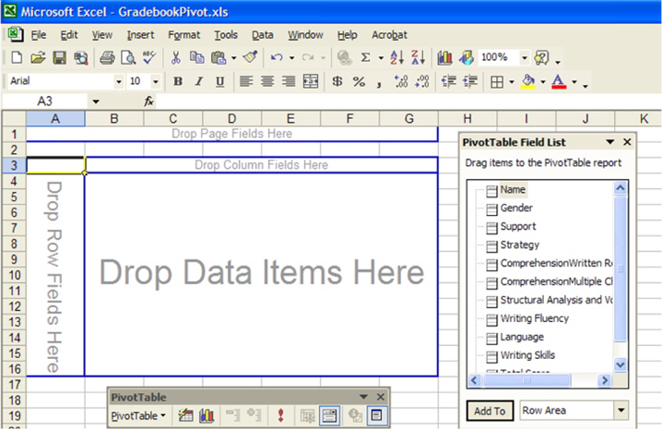
The pivot table contains all the fields from the previous spreadsheet. Click on, drag, and drop Gender in the Row Fields, drop Support in the Column Field and drop Total Score in the Data Field.
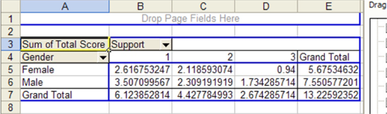
But we don’t want “Sum of Total Score”, we want average. Double click on “Sum of Total Score.”

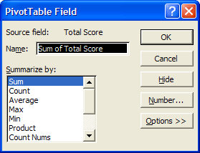
Click on Average on the field that pops up, and click OK.

Also change the data field to %.

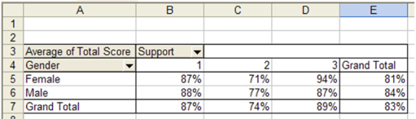This is obviously a nice way to summarize your data. Play around with the pivot table as you can move fields in and out. Notice the down arrows next to Gender and Support. You can filter the data much like the AutoFilter function described earlier.

There are numerous tutorials on the internet describing pivot table use. A nice introduction is at http://it.fuqua.duke.edu/public/2001PivotTableIntroduction.pdf and some links at http://www.geocities.com/jonpeltier/Excel/Pivots/pivotlinks.htm .

