

Assessment and Design Strategies for Improving Student Learning
EDUC 698V

Excel Exercises Part II

The University of Sheffield Excel tutorial (beginning through advanced and beyond) http://www.shef.ac.uk/cics/docs/ap-excel4/ap-excel4.html

Other Excel online tutorials:

From Lehman College: http://lca.lehman.cuny.edu/lehman/itr/html/tutorial.asp?PageID=110&ViewPage=MS%20Excel

From Future Society http://www.fortunesociety.org/computer/faq_tutorials.htm try the interactive quizzes

What you need to know ABOUT Excel: From AskAbout http://www.saskschools.ca/%7Eehs/HeiseIntra/excel.html and portal to more Excel tutorials than you will have time for http://math.about.com/cs/excel/

Getting Started
Start Excel from the Start menu.

Data Entry
During this activity you will produce a workbook containing the details of the personal phone calls of a small department.
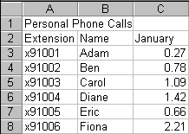
Type the following data into your new worksheet, keeping to the cells indicated.

Formatting
- Make the contents of cells A1, A2, B2, C2 bold.
- Center the cells A2 to C6.
- Select cells A1+B1+C1 then center across selection.
- Set the best fit to columns A, B, and C.
- Select column C and format it to be Currency
- Rename the current worksheet to be Phone Bill.
- Now save your file with the name Personal Phone Calls.

Formulas and Data fill
- Sum the contents of the cells C3:C8, putting the result in cell C9.
- Change the data in the following cells and note each effect on the total.
- C3 → 1.97
- C4 → 0.28
- C5 → 0
- Use data-fill to enter the months February, March, and April in cells D2:F2.
- Under February enter the values 0.43, 1.43, 0.77, 2.04 ,0.58 ,2.11 in cells D3:D8. Then perform an AutoSum in cell D9.
- For March enter the figures 0.67, 1.63, 2.33, 1.82, 1.59, 0.42.
- For April enter the figures 0.77, 1.63, 1.92, 2.18, 0.17, 1.62.
- Use data-fill to display the respective totals in cells E9 and F9.
- Ensure that columns C:F are centered and formatted to be currency.
- For each person, work out the average value of their personal phone bill each month.

Re-Design
- Select the range of cells C9:F9 and drag them to C10:F10.
- Select the cells in the range A1:F10.
- Move these cells to the range starting at cell C2.
- Select the cells C2:H11 and apply the Classic 3 format to them.

Summary Exercise
- Open Sheet2 and rename it to Amount Received. Use all the above techniques to build a nicely formatted table, in the Amount Received worksheet.
- Give the table a main title, then beneath it have columns for Extension, Name, and January, February, March, April.
- Fill in data for the whole table, indicating that some people pay their bill regularly, and some have defaulted.
- Display the amount received per month.
- Finally, on a new sheet have columns for each month, and rows for total money owed and total money received.

Create a Chart
- Select the Amount Received table. Make sure you include the months, the names, and the figures, but don’t select the totals.
- 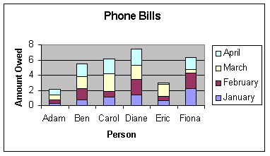
Next click on the Chart wizard button. You will be presented with the sequence of five dialog boxes. Use these to produce a labeled column chart.
Here’s one I prepared earlier.

The Help System
Use the help system to find out the following:
  - If you cannot locate a workbook that you have previously created, how can you search for it?
  - How do you remove gridlines from your printout?
  - How can you make a given table start at the top of a new printed page?
  - How can you have several workbooks open at the same time?
  - How do you create a data entry form in Excel?
  - What is a pivot table?

