Excel Tutorials:

Conditional Formatting (“Red Flagging”)
Conditional formatting allows you to “red flag” a cell depending on its contents. Once you have set the conditions (and told the computer), this can help in visually showing areas of concern when they arise. To do this:
- Populate an excel spreadsheet—or open a file that contains data.
- Highlight the cells you want to apply conditional formatting to
  - You can also click on the cell who’s formatting you want to change (“flag”)--Choosing one cell only. It can be any cell—we will later apply (copy/paste) to the rest of the cells.
- In the menu bar, click on Format→ Conditional Formatting.
- 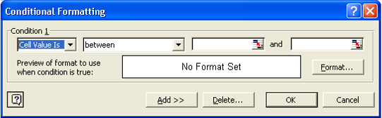Edit the appropriate values in the box which pops up.
- Click the Format Button.
- Edit the Font, Border, and Patterns (Color) tabs to fit the style you would like. Remember, this formatting will only be used if the condition is TRUE.
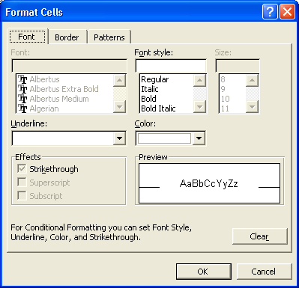
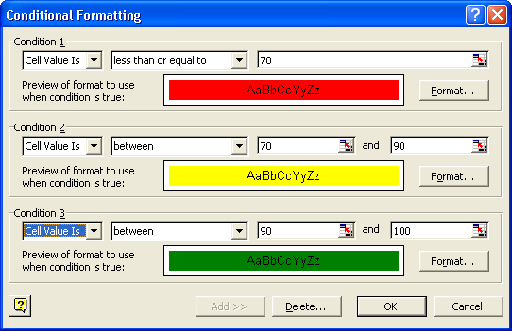
- If you would like to add additional conditional formatting, Click on the ADD>> button above. You can have up to three conditions per cell by default.
Example Completed Conditional Formatting Pop up

What does the formatting I choose mean? If the cell value is less than 70 color it red, if the cell value is between 70 and 90 color it yellow, and if the cell value is between 90 and 100 color it green. You don’t always have to color each cell-you may only want to be notified when say a grade falls below 70.

To copy and paste this formatting
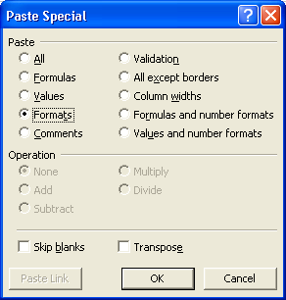
- Click on the cell which has the formatting you wish to copy.
- Either type Ctrl-C or do Edit→Copy
- Click on or highlight the cell(s) that you wish to have the same formatting.
- DO NOT TYPE CTRL-V.
- From the menubar, use Edit→Paste Special
- Click on Formats radiobutton.
- Click OK button.

You do not use the regular Paste (Ctrl-V) because you are not copying a “set” value or a formula, instead you are copying the “formatting” of the cell, i.e. the conditional color selection.

