Assistive Technology for the

Classroom Teacher

http://www.qacps.k12.md.us/comtek/at.htm

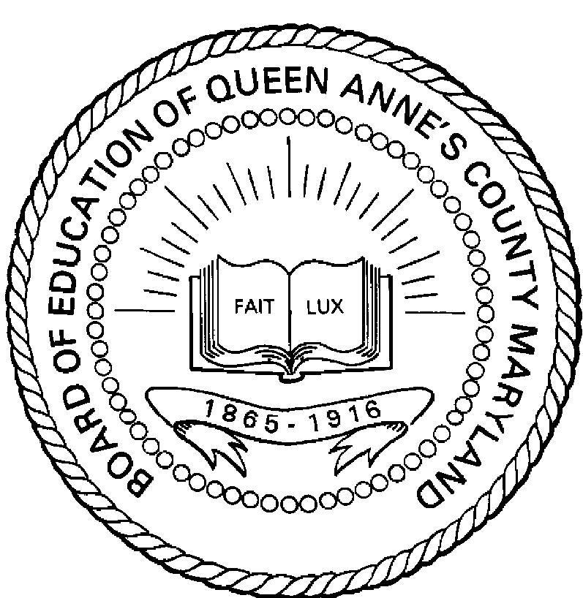
Queen Anne’s County Public Schools

Contacts:

Dave Rose, Queen Anne’s County – 410.758.2403 ext. 185
rosed@qacps.k12.md.us

Davina Pruitt-Mentle, University of Maryland – 301.405.8202
dp151@umail.umd.edu

