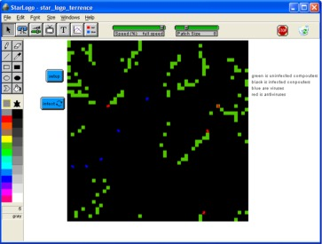
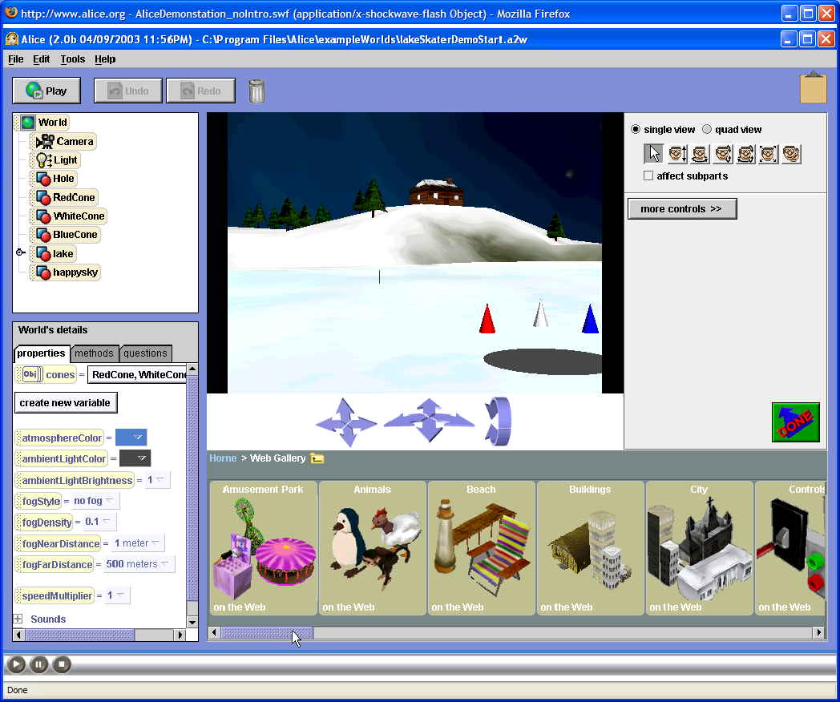
Summer 2008

July 28- August 8, 2008

8-12:00 AM

Joppatowne High School

A $75 deposit is required per student.
Upon course completion, the deposit will be returned in full.

Computer Security/Digital Forensics: Young Scholars Program
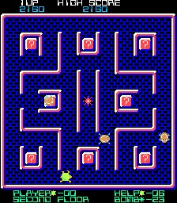
High school CS/DF Scholars gain valuable skills related to digital literacy while exploring career opportunities related to Computer Security, Information Assurance, and Digital Forensics. Investigate the design and use of games and simulations for educational purposes, and the research and development issues associated with each. Experience various modeling and simulation software packages (MicroWorlds, Excel, Scratch, and StarLogo).
Participants will engage in hands-on activities and learn about digital literacy (technology fluency and applications, team building, collaboration tools, problem based critical thinking), defending against viruses, Trojan Horses, and worms; and applying basic security concepts through gaming, modeling and simulation development, while investigating exciting careers that interconnect the fields of science, math, technology, and computer security. Students will be given an opportunity to open, examine and install hardware components of a personal computer. Students will also gain basic knowledge of a computer operating system. Students will also discuss such topics as cryptography, system vulnerabilities, and careers in computer security/digital forensics. Tours of local labs will be conducted, and students will have the opportunity to hear from a variety of speakers from state and federal agencies and local security companies.

- Explore various modeling and simulation software packages (MicroWorlds, Excel, Scratch, and StarLogo)
- Create an Animated Story & Interactive Game/Maze with MicroWorlds
- Learn nore about careers in IA/IA and Digital Forensics
- Develop an Interactive Educational Mini Simulations with Excel, Star Logo and Scratch
- Develop Digital Forensics Skills through activities and exercises

For more about the course: syllabus, standards met, past products, course outline visit: http://www.edtechpolicy.org/YoungScholars/2007/YSP2007.html
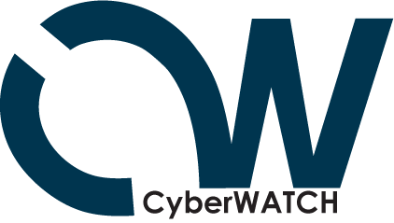
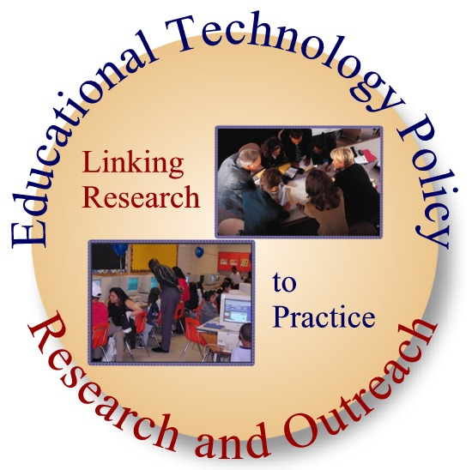
Tentative Field Trips & Speakers:

- FBI Digital Forensics
- Edgewood Chemical Biological Center
- Maryland Internet Crimes Against Children Task Force
- CyberWATCH
For More Information:
Davina Pruitt-Mentle
410 531 3910
dpruitt@umd.edu

Leah Beaulieu
(JHS coordinator)
410 612-1510
Leah.Beaulieu@hcps.org

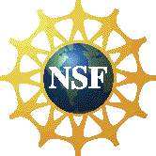

Summer 2008

July 28- August 8, 2008

8-12:00 AM

Joppatowne High School

(Transportation to and from JHS must be provided)

Computer Security/Digital Forensics: Young Scholars Program

Student Name (Last name, First Name, MI) :______________________________
Street Address: ______________________________
City, State, Zip Code: ______________________________

Parent/Guardian (Last name, First Name) :______________________________
Home Phone: ______________________________
Parent/Guardian Work/Cell Phone: ______________________________
Parent/Guardian Email Address if available: ______________________________

Emergency Contact (Last Name, First Name): ______________________________
Emergency Contact Home Phone: ______________________________
Emergency Contact Work/Cell Phone: ______________________________

______________________________________________________________ ___________________________
Signature of Student Date

______________________________________________________________ ___________________________
Signature of Parent/ guardian Date
PLEASE RETURN THIS FORM TO MS. BEAULIEU ASAP.
STUDENTS WILL BE ADMITTED ON A FIRST COME, FIRST SERVE BASIS.

