Stars

to 5star
pd
repeat 5 [fd 100 rt 144
]
pu
end

to 9star
pd
repeat 9 [fd 100 rt 160
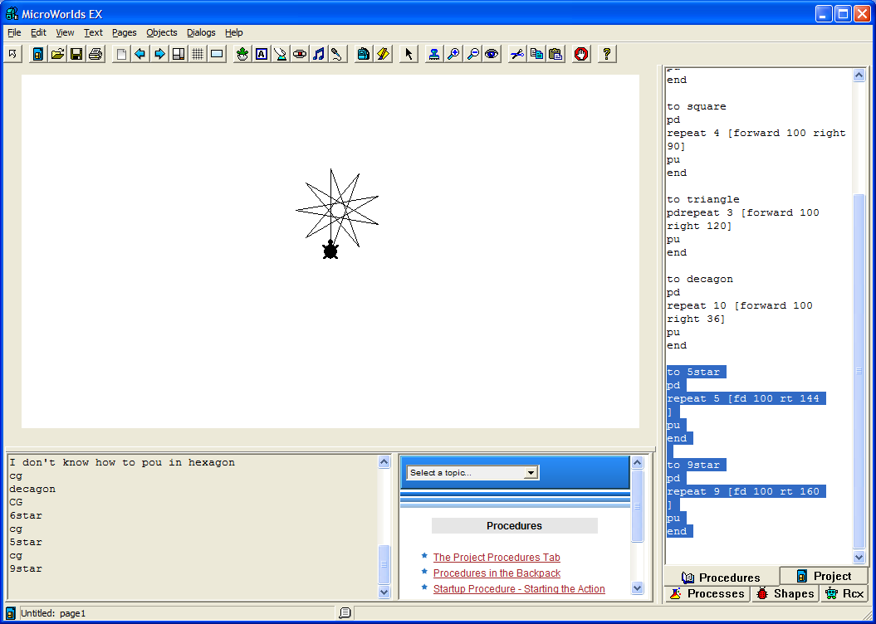
]
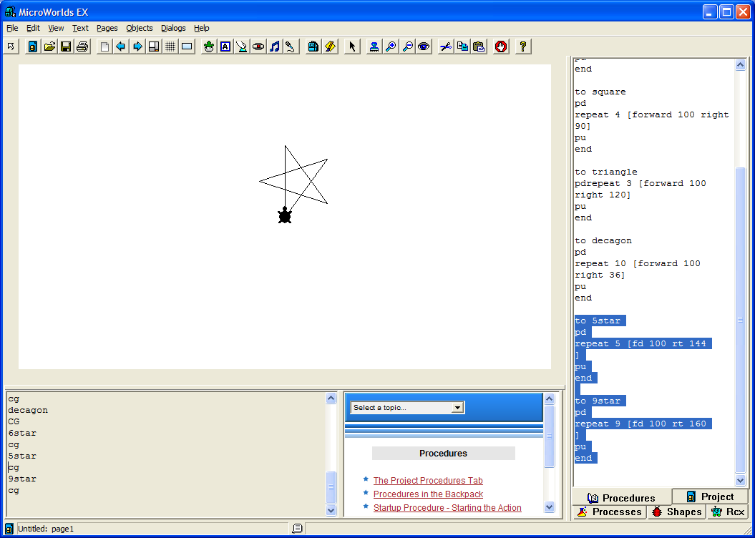
pu
end

Description

The calculation for this is a little weird.

First, count the number of points you want. This must be odd. This is the repeat value.
Then, see how many “rotations” the turtle makes to draw the complete figure. For example, to draw a 5 pointed star, the turtle turns around twice. For a 9 pointed star, it turns 4 times. It may not ever be in the same orientation, but it passes through the same orientation. I believe this is actually (the number of points -1)/2 . The angle will be

360 * [(number of points -1)/2]/number of points

For example 7 points

360*(6/2) /7 = 154.2857

to 7star
pd
repeat 7 [fd 100 rt 154.2857]
pu
end

