Making our First Game

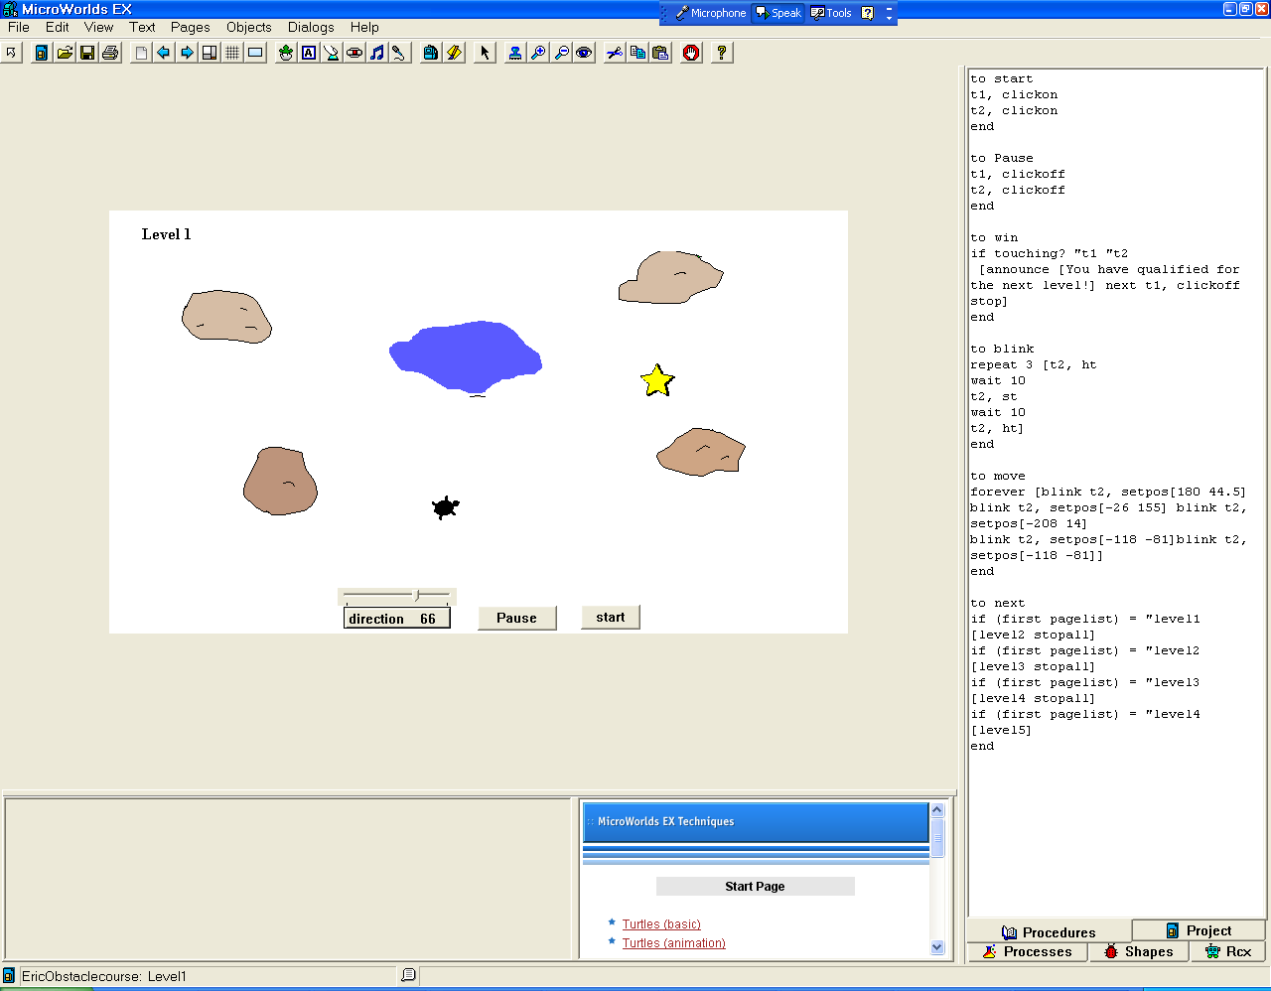

Steps:
- Draw some rocks and a pond
  - “edit” (right click) on one of the rocks
    - Make an announcement just like last week —if the turtle hits the rock. For example: announce [Ouch! That hurt] stopall
  - “edit” (right click) on the pond
    - Make an announcement like above
- Make a Start button
  - Open the backpack
    - Label it
    - Instructions: start
    - Explain “start” in the procedures location (see below end of second page)

- Make a Pause button
  - Open the backpack
    - Label it
    - Instruction: pause
    - Explain “pause” in the procedures location (see below)

- Hatch a turtle (this will be turtle 1 t1 )
seth= set heading

direction is going to refer the turtle to the slider which allows the player to determine the turtles direction

fd 1 / 11: fd 1 divided by eleven makes the turtle move slowly NOTE THE SPACES BETWEEN 1 / 11

win – see procedures for explanation of win
  - Open backpack
  - In the rules section
    - Onclick: seth direction fd 1 / 11 win
    - Choose forever
- Make a slider
  - Name it: direction
  - Min -180
  - Max 180
- Hatch a second turtle (this will be turtle 2 t2 )
  - Perhaps add a shape. This is where the turtle needs
to get to
- in the procedure area explain to your turtle the words,
“start”, “pause” and “win”

to start
t1, clickon
t2, clickon
end

to pause
t1, clickoff
t2, clickoff
end

to win
if touching? "t1 "t2
[announce [You have qualified for the next level!] next t1, clickoff stop]
end

MAKE SURE YOU SAVE THE FILE

Can you “decode” this programming?

to blink
repeat 3 [t2, ht
wait 10
t2, st
In addition, open the backpack on turtle 2 and in the rules section Onclick select once and enter “move”. This explains to the turtle when the player clicks on the start button “Onclick” it is to follow the directions for “move”
wait 10
t2, ht]
end

to move
forever [blink t2, setpos[180 44.5] blink t2, setpos[-26 155] blink t2, setpos[-208 14]
blink t2, setpos[-118 -81]blink t2, setpos[-118 -81]]
end

to next
if (first pagelist) = "level1 [level2 stopall]
if (first pagelist) = "level2 [level3 stopall]
if (first pagelist) = "level3 [level4 stopall]
if (first pagelist) = "level4 [level5]
end

Copy Page 1 to make 4 more pages
Rename each page level1, level2, level3, level4, level5
Go back and on each page Label the Level

On each different page you want to make a different level for the player. Each time should be a little harder for the player. One way is to make the turtle go faster each time. Change the speed of the turtle in the backpack for each level, For example:
Level 1 seth direction fd 1 / 11 win
Level 2 seth direction fd 1 / 9 win
Level 3 seth direction fd 1 / 7 win
Level 4 seth direction fd 1 / 5 win
Level 5 seth direction fd 1 / 3 win

MAKE SURE YOU SAVE YOUR FILE

