


NETS*T Candidate Readiness Benchmark

Performance Assessment Pilot

ISTE has received PT³ funding to “Develop and implement model assessments for entry into Teacher Education programs.” As part of this initiative, ISTE has selected IC³ to partner on a limited implementation pilot. The goal of the pilot is to support pre-service programs in piloting IC³ as the Candidate Readiness Benchmark assessment for NETS*T. The results of the pilot will be presented at SITE in March.

NATIONAL
BOARD-LIKE
CERTIFICATION

(NETS*T Resource for Assessment, 2003, ISTE, Eugene, OR, p.6)

Candidate Readiness is the first of four profiles of the NETS*T standards, corresponding to the four stages in a teachers career. This General Preparation profile focuses on the foundation technology skills that a prospective teacher should have when they enter a teacher training program to begin learning instructional technology specific skills.

Whereas it is now generally accepted that the latter three profiles are best assessed through some type of e-portfolio assessment, ISTE is interested in determining whether a computer scored, performance assessment is valid, reliable, and scalable for the first stage, and perhaps for selected portions of the other stages.

ISTE has selected IC³ for a pilot. The Internet and Computing Core Certification (IC³) is an internationally benchmarked set of three assessments covering literacy and competency within the following domains:
- Computer Fundamentals (hardware and software)
- Key Applications (word processor, spreadsheet, presentation)
- Living On-Line (e-mail, browser, net-etiquette, etc.)

IC³ is a certification in the family of IT certifications that includes Microsoft Office Specialist (MOS), A+ and others (MCSE, Cisco, etc.). Each of the three 30-60 minute IC³ exams combines simulations and linear (multiple-choice) items and produces diagnostic reports. IC³ is NOT an education specific assessment appropriate for later stage NETS*T benchmarking. It is, by design, a cross-industry assessment of those general IT skills any person should have upon entering an information intensive industry.

Also included in this pilot will be an alpha trial of a NETS*T digital transcript. This transcript is designed to provide teachers with an enduring unique URL holding the basic location and endorsing entity associated with each NETS*T benchmark. Since the platform used to assess the educator’s competencies will likely vary from pre-service to in-service institutions, a digital transcript is proposed as a way of offering centralized and secure access. Any ePortfolio assessments, course completions, and program certifications from any institution or platform could be included. Educators could use this site to document validated progress towards full NETS*T qualification.

The pilot will produce three outcomes:
- a gap analysis of IC³ and the NETS*T General Preparation Profile
- a set of implementation models for IC³ in pre-service training
- a set of requirements for a NETS*T digital transcript

As of January 9, twelve teacher training institutions have signed up for the pilot:

- Harding University, College of Education
- University of Maryland
- International Graduate Center
- University of Illinois, Urbana-Champaign
- Iowa State University
- Delta State University
- The University of Mississippi
- East Carolina University
- University of Virginia
- Wake Forest University
- University of Houston
- University of Colorado at Denver

Each participating institution will be set up as an IC³ test center and will administer the three IC³ tests and a custom on-line survey instrument to up to 60 students and faculty members. The survey instrument follows. Results of the pilot will be presented at SITE in March where a second pilot cohort will be commenced.

NETS*T Candidate Readiness Benchmark Pilot
Survey Questions

Questions 1-8: Please rate your ability in each of the three major areas listed above using the following scale.
1 – I have no skill or knowledge in this area.
2 – I understand and can use some of the features/equipment listed in this area
3 – I have a significant knowledge and skill in this area.
4 – I could teach/train other students/teachers in this area.
- Computing fundamentals (hardware, software and operating systems)
- Word Processor
- Spreadsheets
- Presentation Software
- Basic Online Tools (e-mail and the Web)
- Synchronous On-Line Tools (instant messaging, chat)
- Digital image and video editing
- Web Site Design and Maintenance

Questions 9-16: Please rate what level of skill you believe k12 teachers should have in each of the following areas.
1 – No skill or knowledge needed in this area.
2 – Teachers should have some basic knowledge and skill in this area.
3 – Teachers should have a significant knowledge and skill in this area.
4 – Teachers should be sufficiently comfortable in this area to teach/train others.
- Computing fundamentals (hardware, software and operating systems)
- Word Processor
- Spreadsheets
- Presentation Software
- Basic Online Tools (e-mail and the Web)
- Synchronous On-Line Tools (instant messaging, chat)
- Digital image and video editing
- Web Site Design and Maintenance

(17) Indicate how well you believe IC3 tests the technology skills and knowledge that people should have when they enter a teacher training program.
- The IC3 assessment does not cover any of the relevant skills and knowledge
- The IC3 assessment covers an inadequate amount of relevant skills and knowledge
- The IC3 assessment covers most of the relevant skills and knowledge
- The IC3 assessment covers all of the relevant skills and knowledge

(18) Please indicate in the space below what additional subject matter should be included in a Candidate Readiness Benchmark, or which subject matter included in IC3 should be eliminated or minimized:

[Free Response Field]

(19) Please indicate how well prepared someone with the foundation skills represented in IC3 would be to enter a teacher education program:
- Someone with these skills would not be prepared for a teacher education program
- Someone with these skills would be somewhat, but not sufficiently, prepared for a teacher education program
- Someone with these skills would be sufficiently prepared for a teacher education program
- Someone with these skills would be well prepared for a teacher education program
- Someone with these skills would be very well prepared for a teacher education program

(20) Please indicate how well prepared someone with foundation skills represented in IC3 would be for using technology in the classroom:
  - Someone with these skills would not be prepared to use technology in the classroom
  - Someone with these skills would be somewhat, but not sufficiently, prepared to use technology in the classroom
  - Someone with these skills would be sufficiently prepared to use technology in the classroom
  - Someone with these skills would be well prepared to use technology in the classroom
  - Someone with these skills would be very well prepared to use technology in the classroom

(21) How well did the IC3 exam delivery technology work?
- The exam delivery technology did not work
- The exam delivery technology worked, but I encountered technical problems during delivery that made it difficult to complete one or more exams
- The exam delivery technology worked, but I encountered issues relating to performance or reliability
- The exam delivery technology was successful, although I ran into small problems regarding performance or reliability
- I encountered no problems with the exam delivery technology

(22) Please indicate how well the exam questions fairly and accurately assess knowledge and skills being measured:
- Most questions did not seem to fairly or accurately measure skills and knowledge
- Many questions did not seem to fairly or accurately measure skills and knowledge
- Some questions did not seem to fairly or accurately measure skills and knowledge
- A few questions did not seem to fairly or accurately measure skills and knowledge
- Most, if not all, questions fairly or accurately measured skills and knowledge

(23) The current IC3 exam covers the Windows platform. Do you consider it important to also cover the Macintosh platform?
[ ] Yes - Covering the Macintosh platform is important
[ ] No - Covering the Macintosh platform is not important

(23a) If you answered "Yes" to the previous question, what do you think is the best way to cover Macintosh in the IC3 assessment?
- Create a separate IC3 exam that covers Macintosh versions of operating system and application software
- Include a number of questions on the Macintosh platform in the existing IC3 exams, to determine if candidates are capable of working on both platforms
- Include some additional knowledge and concept questions on the Macintosh, but leave the operating system and application elements of the assessment as is.

(24) Overall, how was your experience taking the IC3 assessment?
  - Poor
  - Average
  - Good
  - Very Good
  - Excellent

(25) Would you recommend IC3 as a good baseline for education technology-specific coursework?
[ ] Yes
[ ] No

(26) Should IC3 be required for program entrance or completion?
[ ] Yes
[ ] No

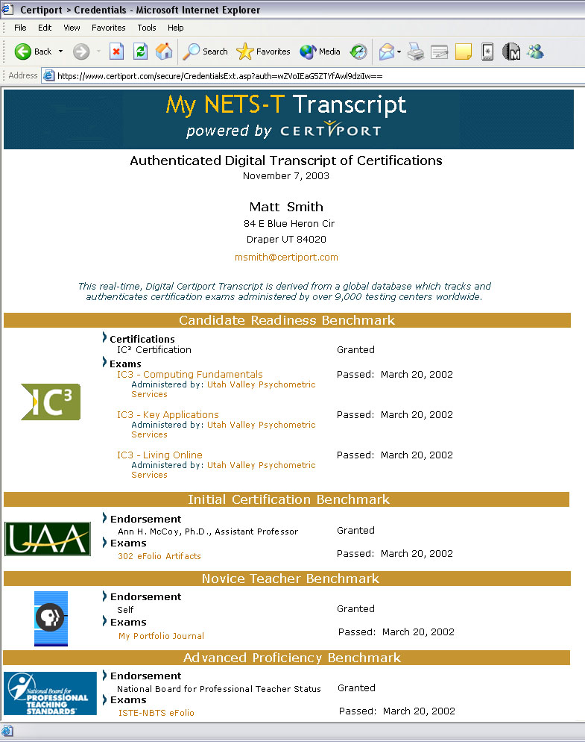

(27) Your record of IC3 progress and completion (illustrated above) is automatically provided to you free of charge when you begin the IC3 program. Would you consider including a URL for such a Digital Transcript on your resume?

[ ] Yes
[ ] No

(28) Would you be interested in a Digital Transcript that provided you the ability to add links to other types of assessments (like e-portfolios) in order to demonstrate your progress towards other NETS-T standards and indicators?

[ ] Yes
[ ] No If not, why?

For questions 29-34, select your level of agreement
1 – Strongly agree
2 - mostly agree
3 – neutral, no opinion
4 – mostly disagree
5 – strongly disagree
(29) Technology is an essential tool to support all teaching and learning.
(30) Technology skills are a basic skill that all students should receive from their k12 education.
(31) Technology takes time and resources away from more important academic activities.
(32) When you were a k12 student, most teachers used technology effectively to support classroom instruction.
(33) As an undergraduate, most faculty members used technology effectively.
(34) I have a clear vision of how I would use technology as a teacher.

